

**Contents**

**Reducing gambling harm for positive change**

**5**

**Case Study 1: David and Helen**

**6**

**Dimensions of gambling harm**

**7**

**Gambling in Tasmania**

**9**

**Tasmanians seeking help for gambling**

**11**

Age and gender

11

Income

11

Two forms of gambling are particularly harmful

12

Affected others

15

**Gambling harm affecting health**

**16**

Emotional and psychological distress

17

Impacts on mental health

17

Suicide and suicidal behaviour

18

Impacts on physical health

18

**Case study 2: Sam**

**19**

**Gambling harm affecting resources**

**20**

**Case study 3: Charlie, Courtney and Mitchell**

**21**

Financial impacts

22

Work and study impacts

25

Criminality

25

**Gambling harm affecting relationships**

**27**

Relationships and family dysfunction

28

Family violence

29

Family environment and impact on children

30

Community connectedness and cultural harms

32

Intergenerational harms and persistent disadvantage

33

**Case study 4: Gail**

**36**

**Conclusion and recommendations**

**38**

**2**

**What’s the real cost?** | anglicare-tas.org.au

**Glossary**

**Affected others**

People directly affected by another person’s gambling behaviour.

**Australian Unity Wellbeing Index**

The Australian Unity Wellbeing Index is a survey tool that measures levels of satisfaction across standard of living, health, achieving in life, relationships, personal safety, community connectedness and future security. It is produced by Australian Unity in partnership with Deakin University.

**Capability**

The ability to do something or achieve an outcome given the right conditions.

**Consumer surplus**

The benefit that a consumer derives from a good or service when the price paid is less than they would be willing to pay.

**Disadvantage**

In this paper refers to socioeconomic disadvantage and means a lower relative access to material and social resources as well as a decreased ability to participate in society.

**Electronic gaming machine (EGM)**

A computerised gambling device that has a video screen displaying symbols on simulated reels.

**External cost**

A cost incurred by a person (an affected other) as a result of an economic transaction they were not involved in. Also known as a spill-over cost or third-party cost.

**Human capital**

The skills, knowledge and experience possessed by an individual or population.

**Institutions**

Human-devised social structures of rules and norms that shape and constrain individual behaviour.

**Kessler Psychological Distress Scale**

The Kessler Psychological Distress Scale (K10) is a measure of psychological distress. The K10 scale involves 10 questions about emotional states each with a five-level response scale.

**Low-risk gambling**

Gambling behaviour by a person that results in a score between 1 and 2 on the Problem Gambling Severity Index (PGSI).

**Medium-risk gambling**

Gambling behaviour by a person that results in a score between 3 and 7 on the Problem Gambling Severity Index (PGSI).

**Problem gambler**

A person whose behaviour scores 8 or more on the Problem Gambling Severity Index (PGSI).

**Problem gambling**

Gambling behaviour by a person that results in a score of 8 or more on the Problem Gambling Severity Index (PGSI).

**3**

**What’s the real cost?** | anglicare-tas.org.au

**Productivity**

A measure of the rate at which output of goods and services is produced per unit of input (labour, capital, raw materials etc.).

**Problem Gambler Severity Index (PGSI)**

A widely used measure of at-risk gambling behaviour. An increased score indicates a higher level of risk, with zero indicating no risk and ‘problem gambling’ defined by a score of 8 or more.

**Psychological distress**

Non-specific symptoms of stress, anxiety and depression.

**Regressive taxation**

Regressive taxation places a proportionately greater burden on low- income earners than high-income earners. It is in opposition

to a progressive tax, which takes a larger percentage from high- income earners.

**Resources**

A stock or supply of money, materials, staff and other assets that can be drawn on by a person or organisation in order to function effectively.

**Social capital**

The networks of relationships among people who live and work in a particular society, enabling that society to function effectively.

**Suicidal behaviour**

A range of behaviours or actions which are related to suicide, including suicidal thinking, self-harming behaviours and/or suicide attempts.

**A note about terminology**

We acknowledge that the terms **problem gambler** and **problem gambling** are problematic and not consistent with a public health approach to gambling. However, these terms are widely used in research and literature to refer to people experiencing harm from gambling, usually with a Problem Gambling Severity Score of 8 or more. These terms are used in this report only where necessary in order to avoid ambiguity. They are not intended to criticise the behaviour of individuals.

**4**

**What’s the real cost?** | anglicare-tas.org.au

**Reducing gambling harm for positive change**

Strong relationships, good health and access to adequate resources are outcomes that benefit all Tasmanians.

Issues holding Tasmanians back include poor mental health, relationship breakdowns, family dysfunction, domestic violence and abuse, poor education outcomes, poverty and persistent disadvantage. Their causes are diverse and complex.

Reducing gambling harm is a policy lever with the potential to positively impact these complex issues.

**Gambling-related harms are the adverse impacts from gambling on the health and wellbeing of individuals, families, communities and society.**

**These harms are diverse, affecting resources, relationships and health, and may reflect an interplay between individual, family and community processes. The harmful effects from gambling may be short-lived but can persist, having longer term and enduring consequences that can exacerbate existing inequalities.**

(Wardle et al. 2018)

When we think of gambling-related harm, what often comes to mind is gambling behaviour leading to crisis such as bankruptcy, job loss, homelessness or divorce. That is partly because these impacts are more easily measured, understood and reported. We also tend to know more about severe harm because people experiencing it are more likely to seek help.

David sought help from Anglicare’s financial counselling service and his story is an example of crisis harms that can be experienced as a result of someone else’s gambling ( **refer to Case Study 1, p.6**).

Situations such as David’s unfortunately occur too frequently. The devastating consequences of severe harms gain attention and may lead to the assumption that only ‘problem gambling’ results in gambling harm.

However, recent research suggests that indirect and intangible gambling harms, which are harder to measure, account for a greater proportion of gambling harm than was previously thought.

Using local case studies and data from Anglicare’s counselling services and drawing on recent research, this report will explore the real cost of gambling. The report will consider costs of gambling harm in relation to impacts on health, resources and relationships. Finally, intergenerational harm and its role in maintaining persistent disadvantage will be discussed, showing how reducing gambling harm can deliver benefits for all Tasmanians.

**5**

**What’s the real cost?** | anglicare-tas.org.au

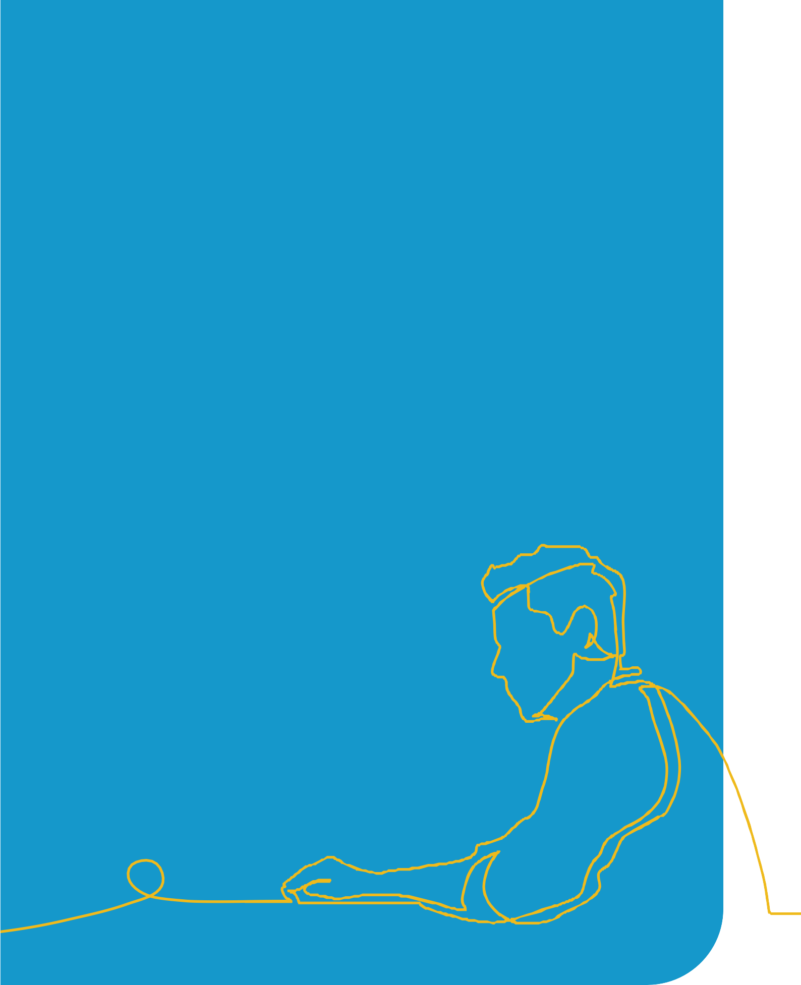

**Case Study 1: David and Helen1**

David retired from a career as a respected professional to enjoy a comfortable retirement on the superannuation earned during his working life. He was delighted to reconnect with Helen, whom he had known many years ago, and their relationship brightened his hopes for his later years.

David soon found out that Helen had a bit of a gambling problem and he assisted her out of a tight spot financially. However, she had got help and sorted herself out so they continued to plan for a future together.

They moved to Tasmania and bought a house outright. With no mortgage, they settled down to enjoy a carefree retirement.

However, Helen had a gambling addiction involving poker machines. She funded it with money intended for bills and by forging David’s signature to fraudulently mortgage their home. Helen hid this from David by telling the neighbours and local business people that he was developing dementia and so they should only deal with her.

David first became aware of the problem when bailiffs came to repossess his home. Although it should have been possible to establish that David was the victim of fraud, he had no money to pay a lawyer and Helen had disappeared.

David lost his home, his retirement savings, his dream of a life partner and his reputation in the community. He is now

living off the age pension in rented accommodation and is painstakingly repaying the debts run up by Helen.

He feels deeply distressed and anxious. The extreme stress he is experiencing is likely to impact his physical health and he is less able to afford quality health

care. He has withdrawn from social involvement in his community and plans to move interstate once he has repaid Helen’s debts.

1 Names and some details have been changed to protect privacy.

**6**

**What’s the real cost?** | anglicare-tas.org.au

•

•

**Dimensions of gambling harm**

Gambling harm is complex, multi-dimensional and far-reaching. Its impacts spread like ripples in a pond from the gambler to their friends and family (affected others), the community and the economy.

Gambling harm adversely affects health, resources and relationships ( **see Figure 1, p.8**):

•

Health impacts can be mental and physical. Harms include psychological and emotional distress and there is growing evidence of the role of gambling harm in suicide (Suomi & Dowling 2020; Suicide Prevention Australia & Financial Counselling Australia 2022).

Harms to resources include financial impacts (reduced disposable income and increased debt), reduced performance and engagement in work and study, and crime. These affect not only the resources available to a gambler and their household but those of the community as a whole.

Relationships are impacted at the interpersonal (social) and community (social and cultural) level. Recent research has highlighted the role of gambling harm in family dysfunction, domestic violence and abuse, and its impacts on children (Hing et al. 2020; Suomi et al. 2022).

Many impacts reinforce persistent disadvantage and reduce future potential, resulting in lifetime and intergenerational harm. This includes the redistribution of funds from lower to higher socioeconomic groups, family dysfunction, and the ongoing (legacy) effects of other harms such as mental health impacts and crime.

While gambling choices occur at the individual level, there are often adverse impacts on people who have not been involved in these decisions. It is recognised that gamblers tend to underestimate how much they lose and often have a poor understanding of the financial risk

involved (O’Neil, Whetton, Delfabbro et al. 2021). Recent research has revealed that gamblers also significantly underestimate the impact of their gambling on others (Goodwin et al. 2017).

As will be discussed further ( **see p.20**), the impacts on affected others, particularly those within the gambler’s household, should be included in the estimates of the socioeconomic costs of gambling.

**7**

**What’s the real cost?** | anglicare-tas.org.au

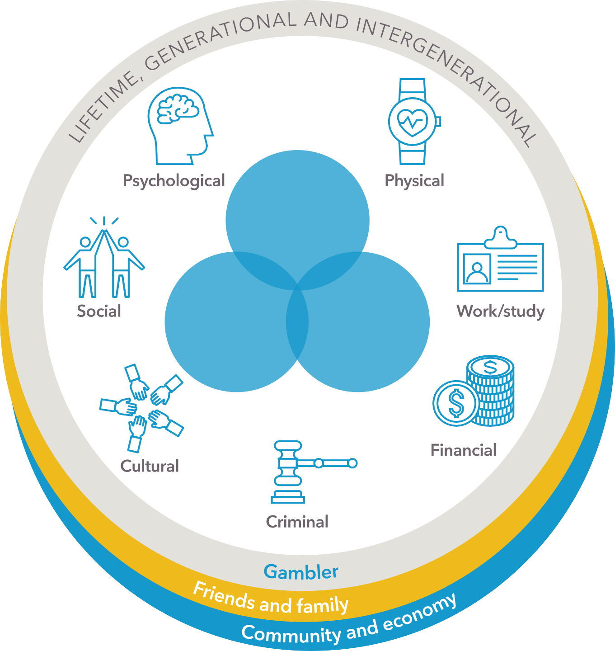

**Gambling Harm**

**Health**

**Relationships**

**Resources**

Figure 1 Dimensions of gambling harm, drawing on the frameworks described by Wardle et al. (2018) and Langham et al. (2016).

**8**

**What’s the real cost?** | anglicare-tas.org.au

only a proportion of the harms from gambling are costed

harm to people affected other than gamblers is underestimated

the costings for some social harms are conservative

intergenerational impacts are not included.

**Gambling in Tasmania**

Just under half (47%) of Tasmanian adults gamble with around 86,600 (18%) engaging in non- lottery gambling activities (O’Neil, Whetton, Kosturjak et al. 2021).2

In 2020-21, Tasmanian gamblers lost $398 million, which included electronic gaming machine (EGM) losses of $192 million (Tasmanian Liquor and Gaming Commission 2021). The following year, EGM losses were $178 million and total losses for 2021-22 are estimated at around $380 million (Department of Treasury and Finance 2022).3

That is a loss of over $1 million a day and an average annual loss of $1,676 per gambler.

As a recreational pursuit, non-problem gambling generates consumer surplus. However, only 10% of Tasmanians report that gambling makes their life more enjoyable. Eighty per cent (80%) of Tasmanians think that gambling does more harm than good in the community and only 6% of

people (including gamblers) disagree with this statement (O’Neil, Whetton, Delfabbro et al. 2021).

The most recent Social and Economic Impact Study (SEIS) estimated that Tasmanians spent

$59.4 million more on gambling than they either planned to spend or could afford (O’Neil, Whetton, Kosturjak et al. 2021). It also estimated that social harm from gambling costs Tasmania up to $159.6 million.

The authors of the report indicate that the real cost of gambling harm is not fully captured by this estimate. This is because:

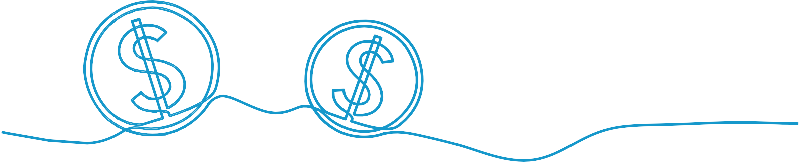

•

•

•

•

Data from relevant Anglicare support services (financial counselling and Gamblers Help) support this view ( **see p.11**).

1. Non-lottery gambling excludes lotteries, bingo and Keno.
2. Net expenditure on gambling other than EGMs based on the most recent data available (2020-21).

**9**

**What’s the real cost?** | anglicare-tas.org.au



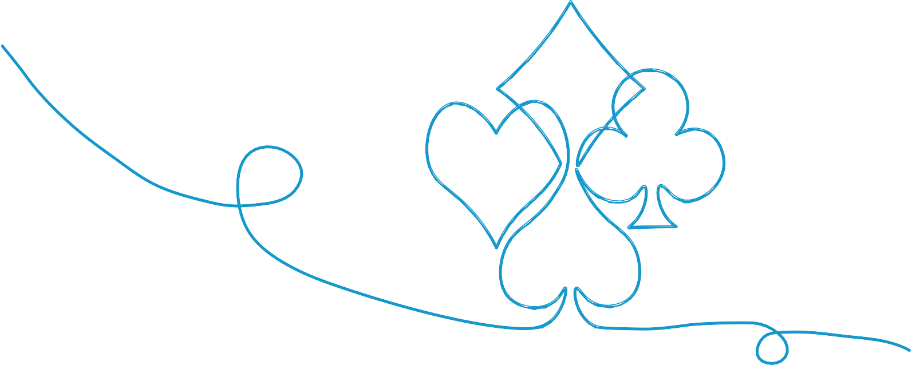

**Tasmanian gamblers lose over $1 million a day**

$60mil

**Tasmanians overspend $60 million on gambling**

The real cost of gambling includes significant harms that are hard to measure

**10**

**What’s the real cost?** | anglicare-tas.org.au

40%

**40% of gambling revenue comes from ‘problem gamblers’**

**8 in 10 Tasmanians believe that gambling does more harm than good**

18%

**18% of Tasmanian adults engage in non- lottery gambling**

**Tasmanians lose an average of $1,676 per gambler annually**

**Tasmanians seeking help for gambling**

**In 2021-22, assistance was provided by Anglicare support services to 347 Tasmanians harmed by gambling.** Of these, 190 people presented for a new issue during this period and provided data that is presented in this section.4

Only around one in 10 moderate risk and ‘problem gamblers’ seek help, so while this data provides key insights about people who did seek help due to gambling harm, it represents just a fraction of all Tasmanians experiencing gambling harm.5

**Age and gender**

Per capita, people between the ages of 45 and 54 were most likely to seek gambling-related help, closely followed by people in the 35 to 44 age group. However, people from all age groups were represented, including people aged under 18 and over 65 years.

Sixty-three per cent (63%) of people assisted were male and 37% were female.

**Income**

Financial counselling is a key pathway for people seeking help due to gambling harm. People on low incomes are more likely to experience financial issues so it is unsurprising that they are over-represented in this data, with 48% in the lowest income quintile (lowest 20%) and 23% in the second lowest income quintile for Tasmania. People experiencing financial harm from gambling compared to other types of gambling-related harm are also likely to be over- represented in this data.

Over half of people seeking help (53%) reported employment or self-employment as their primary source of income.

Almost two thirds (65%) of people seeking help due to gambling harm came from local government areas (LGAs) with a relative socioeconomic disadvantage index below the Tasmanian average.

**Tasmanians from socioeconomically disadvantaged LGAs were 70% more likely to seek help for a gambling problem.6**

1. An additional 47 people made contact but did not proceed for various reasons and for whom further data was not recorded.
2. The terms ‘problem gambler’ and ‘problem gambling’ refer to people with a PGSI score of 8 or more who are at significant risk of gambling harm (see ‘Measuring gambling risk’ on  **page 13**).
3. On a per capita basis. Socioeconomically disadvantaged LGAs defined as those having a Relative Socioeconomic Disadvantage Index below the state-wide average.

**11**

**What’s the real cost?** | anglicare-tas.org.au



















**Two forms of gambling are particularly harmful**

Electronic gaming machines and online gambling are the main gambling activity of 88% of people seeking help for gambling-related harm.

The main gambling activity of 76% of those seeking help was electronic gaming machines (EGMs) with most use occurring in hotels and clubs. Online gambling (including sports betting) was

the main activity of 12% of those seeking help. Only 12% of cases nominated any other form of gambling, such as casino gaming tables, race wagering, Keno or lotteries, as the primary gambling activity involved.

**Three in four people seeking help use electronic gaming machines (EGMs).**

**Figure 2.** Primary gambling activity of people seeking gambling counselling support.

Source: Anglicare Tasmania data

**Figure 3.** Location of primary gambling activity

of people seeking gambling counselling support.

Source: Anglicare Tasmania data

**12**

**What’s the real cost?** | anglicare-tas.org.au

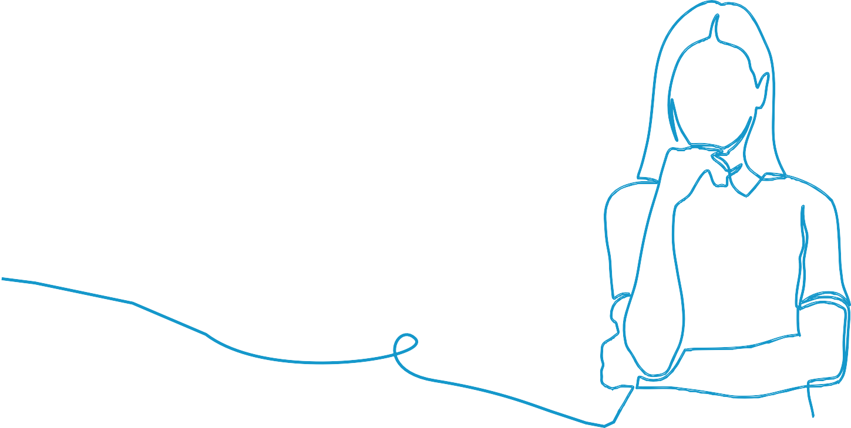

**Measuring gambling risk**

The Problem Gambling Severity Index (PGSI) is a widely used measure of at-risk behaviour in gambling. It is a research-based tool that asks participants to self-assess their gambling

behaviour over the past 12 months by scoring themselves against 9 questions. A total score is calculated by adding the scores for each question (between 0 and 3), which is used to categorise their risk of harm from gambling.

PGSI is a measure of a person’s risk of experiencing harm from their own gambling. It is not a measure of the gambling harm that they (or others) actually experience, nor is it the same as a clinical diagnosis of gambling disorder. A person’s risk from gambling may change over time or with life circumstances.

**Total score**

**PGSI Category**

**Tasmanian adults\***

**%**

**n.a.**

Non-gambler

256,230

52.9

**0**

Non-problem gambler

197,140

40.7

**1 – 2**

Low-risk gambler

20,830

4.3

**3 – 7**

Moderate-risk gambler

8,230

1.7

**8 or more**

Problem gambler

1,940

0.4

* Proportion of survey respondents in each PGSI category reported by O’Neil, Whetton, Delfabbro et al. (2021) applied to Tasmanian adult population; 2021 ABS Census data

**13**

**What’s the real cost?** | anglicare-tas.org.au





















Among Tasmanians seeking assistance, 95% of electronic gaming machine users were over 25 years of age. The most frequent users are more likely to be widowed, separated or divorced and are less likely to be working or studying. Electronic gaming machines are also disproportionately located in relatively socioeconomically disadvantaged LGAs.

This data indicates that the government’s welcome decision to introduce card-based gaming and default pre-commitment is justified.

By contrast, online gamblers are younger, more likely to be working, and more likely to be married or living with a partner. Over 90% of Tasmanian online gamblers who sought assistance were under 45 and almost half were under 25. Counsellors from Anglicare’s gambling support services have seen an increase in the number and proportion of people seeking help as a result of sports betting and other online gambling in recent years.

**Age by primary form of gambling**

Gaming machines

Internet

**Figure 4.** Age of people seeking help whose primary gambling activity was electronic gaming machines or gambling online. Source: Anglicare Tasmania data.

In short, gambling harm in people over 45 is mainly due to electronic gaming machines and for people under 25, it’s online gambling. For people between 25 and 45, it’s both.

It is anticipated that online gambling and other new forms of gambling will account for a larger proportion of gambling-related harm into the future.

Legal online gambling providers must be registered with and are regulated by the Australian Government. However, access to illegal offshore providers is possible.

**We’re starting to see … young 20-something-year-old men getting into significant debt in a really short amount of time after being 18. 20, 21 years old, and $20,000 lost.**

(Gambler’s Help counsellor)

**14**

**What’s the real cost?** | anglicare-tas.org.au

























**Affected others**

On average, each ‘problem gambler’ directly affects six other people (Goodwin et al. 2017). Each moderate risk gambler affects three other people and even low risk gamblers each affect one other person ( **see p.13**).

**Over 57,000 Tasmanians are harmed by someone else’s gambling**, based on these findings.

Goodwin et al. (2017) also reported that people who gamble underestimate how many people are impacted by their gambling. Their findings suggest that an estimate of affected others based on reports by gamblers would be 70% lower at just 16,000. People who gamble appear to also underestimate their losses. This means that estimates based on gambler reports are likely to underestimate the harm from gambling experienced by affected others.

Around 60% of affected others are intimate partners of the gambler and 20% are children in their household (Whitty & Paterson 2019). Of the 190 people who sought help for the first time in the past year, 12% were non-gamblers affected by someone else’s gambling.

The chart in Figure 5 shows that few affected others seek help for a gambling problem that has persisted beyond five years. This may be because partners and family stop seeking help after relationship breakdown. By contrast, most gamblers seeking help have had a problem for at least two years. The delay may be due to a lack of recognition about needing help. Alternatively, a relationship breakdown can act as a trigger to seek help.

One in four Tasmanians who sought help in relation to gambling harm in 2021-22 had dependent children living with them, with at least 110 children living in these households. It is estimated that between 25% and 50% of people with a gambling problem have dependent children (Suomi et al. 2022).

**How long has gambling been a problem?**

**Figure 5.** Gamblers and non-gamblers (affected others) seeking help from Anglicare gambling support services and duration of gambling issue. Source: Anglicare Tasmania data

**15**

**What’s the real cost?** | anglicare-tas.org.au

•

•

•

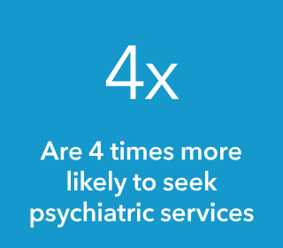



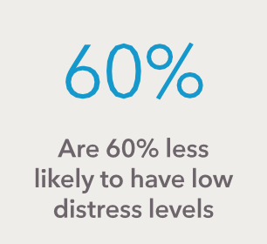



**Gambling harm affecting health**

Gambling causes harm due to:

⦁ psychological and emotional distress

⦁ negative mental and physical health effects.

**People who gamble and have a PGSI 8+:**

**Table 1 Summary of the health-related costs of gambling harm**

**Gambler**

Reduced life satisfaction

Reduced wellbeing due to erosion of personal values

Emotional distress due to

**Affected others**

Reduced life satisfaction Emotional distress due to

**Community**

Decline in social capital

Costs of provision of services to assist with psychological and emotional harms

Increased cost of health services to treat gambling and costs of other conditions caused or exacerbated by gambling.

Impact of suicide/suicidal behaviour on community (emotional and financial)

Increase in benefits claims for long-term disability/chronic health conditions

•

•

•

•

•

•

Frustration

Conflict with own values Shame and stigma

Insecurity and vulnerability

Feelings of suspicion

Experience of blame for gambling

Reduced self-worth

Fear of creditors

Intimate partner violence (IPV)

•

•

•

•

•

Shame and stigma

Insecurity

Powerlessness/loss of control Reduced self-worth

Fear of creditors

Increased stress, anxiety and depression

Substance abuse/misuse

Physical health impacts of reduced physical activity, poor diet and poor self-care

Increased blood pressure/ insomnia

Physical health impacts of increased substance use/abuse

Injuries resulting from violence

Suicide and suicidal behaviour, including self-harm

Fear of violence

Anxiety Depression Stress

Mental health impacts and suicidal behaviour due to IPV

Exhaustion due to supporting gambler to seek treatment

Physical injury due to violence

Physical impacts of stress and reduced self-care

Impacts of suicide/suicidal behaviour (emotional and financial)

**16**

**What’s the real cost?** | anglicare-tas.org.au

**Emotional and psychological distress**

Gambling results in lower levels of wellbeing. People who gamble at any level of risk report significantly lower levels of overall life satisfaction, with people engaging in ‘problem gambling’ having an average Australian Unity Wellbeing Index of 5.32 compared to the overall average of

8.09 (Rockloff et al. 2020).7

Only 26% of ‘problem gamblers’ were found to be in a state of no or low distress compared to 66% of the general population (Rockloff et al. 2020).

Gambling results in higher levels of psychological distress. Using the Kessler Psychological Distress Scale, a 2020 Victorian study categorised 39% of ‘problem gamblers’ as being in a state of high distress compared to 5% of the general population (Rockloff et al. 2020).

Emotional distress reported by gamblers (Browne et al. 2016) most commonly involves feelings related to:

•

•

•

loss of control and powerlessness

loss of security and safety

shame and stigma.

Reduced feelings of self-worth and fear of creditors have also been described.

Affected others also experience significant psychological distress, often closely associated with impacts on relationships and intergenerational harms.

**Impacts on mental health**

Gambling is associated with higher:

•

•

•

levels of stress, anxiety and depression

rates of smoking, alcohol and substance abuse

prevalence of mood disorders, post-traumatic stress disorder, attention deficit and hyperactivity disorder, bipolar disorder and obsessive-compulsive disorder (Lubman et al. 2017).

In people who gamble, causation of comorbid mental health conditions is complex. However, the role of gambling both in exacerbating these conditions and undermining the effectiveness of treatment is recognised (Suomi & Dowling 2020).

There is robust evidence that gambling plays a causal role in a range of mental health disorders of affected others, including anxiety and depression (Whitty & Paterson 2019; Suomi et al. 2022). Negative effects to mental health also result from gambling-related intimate partner and family violence.

7 The term ‘problem gambler’ and ‘problem gambling’ is used frequently in the literature to refer people with a PGSI score of 8 or more who are at significant risk of gambling harm (see ‘Measuring gambling risk’ on  **page 11**).

**17**

**What’s the real cost?** | anglicare-tas.org.au

**Suicide and suicidal behaviour**

The economic cost of suicide and suicidal behaviour in the Australian workforce alone has been estimated at $6.73 billion (Kinchin & Doran 2017). Gambling is causally linked to financial distress, unemployment and relationship breakdown, all of which are significant risk factors for suicide.

Suicide and suicidal behaviour are linked to gambling (Suomi & Dowling 2020). UK studies analysing gambling harm and suicide found that, after controlling for psychiatric comorbidities, a strong relationship remained between current ‘problem gambling’ and suicidal behaviour, suggesting that they do “not explain the whole relationship and other mechanisms may exist” (Wardle et al. 2020; Wardle & McManus 2021).

However, there is a significant gap in data on gambling-related suicides, including data for Tasmania. With an absence of data about links between gambling harm and suicide, the SEIS cannot provide an estimate of the cost of gambling-related suicides and suicidal behaviour (O’Neil, Whetton, Kosturjak et al. 2021).

Suicide Prevention Australia and Financial Counsellors Australia identify gambling as a significant risk factor for suicide and have published a ‘roadmap’ for change to reduce gambling-related suicide. This includes systemic changes to ensure active investigation of gambling activities in cases of possible suicide and consideration of gambling by Coroners' Courts (Suicide Prevention Australia & Financial Counselling Australia 2022).

**Impacts on physical health**

Direct impacts to physical health include injuries from gambling-related violence, including family violence.

Gambling-related harm also includes adverse impacts on physical health resulting from:

•

•

•

•

•

stress (such as high blood pressure, insomnia)

sedentary behaviour and lack of exercise

poor self-care

nicotine, alcohol and substance abuse

mental health conditions.

Intimate partners of problem gamblers have reported experiencing high blood pressure, headaches and gastro-intestinal disorders (Dowling 2014). Children in gambling households are reported to experience higher rates of asthma, allergies and chronic headaches (Dowling 2014).

**18**

**What’s the real cost?** | anglicare-tas.org.au

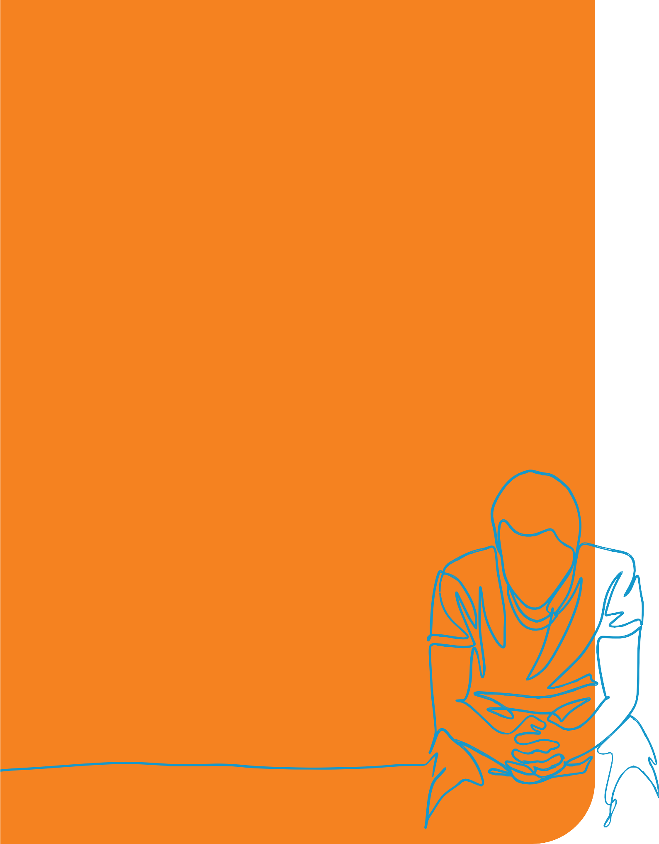

**Case study 2: Sam**

Sam started gambling at a young age. By the time he was 15 he had a real problem, mostly gambling online. When he finished school, Sam went on to study law at university and got a part-time job. He spent most of his earnings of around $800 a fortnight on gambling.

When he was 20, Sam lost his part-time work during the COVID-19 pandemic. However, he continued to gamble, linking his grandfather’s savings account to his online gambling profile. Over the next three weeks, instead of placing his usual bets of $2 to $5 per race, he increased his betting to between $100 and $200 per race. He

spent time gambling instead of studying. One evening, the funds ran out. Sam had lost

$16,000 of his grandfather’s money.

Sam panicked and accessed his father’s online bank account. He transferred $5,000 to his gaming account and tried to win back the losses. Instead, he lost all the money in the space of an hour. Sam accessed his father’s account again, transferring another $5,000, which he also lost in less than an hour.

At this point, Sam told his father what had happened. His gambling addiction had led him to engage in fraud and steal $26,000 from his family.

Sam contacted a financial counsellor, who helped him start getting back on track. His situation was complicated by a fraud investigation launched by his father’s bank and the online gambling provider threatened to report Sam’s behaviour to the authorities if the

$6,000 he still owed was not paid in full. The financial counsellor helped Sam to access his superannuation under the COVID-19 provisions and Sam’s mother

paid the remainder of the debt to the gaming provider.

Facing risk of prosecution for fraud, Sam accessed legal advice, found work and is gradually paying back the money he owes. He is also receiving counselling from Gamblers Help for his gambling addiction. He has moved interstate.

However, as a result of gambling, Sam has lost his relationship with his family, has reduced his lifetime savings and no longer has a future as a lawyer.

**19**

**What’s the real cost?** | anglicare-tas.org.au

**Gambling harm affecting resources**

Gambling harms that impact resources are generally more easily monetised than other harms. They include:

•

•

•

financial impacts

impacts on work and study (occupational impacts) impacts of crime.

It is important that decisions by gamblers are not assumed to be joint household expenditure decisions. When gambling by one member of the household limits the spending choices of other members of the household, this imposes an economic cost (an external or spill-over cost). Failure to include these as external costs in cost-benefit analysis is likely to result in policies that systemically perpetuate power imbalances and gender inequity, fail to protect the vulnerable and facilitate economic abuse.

**Table 2 Summary of costs of gambling harm affecting resources**

**Gambler**

Excess expenditure on gambling due to addictive behaviour

Excess expenditure on gambling due to lack of information or understanding of

🞄 Financial risks (odds)

🞄 Impact on affected others

Impact on credit rating, increased cost of finance and reduced capacity to access finance

Increased debt

Severe financial distress, including bankruptcy

Reduced productivity at work

Reduced academic/study performance

Job loss and unemployment (financial and health costs)

Legal costs

Imprisonment – reduced lifetime income

**Affected others**

Reduced household income to spend on other goods and services, including own preferences

Deprivation of essential needs (housing, heating, food, medicine, education costs)

Forced cohabitation in unhealthy partnership due to financial constraints

Impact on credit rating, increased cost of finance and reduced capacity to access finance

Increased household debt

Reduced household savings/ assets

Bankruptcy of family members

Cost to affected others of unemployment

Cost of reduced productivity of gambler (to employer)

Cost to employer of recruiting new employee

Uncompensated cost of crime to victims (including unreported crime)

Impact of imprisonment on affected others (reduced household income)

**Community**

Delayed payment of accounts Unpaid accounts

Costs of debt recovery (whether or not successful)

Cost of assistance from welfare/ community organisations (e.g. food banks)

Increased use of housing and community services

Increased use of financial counselling and assistance with debt management

Increased government income support

Reduced productivity and productive potential

Cost of reduced voluntary work

Costs of crime – enforcement, investigation, legal costs, court costs and incarceration

Compensation of victims of crime

Education costs without expected return

**20**

**What’s the real cost?** | anglicare-tas.org.au

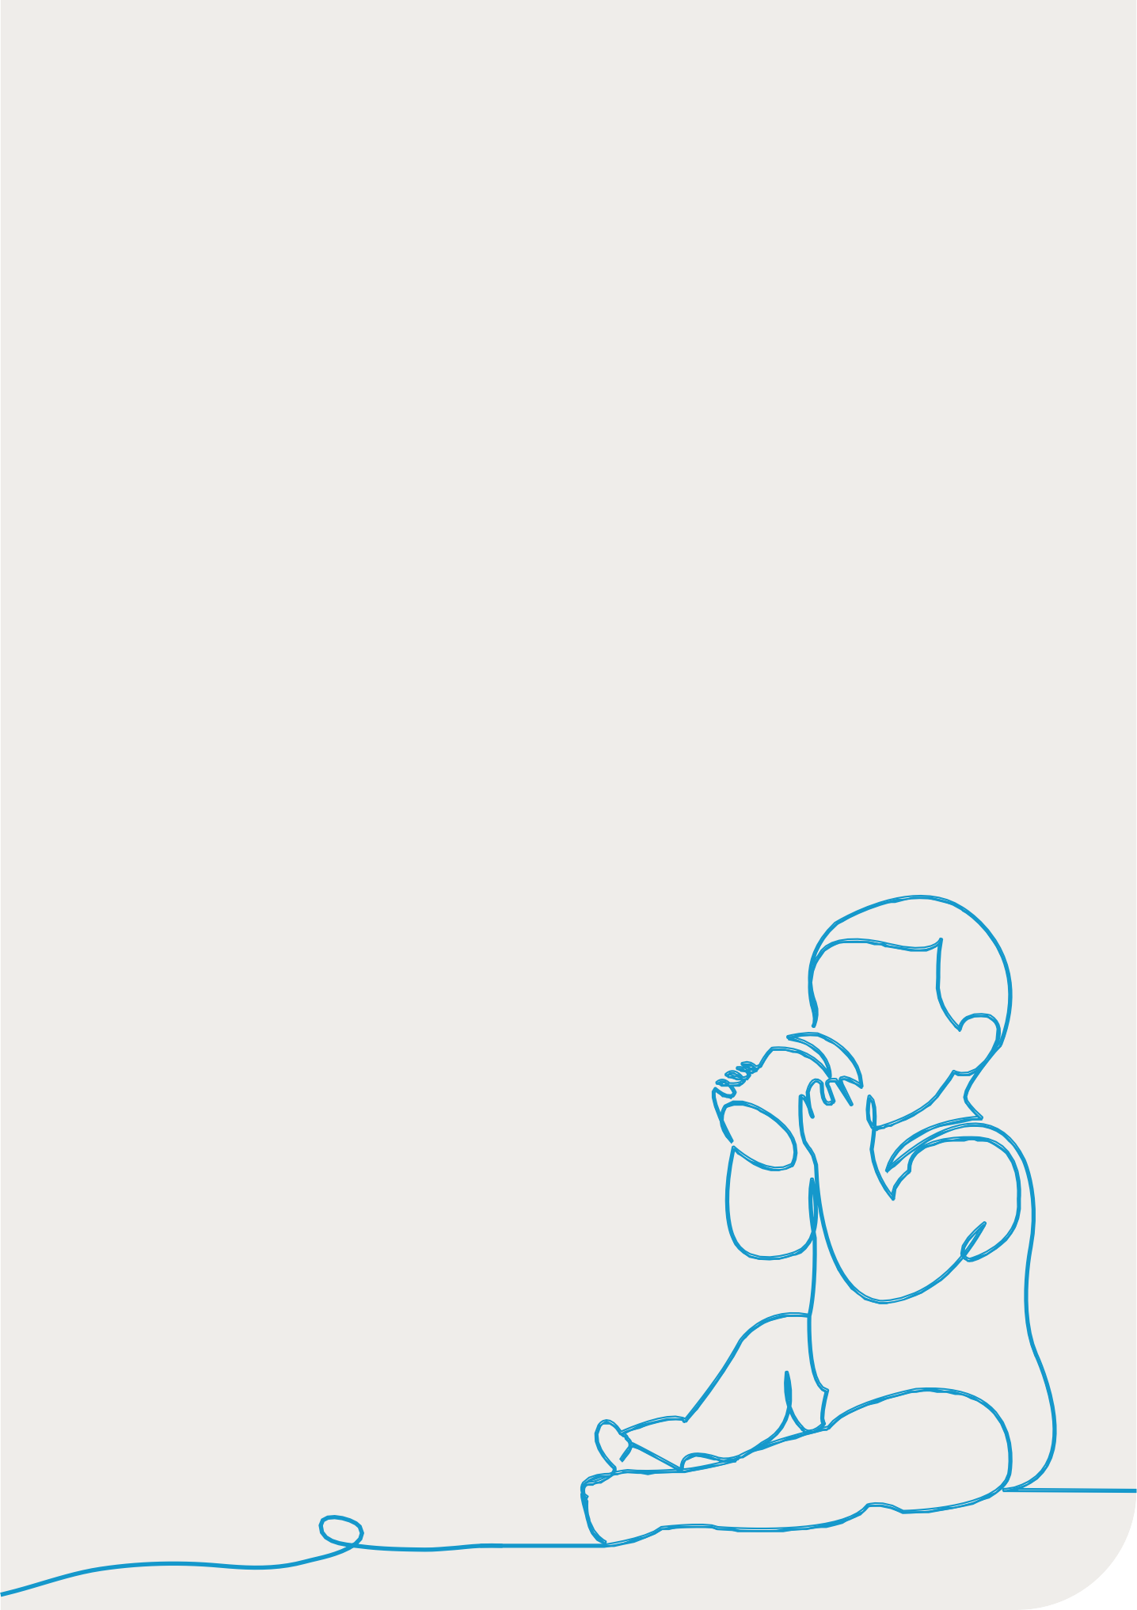

**Case study 3: Charlie, Courtney and Mitchell**

Charlie is 6 months old and lives with his parents, Mitchell and Courtney. The first two years are critical in shaping a child’s future and Charlie needs a stable home, free from conflict, with people providing loving care and attention.

Charlie’s primary caregiver is Courtney and together Mitchell and Courtney are ‘renting to buy’ their home from Courtney’s mother. Mitchell is just starting a new job and Courtney receives part parenting income support.

Mitchell recently admitted to Courtney that he had been gambling. He had gambled away his pay on a number of occasions and had then taken out short term loans to hide the lack of funds. It was out of hand and now he had debts of over $12,000.

This was a shock to Courtney and has caused issues in their relationship. Mitchell agreed to close his bank account and have his pay go into Courtney’s, which he could not access. While these arrangements helped to control his gambling losses, they have created new issues in their relationship. This is affecting their capacity to provide Charlie with their full attention and a conflict-free home.

Courtney’s dad helped them out financially so that they could provide basic material needs for Charlie, such as nappies and food. They were fortunate that Courtney’s mother was their landlord and that she was willing to loan them the money they owed on rent.

Mitchell and Courtney sought help from a Financial Counsellor, who helped them negotiate with the creditors, and eventually Courtney paid off the remaining debts. However, Mitchell has declined counselling from Gambler’s Help.

Although Courtney and Mitchell have started to get things back on track financially, gambling

has reduced their lifetime savings. It will also take some time to rebuild trust in their relationship with each other and with Courtney’s parents. The strain in their relationship, their anxiety and their preoccupation with their financial crisis are likely to have impacted both Charlie’s development and Mitchell’s performance at work.

If Mitchell’s gambling problem continues, family dysfunction is likely to have a lifelong impact on Charlie’s behavioural development, educational outcomes, relationships and future potential.

**21**

**What’s the real cost?** | anglicare-tas.org.au



**Financial impacts**

Analysis of the Household, Income and Labour Dynamics in Australia (HILDA) survey (Armstrong & Carroll 2017) found that, compared to non-gamblers, medium-risk and problem gamblers are significantly more likely to have been unable to pay:

* electricity, gas or phone bills on time
* mortgage or rent on time.

Problem gamblers are also significantly more likely to have:

•

•

•

•

•

pawned or sold something

gone without meals

been unable to heat their home

asked for financial help from friends or family

asked for help from welfare/community organisations.

The proportion of adults who reported experiencing each of these stressful financial events was higher for all gamblers except those classified as non-problem gamblers.

In a recent ACT survey (Whitty & Paterson 2019), affected others reported:

•

•

•

experiencing financial hardship (24%)

not having enough money for family activities and projects (20%)

not having enough money to pay household bills (17%).

**Figure 6.** When a person gambling loses more than they can afford, it is the members of the community (shown at left) who pay.

**22**

**What’s the real cost?** | anglicare-tas.org.au

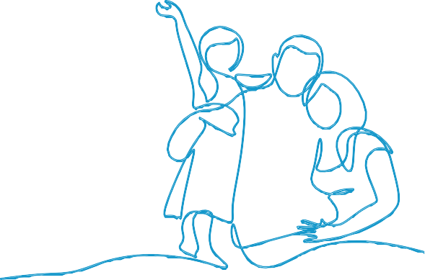

**What happens when a gambler loses more money than they can afford?**

When a gambler does not have the money or budget to pay for their gambling, the money ultimately comes from other members of the community ( **see Figure 6, p.22**). Household members, friends and family are often coerced into ‘bailing out’ the gambler. Because they are denied a free choice of spending their money according to their own preferences, this should be counted as an external cost of gambling harm.

**Other members of the household**

The money often comes from the household or family budget or by selling household assets. In this case, it is usually the gambler’s partner and children who pay.

They miss out on what might have been bought with the money lost, such as family holidays, school excursions, technology equipment, clothes and food.

**Friends and family**

Friends and extended family often feel obliged to help out by providing financial or

material assistance. Friends and family miss out on whatever they would have chosen to spend these funds on and this includes lost expenditure in local non-gambling businesses.

**Businesses in the community**

Businesses in the community are paid late or not at all. The money owed may be fully or partially written off as a bad debt. When Tasmanian businesses are not paid, it affects their cash flow, which in turn affects their capacity to pay their own creditors, invest, grow, employ people and, ultimately, affects their viability. The effect ripples through the whole economy.

**Taxpayers**

The gambler, their household or the friends and family who assist them may need additional financial support from the government as a result of the gambling losses. This is particularly the case if the gambler loses their job or their superannuation. This cost is borne by the taxpayer and these resources are not available to fund other government services.

**23**

**What’s the real cost?** | anglicare-tas.org.au

David, who had been a self-funded retiree,

became reliant on the age pension purely as a result of harm from Helen’s gambling addiction.

While David is gradually paying off the debts run up by Helen, the cash flow of these local businesses is reduced and they incur administrative costs. It has flow on effects as the businesses are less able to pay their own creditors.

Courtney’s mum and dad provided significant financial assistance to Mitchell and Courtney.

Sam’s mum helped to cover part of his $6,000 debt to an online gambling operator.

Courtney and Charlie are dependent on Mitchell’s income and his gambling has resulted in them having to cut back expenditure on necessities such as nappies, food and clothes.

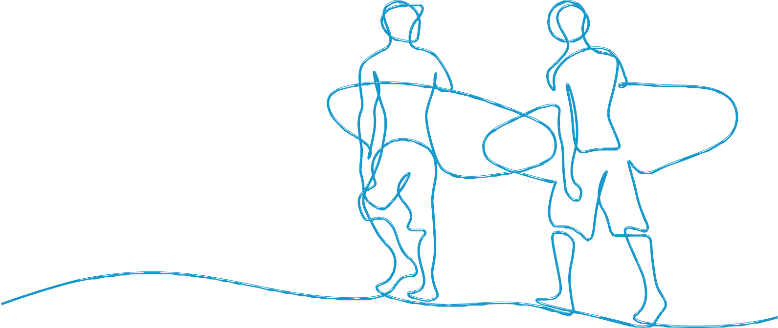

**Victims of crime**

In extreme cases, gamblers steal from friends, family, clubs or employers to pay their debts. Family and friends often do not press charges. In many cases it is not possible to recover the stolen funds in full, and legal costs are usually incurred.

**Welfare and community organisations**

Gamblers seek help from welfare and community organisations when unable to meet their basic needs as a result of gambling losses. Problem gamblers are three times more likely to seek help from welfare and community organisations than non-gamblers.

Because friends and family often feel obliged to pay outstanding amounts or do not press charges when they are victims of crime, the costs are not fully reflected in estimates of gambling harm. Similarly, estimates of the costs of gambling to the economy may not include the full costs of delayed payment to businesses.

People affected by medium- and low-risk gamblers also incur many of these costs.

Legal, administrative and interest costs add to the burden of the gambling debt on the community. Late payments to small business alone have been estimated to cost the Australian economy $1.1 billion (Xero 2022). The cost of the time spent by friends, family and community members who assist gamblers experiencing financial difficulties is also not included in estimates of gambling harm.

**24**

**What’s the real cost?** | anglicare-tas.org.au

Without the help of Courtney’s parents, Mitchell and Courtney would have been reliant

on welfare and community organisations for necessities.

Sam stole $26,000 from his grandfather and father. Helen defrauded David of his house and life savings.

**Work and study impacts**

Gambling can divert time and attention away from a gambler’s occupation. A decrease in engagement may lead to reduced performance and productivity at work and/or reduced learning and attainment through study.

This, in turn, results in:

•

•

•

•

•

reduced opportunities for promotion and employment

job loss or inability to gain employment

reduced business and economic productivity

costs to employers (due to absenteeism, costs of replacement recruitment) unproductive education expenses by the individual and community.

As a result of his gambling, Sam now has a history of fraud that prevents him from practising law and limits his future professional career options. The investment by Sam and the community in his studies of law will not deliver the benefits that were expected.

Online gambling is readily accessible 24 hours a day anywhere with an internet connection. Its availability using a mobile device creates the potential to engage in gambling without detection, including at work. Anglicare data shows that Tasmanians seeking help for internet gambling tend to be young, male and employed. People seeking help represent only a small proportion of employed people engaging in online gambling. The costs to Tasmanian businesses and the economy due to reduced work productivity are therefore likely to be substantial.

**Criminality**

Gambling-related crime includes:

•

•

•

financial crime to fund gambling or win back losses

financial crime to pay debts acquired gambling

violent crime, including intimate partner violence ( **see p.29**).

Gambling-related crime also includes gambling to launder the proceeds of crime, which is not discussed here.

Gambling-related crime frequently involves a betrayal of trust or a misuse of power and results in harms to the victims beyond the financial impacts.

Tasmanian gambling support counsellors report economic abuse of family members and older adults, including stealing money, as in the case of Sam, or pawning valuable goods from the home:

**… a more common issue, over the last five years of working in this space, children stealing from parents, but not necessarily financial theft. Things like family heirlooms, selling those off…**

(Gambler’s Help counsellor)

**25**

**What’s the real cost?** | anglicare-tas.org.au

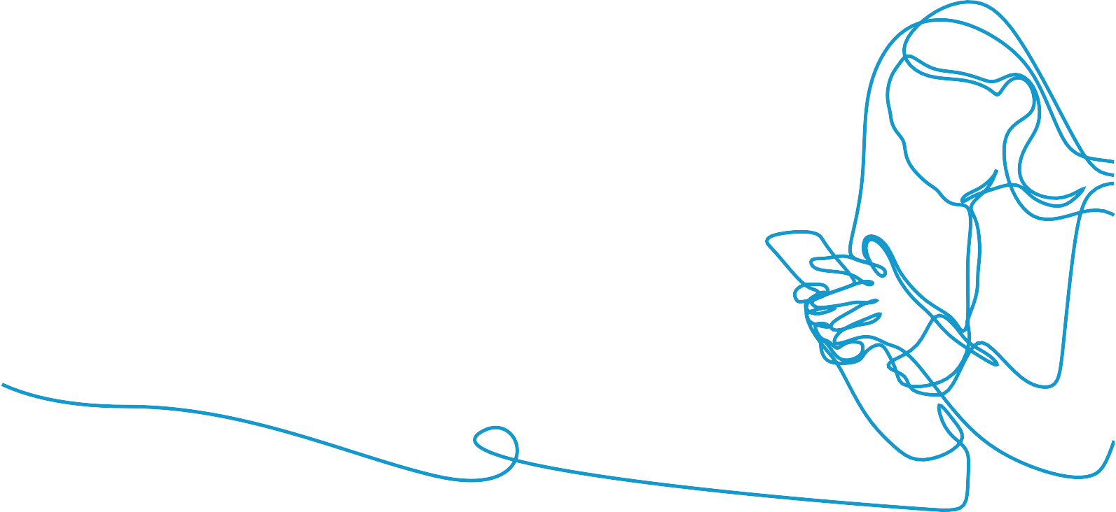

Like older adults, people with disabilities are another group at risk of economic abuse and theft, particularly if their carer has a gambling problem:

**…a young female called up and said that her dad was her carer and she has a physical disability. Dad does her grocery shopping for her, so she gives dad money to do that. Gives him her savings card and she checked the bank about half an hour after she’d sent him off to go to the grocery store and he’d spent all the money at the casino… and that was a regular thing…**

(Gambler’s Help counsellor)

Family members who are victims of crime often do not press charges. Employees in a position of trust who embezzle or steal from their employer are more likely to face prosecution:

**…a man was going through IVF with his wife. It was really stressful for him. So he started gambling, lost a bit of money, then he was trying to win money to pay for the IVF, because it was so expensive, and ended up having a fraud case because he’s done stealing off his workplace. And so, IVF stopped, that obviously caused huge strain within the relationship.**

(Gambler’s Help counsellor)

Crime also results in significant costs as a result of law enforcement, investigation of crime, and through the justice system.

Incarceration for any reason imposes significant and devastating costs on the offender and their family with substantial legacy impacts.

**26**

**What’s the real cost?** | anglicare-tas.org.au

**Gambling harm affecting relationships**

Gambling harms affecting relationships include:

* social harms to interpersonal relationships, including
  + family dysfunction and family violence
  + social harms to community cohesion
* cultural harms.

Relationships underpin wellbeing, development and our capacity to function effectively

in other areas of life. Gambling-related harm to relationships accounts for the largest share of the cost of gambling.

**Table 3 Summary of costs from gambling harm affecting relationships**

**Gambler**

Increased arguments and relationship stress

Reduced quality and quantity of time with partner and family

Relationship role distortion

Loss of trust between family members

Relationship breakdown/divorce/ separation

Domestic violence and abuse Impact on future relationships Social isolation

Reduced ability to fulfil family responsibilities

Reduced ability to fulfil cultural roles

Cultural harms from reduced ability to engage in cultural ritual

Imprisonment – lack of access to partner and family

**Affected others**

Increased arguments and relationship stress

Reduced quality and quantity of time with gambler

Lack of access to loved one when imprisoned

Relationship role distortion

Loss of trust between family members

Unequal contribution to relationship

Relationship breakdown/divorce/ separation

Domestic violence and abuse Impact on future relationships Social isolation

Harm to children of gamblers due to family dysfunction and reduced parental attention

Child abuse and neglect

Other developmental harm to children

Cultural harms including shame as a result of cultural roles not being fulfilled

**Community**

Reduced social capital and community engagement

Increased social isolation

Reduced cultural capital and social connectedness

Increased use of social services and relationship services

Increased family law costs

**27**

**What’s the real cost?** | anglicare-tas.org.au

**Relationships and family dysfunction**

Relationships between intimate partners, children and parents are particularly vulnerable to harm due to gambling.

In family relationships, over half of affected others report significant strain in their relationship with the gambler, characterised by:

•

•

•

•

•

•

diminished trust

arguments

communication breakdown

spending less quality time together

anger

stress or anxiety (Whitty & Paterson 2019).

**Adult child–parent relationships**

Problem gambling can prevent healthy relationships between adult children and their parents, with the problem gambler moving back into a child-like role. A Tasmanian gambling support worker observes:

**So, the potential adult-parent relationship then becomes somewhat of a parent-child relationship, where the adult child is not able to be trusted. There’s monitoring that goes on. There’s a scepticism about their finances, are they being deceitful, and this kind of parental control that comes back over these adult children.**

(Gambler’s Help counsellor)

**Intimate partner relationships**

Typically, the impact of gambling on the intimate partner relationship starts with a denial phase in which the affected other may notice or question unpaid bills (Dowling 2014). However, they often keep concerns to themselves, make excuses for the gambling, believe or hope that the gambling is temporary, and are often easily reassured by the gambler. An example of this phase can be seen early in David and Helen’s relationship ( **see Case Study 1, p.6**).

When gambling continues and the gambler spends less time with their partner, the partner feels rejected. The relationship enters a stress phase that is characterised by arguments, and attempts by the affected other to control their partner’s excessive gambling. They may do this by using emotional and controlling strategies, including becoming moody, and making threats and ultimatums. There is increasing avoidance of family and friends, although they may provide bailouts.

Finally, the relationship enters an exhaustion phase in which the intimate partner may doubt their sanity and experience confusion, impaired thinking, immobilisation, anxiety, panic or rage. The outcome of this is feelings of hopelessness that may result in mental health conditions, substance abuse, physical health conditions, separation or divorce or suicidal behaviour (Dowling 2014).

**28**

**What’s the real cost?** | anglicare-tas.org.au

The resultant family environment is characterised by:

•

•

•

•

•

an increase in arguments and conflict

poorer communication

a decrease in direct expression of feelings

lower levels of positive engagement and support

reduced participation in social and recreational activities.

Family violence is also associated with moderate-risk gambling and gambling addiction and is discussed below.

**Family violence**

There is strong evidence supporting a link between gambling and intimate partner violence with over a third of people experiencing gambling harm reporting that they have been victims of intimate partner violence (IPV) or have perpetrated IPV (Dowling et al. 2016). ‘Problem gamblers’ are also over-represented as perpetrators of IPV (Dowling et al. 2016).

Intimate partner violence perpetrated by people experiencing gambling harm is characterised by coercive and controlling behaviours used to:

•

•

•

access money for gambling

hide their gambling from others

blame their partner for their gambling and abusive behaviour.

Victim/survivors of gambling-related IPV reported that “access to personal and joint money for gambling represented a ‘battleground’ that resulted in them experiencing significant social, psychological and financial harm” (Banks & Waters 2022).

People experiencing gambling harm who perpetrate IPV usually subject their intimate partner to economic abuse, and physical violence, threats and intimidation may also be involved. Gamblers who are subjected to IPV have reported a range of abuse including physical, emotional and sexual abuse. Where it occurs, control of household finances by the male partner has also been reported to play a role in reinforcing IPV (Hing et al. 2020).

Gambling-related IPV often involves the use of alcohol and other substances (Hing et al. 2020; Dowling et al. 2018). Some people who gamble, usually women, may do so as a strategy for coping with IPV (Hing et al. 2020).

There is also evidence that gambling-related family violence victimisation and perpetration can extend beyond intimate partners to children and other members of the extended family (Dowling 2014).

**29**

**What’s the real cost?** | anglicare-tas.org.au

•

•

•

•

•

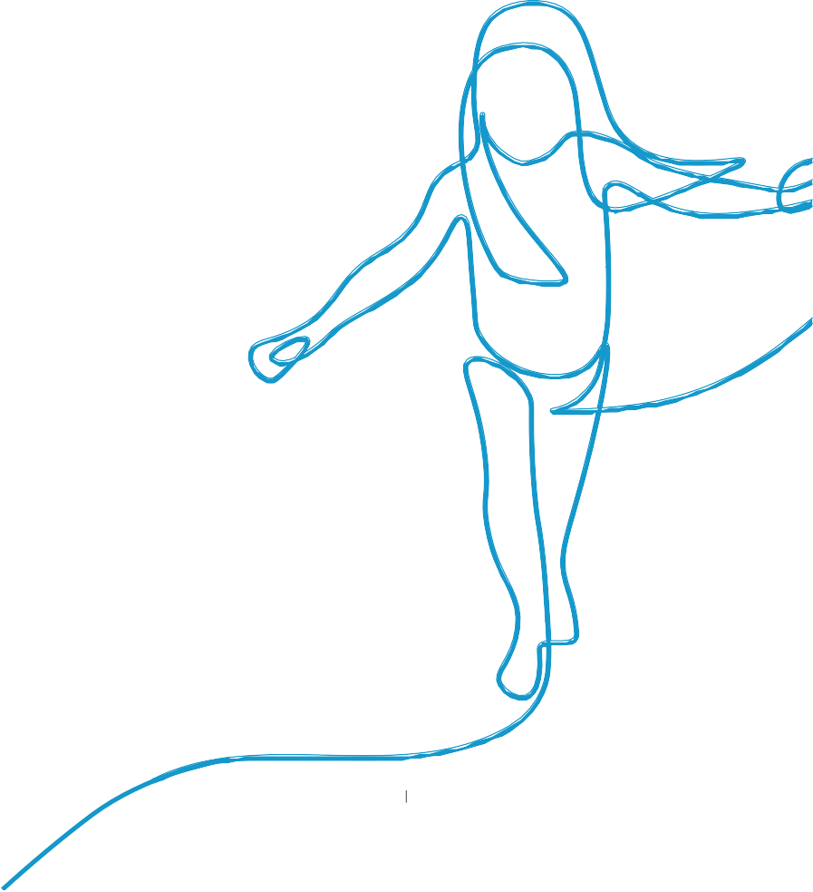

**Family environment and impact on children**

Children in a household impacted by gambling harms are more likely to experience financial deprivation, emotional deprivation, family conflict, family violence, inconsistent supervision and discipline, hostile parenting, parental neglect or abuse and decreased stability and security (Dowling 2014).

There is strong evidence that children of parents who gamble experience higher levels of psychological harm, dysfunctional family relationships, violence, behavioural harms, financial harms, and impacts on their physical health (Suomi et al. 2022). Children who have a parent with a gambling addiction are between 7 and 14 times more likely to engage in high risk gambling behaviour themselves (Dowling 2014).

A recent systematic review (Suomi et al. 2022) found that emotional distress was the most frequently reported impact on wellbeing of children of gambling parents, along with:

•

•

•

•

•

•

•

•

•

•

•

higher rates of depression

increased risk of suicidal behaviours

feelings of profound unhappiness and ‘pervasive loss’

dysfunctional relationships or lost contact with their parents

twice the incidence of separation or death of one parent before the age of 15

a lack of quality time with the gambling parent reported by 37-49% of children

loss of parental affection, attention and security

two times the risk of experiencing child abuse

increased risk of perpetrating child abuse as adults verbal and physical violence and neglect

behavioural and adjustment problems in 25% of children such as running away, drug and alcohol use, criminal activity and gambling

experiencing a lack of food and housing due to financial stress

bearing adult financial responsibilities at a young age

changing school and lacking money for recreation

parents stealing money from them

poorer physical health.

**Children whose parent gamble:**

Experience emotional distress

Have higher rates of depression

Have increased risk of suicidal behaviours

Are twice as likely to lose a parent due to separation or death by age 15

37-49% report a lack of quality time with their parent who gambles

Are twice as likely to experience child abuse

Are more likely to perpetrate child abuse as adults

**30**

**What’s the real cost?** | anglicare-tas.org.au

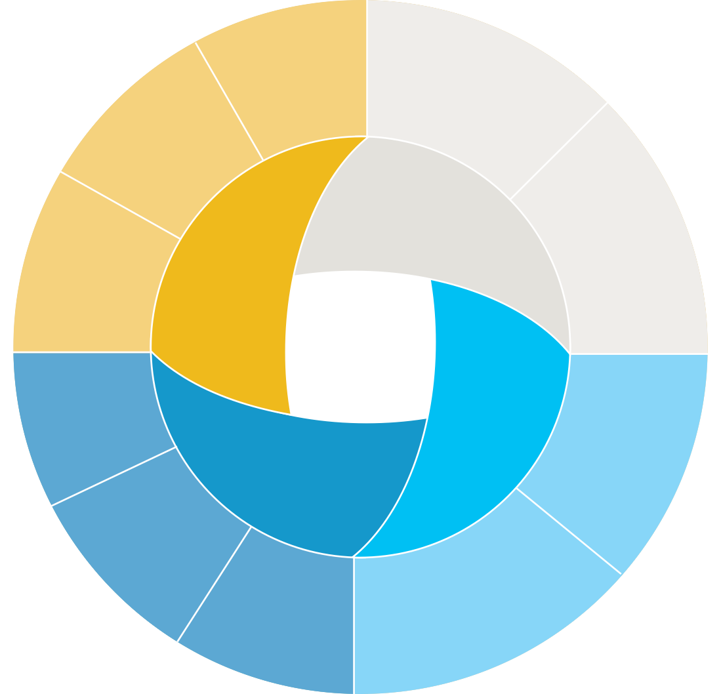

A key issue in relation to children is the impact of gambling harm on their development, which affects both their current wellbeing and future potential. A framework for conceptualising gambling-related harm that adds developmental harm to the domains of relationships, health and finances/resources is shown in Figure 7 (Blake et al. 2019).

**Physical**

**Living standards of family**

**Mental**

**Financial**

**Attitudes to and concerns about money**

**Emotional wellbeing**

**Health**

**Development**

**Family**

**Education**

**Relationships**

**Friends and the community**

**Social and emotional functioning**

**Behaviour**

**Figure 7.** A framework of gambling-harms that may affect young people now as well as their future potential. Reproduced from Blake et al. (2019).

**31**

**What’s the real cost?** | anglicare-tas.org.au

•

•

It is important to note that the impacts of family dysfunction, domestic violence and financial deprivation have particularly lasting effects if experienced during the first 1,000 days of a child’s life. This is because the first 1,000 days is “the period of maximum developmental plasticity, and therefore the period with the greatest potential to affect health and wellbeing over the life course” (Moore et al. 2017).

These lifelong impacts of gambling harm can result from:

•

poverty impacts on:

-

-

-

parental stress levels and caregiving capacity

stress levels in the child

reduced capacity of the parents to financially invest in more than the child’s immediate needs

negative impact of family dysfunction on parenting style and parent-child attachment, which in turn leads to the development of neural pathways focused on survival rather than learning and growth

trauma through exposure to conflict and domestic violence that:

-

-

-

disrupts the progress of critical development processes

affects how the child relates to and interprets the world around them increases the likelihood of developing risky behaviours later in life

•

increased maternal alcohol, tobacco and illicit drug use; poor nutrition (Moore et al. 2017).

Beyond the first 1,000 days, it is possible for children to recover from these adverse events if they subsequently experience positive family relations, social support, safety, good nutrition and healthy environments. They also need a safe and secure family environment and community connections (both physical and social), healthy environments, optimal nutrition, and exposure to natural environments (Moore et al. 2017).

In Case Study 3, it is the developmental impacts on Charlie that may be of the most consequence.

**Community connectedness and cultural harms**

Just as gambling distracts the gambler from their work, study and individual relationships, gambling results in reduced time spent in community activities. Gamblers and their families experience increased social isolation, which has secondary effects on mental health.

Other members of the community are affected by the reduction in social participation which, in turn, reduces community cohesion.

Cultural harms result from the impact of gambling on cultural and religious practices and the capacity to fulfil cultural roles. These include feeling of shame, loss of cultural connections and loss of cultural practices (Browne et al. 2016).

In the case of David and Helen, the extreme shame that David experienced was partly due to his inability to fulfil a cultural role as a self-refunded retiree and a respected member of the community.

**32**

**What’s the real cost?** | anglicare-tas.org.au

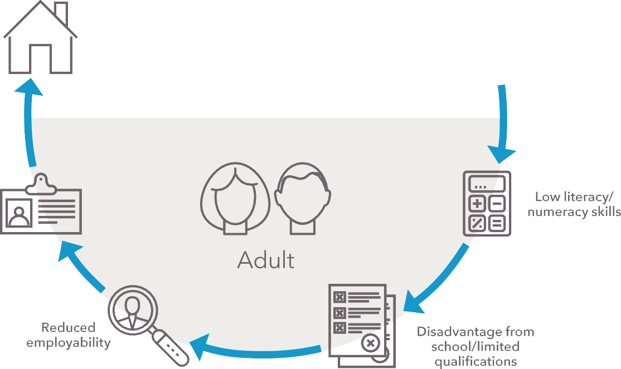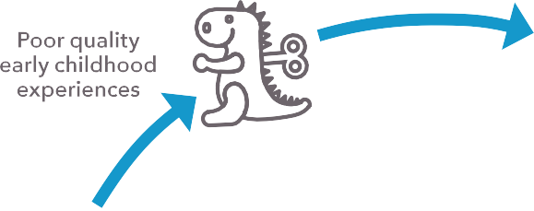

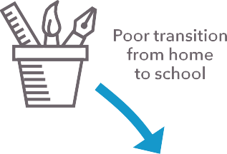

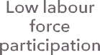

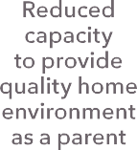

**Intergenerational harms**

**and persistent disadvantage**

Lifetime and intergenerational harms of gambling result from:

* significant changes in future potential as a result of gambling
* reduced lifetime potential of children in gambling households.

**Changes in future potential as a result of gambling**

Many of the people seeking help through Anglicare’s gambling support services have experienced harm that reduces future potential. Examples include reduced options for career and potential reduction in lifetime earnings as was experienced by Sam. Relationship breakdown and impacts on future relationships can result in reduced life expectancy and children not being born.

**Reduced lifetime potential of children in gambling households**

The recent findings of impacts of parental gambling on children outlined in  **on page 30** have serious implications for their lifetime potential. In addition to impacting their wellbeing and choices in life, it reduces the productive capacity of the Tasmanian economy and the wellbeing of the community as a whole. Figure 8 provides a simplified summary of how disadvantage itself results in further disadvantage.

**Figure 8.** Cycle of disadvantage in education and employment. Adapted from McLachlan et al. (2013).

**33**

**What’s the real cost?** | anglicare-tas.org.au

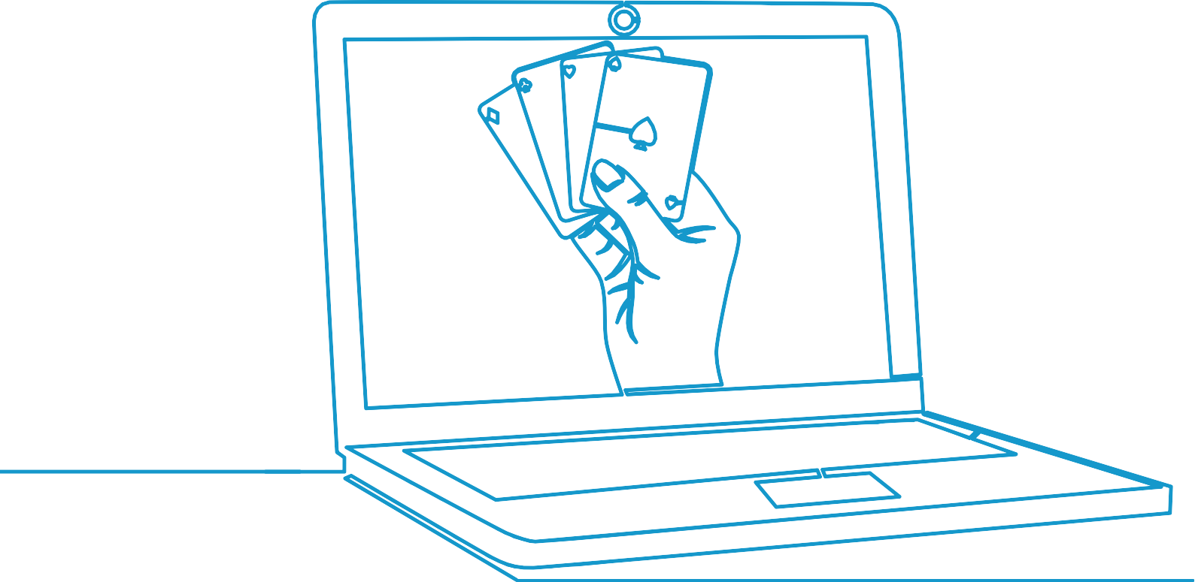

Gambling also has a distributional impact that entrenches persistent poverty and disadvantage, with revenue disproportionately coming from socioeconomically disadvantaged communities. The revenue that goes to the gambling industry transfers money away from socioeconomically disadvantaged communities and reinforces inequality. By similar reasoning, taxes on gambling collected by the Tasmanian Government also transfer money away from lower socioeconomic communities (regressive taxation).

On average, children from poor and disadvantaged households have poorer cognitive and social outcomes and probably poorer health outcomes (Warren 2017). As a result, they are more likely to have poor health or a disability, low levels of educational attainment, and experience unemployment – factors which are associated with persistent poverty, disadvantage and social exclusion (McLachlan et al. 2013).

Reducing gambling harm is a policy lever with the potential to positively impact many of the factors contributing to disadvantage. Figure 9 shows a simplified model for the development of persistent disadvantage, adapted from work by the Productivity Commission (McLachlan et al. 2013). Based on the research findings outlined in this paper, the factors which can be positively influenced by reducing gambling harm are highlighted in blue.

Improving educational, social and health outcomes of children from disadvantaged backgrounds is not only a matter of social justice, it delivers benefits to the economy through increased productive capacity and decreased government costs.

**34**

**What’s the real cost?** | anglicare-tas.org.au

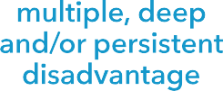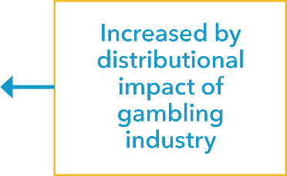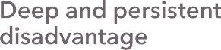

**Figure 9.** Simplified model of factors leading to disadvantage with factors adversely affected by gambling harm highlighted.

Adapted from McLachlan et al. (2013).

**35**

**What’s the real cost?** | anglicare-tas.org.au

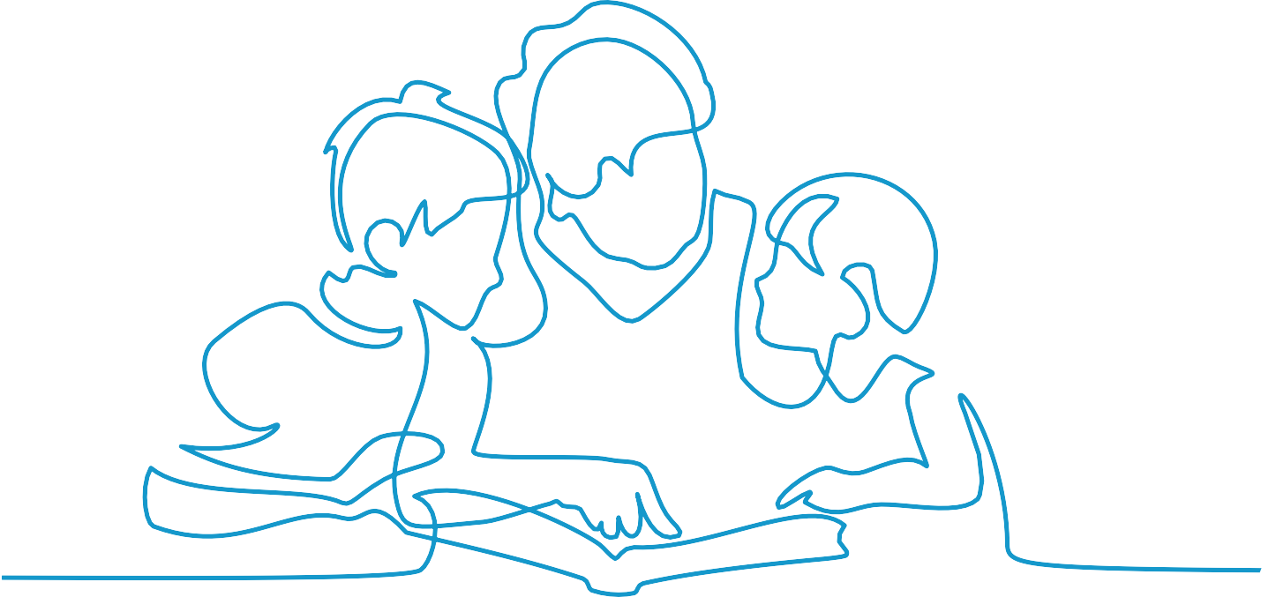

**Case study 4: Gail**

Gail is 70 and lives on the age pension. She enjoys gambling but would not say that she has a problem. However, when she found herself facing some unexpected bills, she decided to contact Gamblers Help and request a period of self-exclusion while she got on top of things.

It didn’t take Gail long to pay off the bills and then she found that she was saving money. In fact, for the first time in ten years she was able to fly to Queensland to visit her daughter Sue and her grandsons Joey and Daniel, which she described as “the bee’s knees”.

At the end of the self-exclusion period, Gail contacted Gamblers Help to have it extended. She told the counsellor that during the period of self-exclusion she didn’t feel like gambling at all. She couldn’t believe she would previously sit at a machine for hours just putting money into it and walking away with nothing. Her trips to see family were far more valuable than gambling.

She discovered she could do many things that she had not been able to do before. She is able to buy Christmas gifts for her grandchildren and no longer has the stress of making up excuses why she can’t afford them. Not only that, she has joined a film class, a poetry class and a book writing group.

**There were all these things that she was now experiencing at 70 years old. It was so cool.**

(Gambler’s Help counsellor)

**36**

**What’s the real cost?** | anglicare-tas.org.au

If you or someone you know needs help with gambling issues, phone

**1800 243 232**

and ask to speak to a Gamblers Help Counsellor

Out of hours support is available by calling the National Gamblers Help Hotline on **1800 858 858**

**Gambling does not need to hold Tasmanians back**

At the individual level help is available.

Gambling causes harm and you are entitled to access services if you have been harmed by gambling or want to access tools and services to help you stay in control.

From a policy perspective, gambling harm is an avoidable cost. The extensive impacts on affected others (external costs) justify government intervention to reduce gambling harm.

The Tasmanian Government is making significant investments to address complex issues including mental health, suicide prevention, family and domestic violence, child and youth safety and wellbeing, cost of living pressures, disadvantage, and housing affordability.

Reducing the avoidable costs of problem gambling is a policy lever that is available to increase the effectiveness of these investments. Implementing policies to reduce gambling harm will have an added benefit of reducing *unnecessary* load on government services, including health services, which are already experiencing supply constraints.

The potential benefit of card-based pre-commitment for gaming machines is two-fold:

* It provides an additional tool to gamblers which increases their choice and level of control.
* It has the potential to reduce serious gambling harm and provide benefits all Tasmanians.

Realising those potential benefits will depend on how and when the government’s proposed model is implemented.

**37**

**What’s the real cost?** | anglicare-tas.org.au

**Conclusion and recommendations**

Reducing gambling harm is a policy lever with the potential to positively impact many factors contributing to complex social issues.

The full social costs of gambling are difficult to measure. However, they are significant and affect all Tasmanians, not just people who gamble. New research indicates that gambling harm in Tasmania is likely to be greater than previously thought, in terms of the impacts to children, harm through domestic violence and the total number of people affected by other people’s gambling. Data on gambling harm and suicidal behaviour in Tasmania is a gap that should be addressed.

Data from relevant Anglicare support services confirms that electronic gaming machines are responsible for the gambling harm experienced by three in four people seeking help. This provides further evidence of the need for harm reduction measures such as the card-based pre-commitment for gaming machines as announced by the Tasmanian Government on 15 September 2022.

Anglicare data also shows that online gambling, particularly sports gambling, is an emerging problem responsible for gambling harm in younger age groups. It is likely that this will be a continuing trend.

The role of an independent Tasmanian Liquor and Gaming Commission is crucial to ensuring that gambling is regulated in Tasmania in the interests of all Tasmanians.

**Recommendations**

**1**

Full and effective implementation by December 2024 of a State-wide player card gaming system with pre-commitment and cashless gaming as announced by the Tasmanian Government on 15 September 2022.

State and Australian Governments work cooperatively to minimise harm from sports gambling and other online gambling, including restricting advertising of sports and online gambling, and investing in effective measurement of online and sports gambling-related harm.

Include gambling harm as a risk factor for suicide and suicidal behaviour in the Tasmanian Suicide Prevention Strategy 2023-2027 and incorporate into the Strategy additional actions designed to strengthen understanding of the prevalence of gambling-related suicide and suicidal behaviour in Tasmania.

Ensure that assessment of social and economic costs to affected others are based on robust methodology, including estimates of costs to affected others due to financial abuse, coercion and unreported crime.

**2**

**3**

**4**

**38**

**What’s the real cost?** | anglicare-tas.org.au

Armstrong, A & Carroll, M 2017, *Gambling activity in Australia: Findings from wave 15 of the Household, Income and Labour Dynamics in Australia (HILDA) survey*, AGR Centre, Melbourne.

Banks, J & Waters, J 2022, “An examination of the interrelationship between disordered gambling and intimate partner violence”, *International Review of Victimology,* DOI: 10.1177/02697580211065508.

Blake, M, Pye, J, Mollidor, C, Morris, L, Wardle, H & Reith, G 2019, *Measuring gambling-related harms among children and young people: A framework for action*, Ipsos MORI, London.

Browne, M, Langham, E, Rawat, V, Greer, N, Li, E, Rose, J, Rockloff, M, Donaldson, P, Thorne, H, Goodwin, B, Bryden, G & Best, T 2016, *Assessing gambling-related harm in Victoria: A public health perspective*, Victorian Responsible Gambling Foundation, Melbourne.

Department of Treasury and Finance 2022, *Electronic gaming machine expenditure by financial year*, viewed October 2022, [https://www.treasury.tas.gov.au/liquor-and-gaming/publications-and-](https://www.treasury.tas.gov.au/liquor-and-gaming/publications-and-research/gambling-industry-data/electronic-gaming-machine-expenditure-by-financial-year) [research/gambling-industry-data/electronic-gaming-machine-expenditure-by-financial-year](https://www.treasury.tas.gov.au/liquor-and-gaming/publications-and-research/gambling-industry-data/electronic-gaming-machine-expenditure-by-financial-year).

Dowling, N 2014, *The impact of gambling problems on families*, AGRC Discussion Paper 1, Australian Gambling Research Centre, Melbourne.

Dowling, N, Ewin, C, Youssef, G, Merkouris, S, Suomi, A, Thomas, S & Jackson, A 2018, “Problem gambling and family violence: Findings from a population-representative study”, *J Behav Addict*, vol. 7, no. 3, pp. 806-813.

Dowling, N, Suomi, A, Jackson, A, Lavis, T, Patford, J, Cockman, S, Thomas, S, Bellringer, M, Koziol-McLain, J, Battersby, M, Harvey, P & Abbott, M 2016, “Problem gambling and intimate partner violence: A systematic review and meta-analysis”, *Trauma, Violence & Abuse*, vol. 17, no. 1, pp. 43-61.

Goodwin, B, Browne, M, Rockloff, M & Rose, J 2017, “A typical problem gambler affects six others”,

*International Gambling Studies*, vol. 17, no. 2, pp. 276-289.

Hing, N, O’Mullan, C, Nuske, E, Breen, H, Mainey, L, Taylor, A, Frost, A, Greer, N, Jenkinson, R, Jatkar, U, Deblaquiere, J, Rintoul, A, Thomas, A, Langham, E, Jackson, A, Lee, J & Rawat, V 2020, *The relationship between gambling and intimate partner violence against women*, ANROWS, Sydney.

Kinchin, I & Doran, C 2017, “The economic cost of suicide and non-fatal suicide behavior in the Australian workforce and the potential impact of a workplace suicide prevention strategy”, *International Journal of Environmental Research and Public Health*, vol. 14, no. 4, p. 347.

Langham, E, Thorne, H, Browne, M, Donaldson, P, Rose, J & Rockloff, M 2016, “Understanding gambling related harm: A proposed definition, conceptual framework, and taxonomy of harms”, *BMC Public Health*, vol. 16, no. 1, p. 80.

Lubman, D, Manning, V, Dowling, N, Rodda, S, Lee, S, Garde, E, Merkouris, S & Volberg, R 2017,

*Problem gambling in poeple seeking treatment for mental illness*, VRG Foundation, Melbourne.

McLachlan, R, Gilfillan, G & Gordon, J 2013, *Deep and persistent disadvantage in Australia*, Productivity Commission Staff Working Paper 1, Productivity Commission, Canberra.

Moore, T, Arefadib, N, Deery, A & West, S 2017, *The first thousand days: An evidence paper*, Murdoch Children’s Research Institute, Parkville, Victoria.

**39**

**What’s the real cost?** | anglicare-tas.org.au

O’Neil, M, Whetton, S, Delfabbro, P, Sproston, K, Brook, K, Hughes, P & Tran, K 2021, *Fifth social and economic impact study of gambling in Tasmania 2021: Prevalence survey report*, South Australian Centre for Economic Studies, Adelaide.

O’Neil, M, Whetton, S, Kosturjak, A, Hancock, J, Dey, T, Delfabbro, P, Sproston, K, Wittwer, G & Eslake, S 2021, *Fifth social and economic impact study of gambling in Tasmania 2021: Industry impacts and trends*, South Australian Centre for Economic Studies, Adelaide.

Rockloff, M, Browne, M & Hing, N 2020, *Victorian population gambling and health study 2018–2019*, Victorian Responsible Gambling Foundation, Melbourne.

Suicide Prevention Australia & Financial Counselling Australia 2022, *Gambling and suicide prevention: A roadmap for change*, viewed September 2022, [https://www.](https://www.financialcounsellingaustralia.org.au/docs/gambling-and-suicide-prevention-a-roadmap-for-change/)

[financialcounsellingaustralia.org.au/docs/gambling-and-suicide-prevention-a-roadmap-for-](https://www.financialcounsellingaustralia.org.au/docs/gambling-and-suicide-prevention-a-roadmap-for-change/) [change/](https://www.financialcounsellingaustralia.org.au/docs/gambling-and-suicide-prevention-a-roadmap-for-change/).

Suomi, A & Dowling, N 2020, *Lived experiences of help-seeking in the presence of gambling related harms and coexisting mental health conditions*, Victorian Responsible Gambling Foundation, Melbourne.

Suomi, A, Lucas, N, Dowling, N & Delfabbro, P 2022, “Parental problem gambling and child wellbeing: Systematic review and synthesis of evidence”, *Addictive Behaviors*, vol. 126, p. 107205.

Tasmanian Liquor and Gaming Commission 2021, *Annual report 2020-21*, Tasmanian Government, Hobart.

Wardle, H, John, A, Dymond, S & McManus, S 2020, “Problem gambling and suicidality in England: Secondary analysis of a representative cross-sectional survey”, *Public Health*, vol. 184, pp. 11-16.

Wardle, H & McManus, S 2021, “Suicidality and gambling among young adults in Great Britain: Results from a cross-sectional online survey”, *The Lancet Public Health*, vol. 6, no. 1, pp. e39-e49.

Wardle, H, Reith, G, Best, D, McDaid, D & Platt, S 2018, *Measuring gambling-related harms: A framework for action*, Gambling Commission, Birmingham, UK.

Warren, D 2017, *Low income and poverty dynamics: Implications for child outcomes*, DSS Social Policy Research Paper 47, Australian Institute of Family Studies, Canberra.

Whitty, M & Paterson, M 2019, *Gambling support study: Understanding gambling harm experienced by female affected others*, ANU Centre for Gambling Research, Canberra.

Xero 2022, *Crunch: Cash flow challenges facing small business*, viewed October 2022, [https://www.xero.com/content/dam/xero/pdfs/xsbi/cash-flow-challenges-facing-small-](https://www.xero.com/content/dam/xero/pdfs/xsbi/cash-flow-challenges-facing-small-businesses-part2.pdf) [businesses-part2.pdf](https://www.xero.com/content/dam/xero/pdfs/xsbi/cash-flow-challenges-facing-small-businesses-part2.pdf).

**Author:** Mary Bennett

**Email:** [maryb@anglicare-tas.org.au](mailto:maryb@anglicare-tas.org.au)

**Website:** [www.anglicare-tas.org.au](http://www.anglicare-tas.org.au/)

© Anglicare Tasmania 2022 ISBN: 978-1-921267-65-9

**40**

**What’s the real cost?** | anglicare-tas.org.au