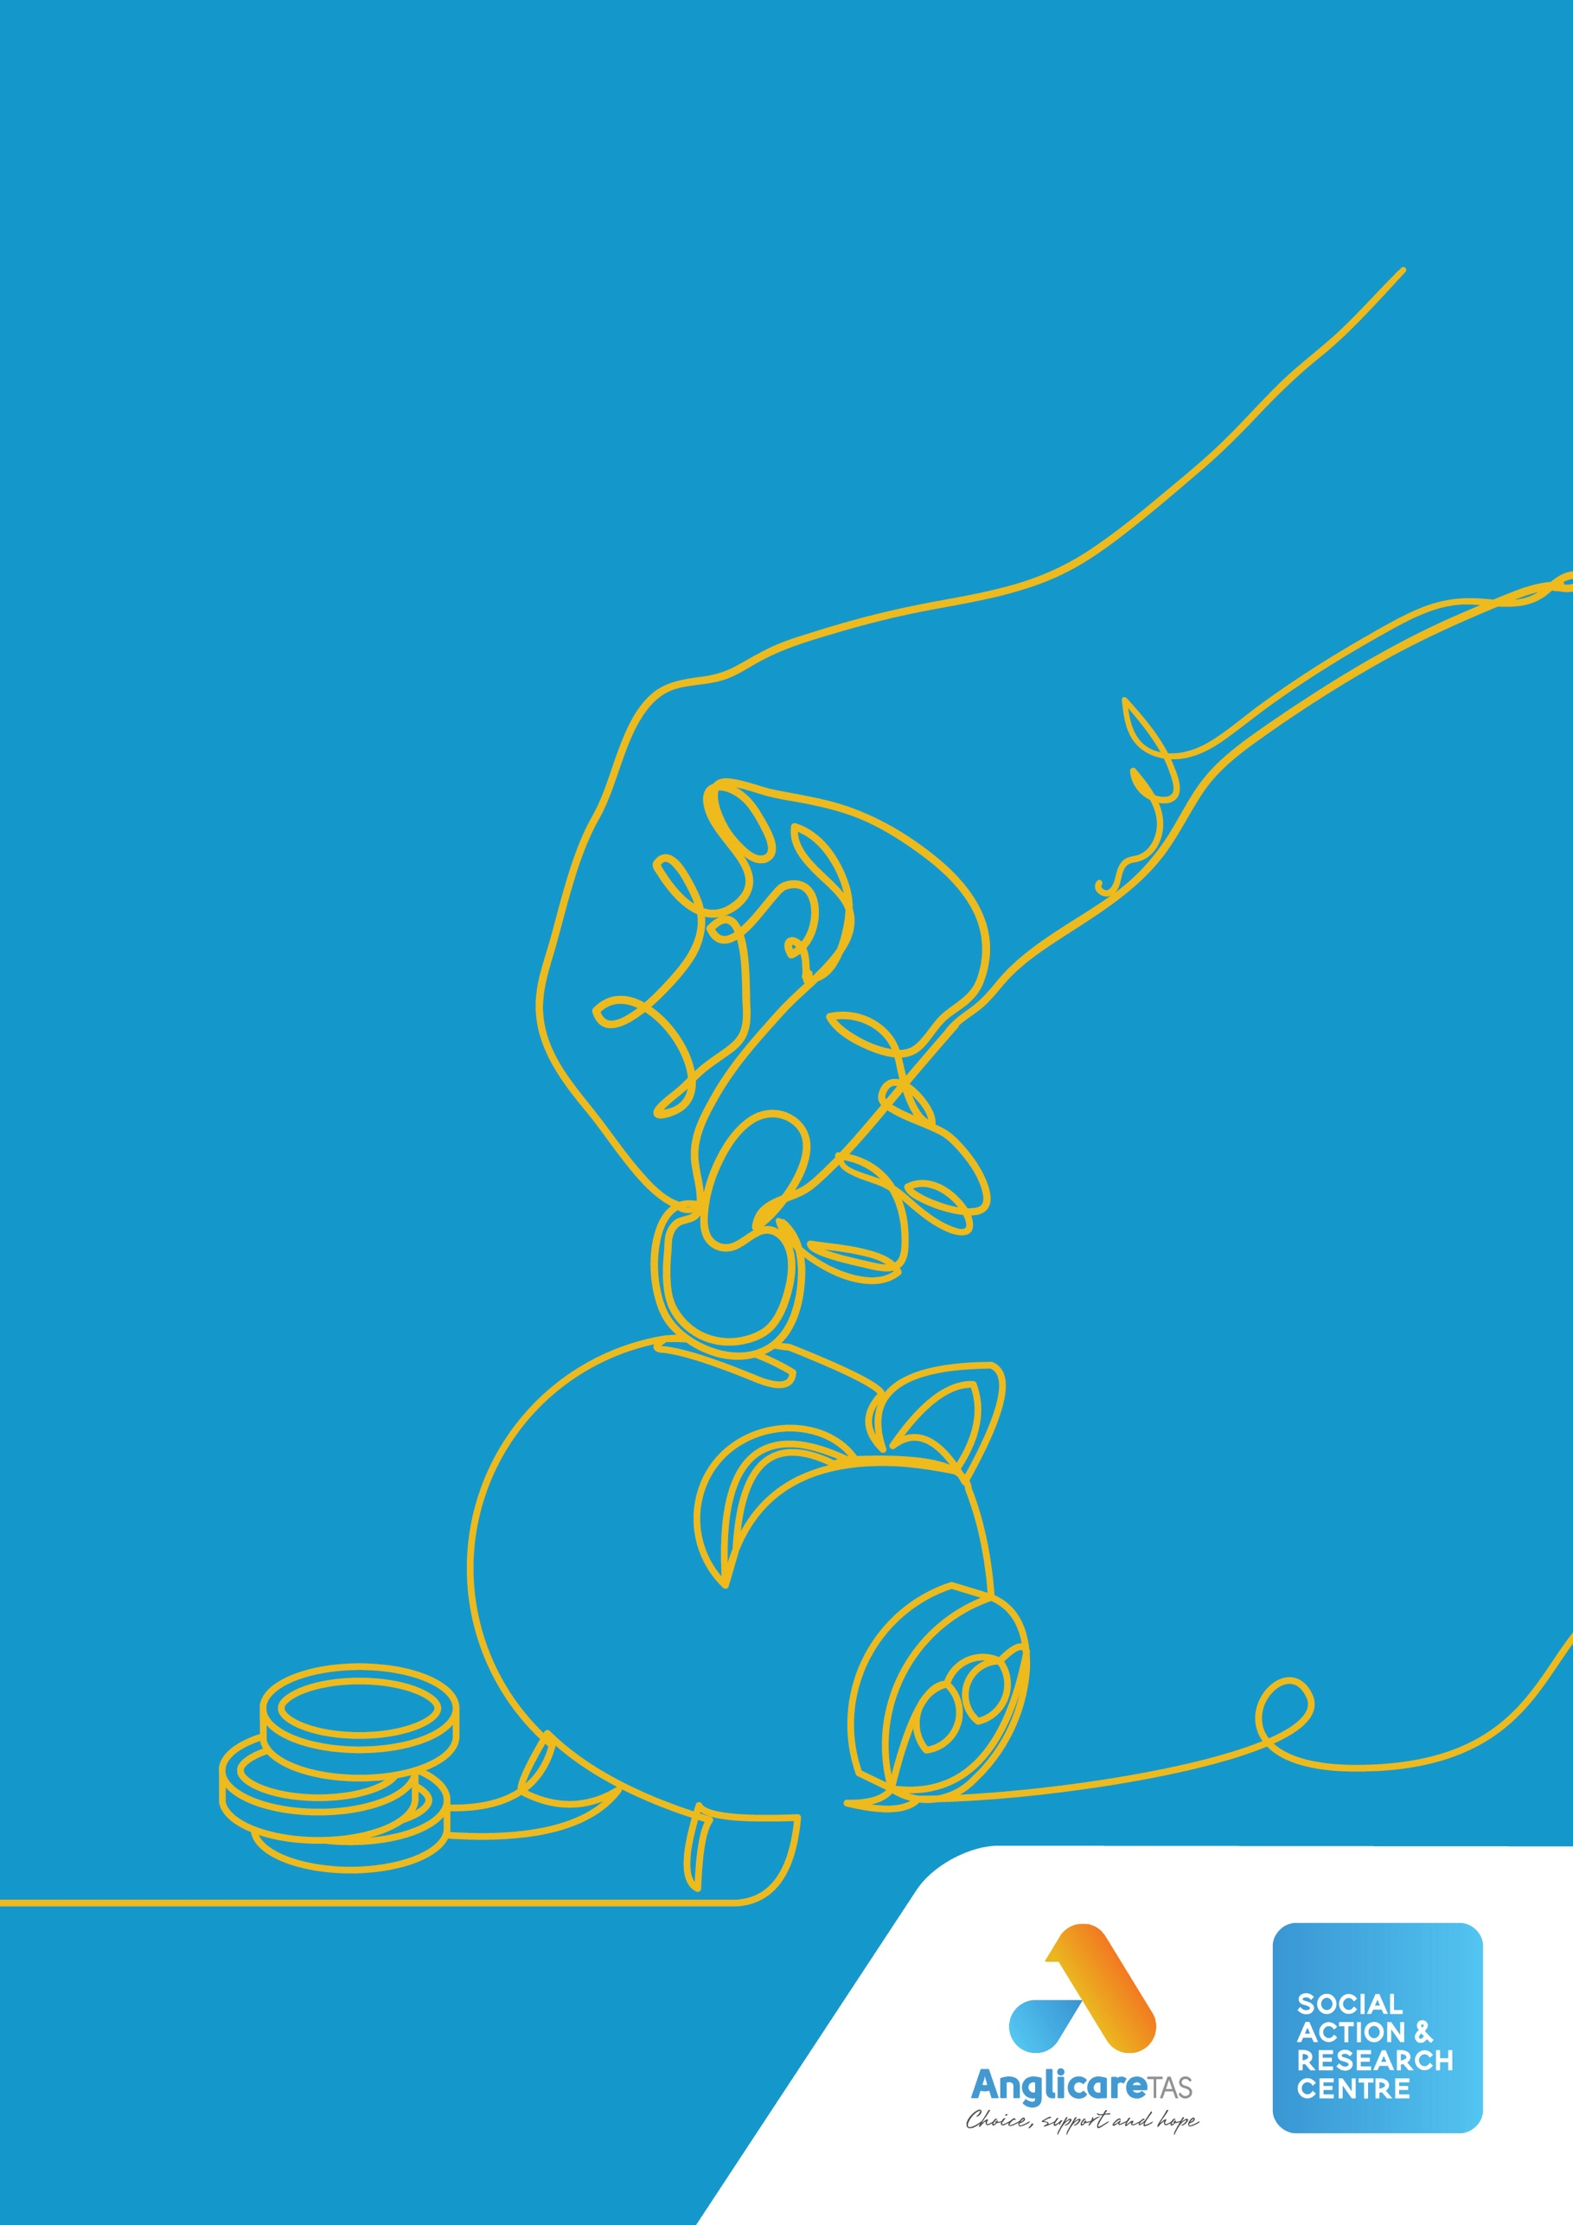
Buy Now, Struggle Later?

Exploring the impacts of Buy Now Pay Later on Anglicare Tasmania’s financial counselling clients
WORKING FOR
A JUST TASMANIA

BUY NOW, STRUGGLE LATER?

Exploring the impacts of Buy Now Pay Later on Anglicare Tasmania’s financial counselling clients



No one could have predicted the perfect storm that would allow BNPL to take hold as it has in Australia. It appeals to the most vulnerable in society and is often their only option for credit. … And if it’s credit, then it needs to be a regulated product.

Financial Counsellor, Anglicare Tasmania

March 2023

Dr Alexandra King
Social Action & Research Centre

Contents
About Anglicare Tasmania 5
Glossary 6
Our research and findings 8
What we did 8
Financial Counsellors told us 8
Financial counselling data reveal that… 9
Financial counselling clients with BNPL debts 10
Financial counselling data reveals that … 11
What we recommend 12
1. Financial counselling and Buy Now Pay Later 13
1.1 Aims and benefits of financial counselling 13
1.2 Anglicare Tasmania’s growing awareness of Buy Now Pay Later use by people in financial stress 14
2. Buy Now Pay Later: Current issues 15
2.1 The rise of Buy Now Pay Later in Australia 15
2.2 Recent moves to strengthen regulation of Buy Now Pay Later 15
2.3 Emerging evidence of harms from Buy Now Pay Later debts for financial counselling clients 17
3. Financial Counsellors’ experiences of Buy Now Pay Later: Survey results 19
Key findings 19
3.1 Introduction 19
BNPL debts are more common than 12 months ago 20
Many clients have multiple Buy Now Pay Later debts or accounts 20
3.2 How clients view Buy Now Pay Later 20
Many clients don’t recognise Buy Now Pay Later as a type of credit 20
Some clients like using Buy Now Pay Later and don’t want to stop using it 21
3.3 How clients use Buy Now Pay Later 21
Many clients are using Buy Now Pay Later to buy food and other essentials 21
Some clients are using Buy Now Pay Later to spend more than they usually would 21
3.4 Impacts of Buy Now Pay Later on clients 22
Many clients are struggling to repay their Buy Now Pay Later debts 22
Buy Now Pay Later debts are thought to be causing clients the most severe difficulties, compared to other debts 22
Some clients may have been coerced into Buy Now Pay Later debts by their intimate partners 22
Hardship policies and practices of Buy Now Pay Later providers are sometimes helpful 23
Clients are sometimes benefiting from using Buy Now Pay Later 23
3.5 Buy Now Pay Later and the need for better regulation 23
Financial Counsellors think Buy Now Pay Later should be better regulated 23
4. Characteristics of clients: Financial counselling data 25
Key findings 25
4.1 Overview 25
4.2 Gender 26
4.3 Age profile 26
4.4 Country of birth and languages spoken 28
4.5 Aboriginal and/or Torres Strait Islander 28
4.6 Educational attainment 29
5. Circumstances of clients: Financial counselling data 30
Key findings 30
5.1 Primary Groups: an indicator of disadvantage 30
5.2 Other measures of social and economic disadvantage 31
Relationship status 32
Parenting and other caring responsibilities 32
Sources of income 33
Employment status 34
Homelessness 34
Housing tenure 34
Family violence 35
Disabilities 36
Mental illness and mental health difficulties 37
Gambling harm 37
6. Buy Now Pay Later debts and other debts reported by clients: Financial counselling data 38
Key findings 38
6.1 Credit and debt issues 38
6.2 Characteristics of Buy Now Pay Later debts 39
6.3 Characteristics of non-Buy Now Pay Later debts 39
7. Impacts of Buy Now Pay Later for people experiencing disadvantage 42
7.1 The rise of fintech and Buy Now Pay Later 42
7.2 Clients with Buy Now Pay Later debts are more likely to experience disadvantage across multiple life domains 42
7.3 Buy Now Pay Later products are targeted to young people and adding to their debt levels 42
7.4 Buy Now Pay Later debts are adding to an already complex picture of indebtedness for clients 43
7.5 Buy Now Pay Later debts complicate financial stress and mental illness 44
7.6 Buy Now Pay Later debts can add to financial stress for victim survivors of family violence 45
7.7 Credit needs to be available and fair for people on low incomes or experiencing disadvantage 45
8. Recommendations 47
Appendix A: Research Methodology 48
Appendix B: Survey of Anglicare Tasmania's Financial Counsellors 52
Appendix C: Quantitative Results of Survey of Financial Counsellors 57
References 62

About Anglicare Tasmania
Anglicare Tasmania is a large community service organisation in Tasmania with offices in Hobart, Glenorchy, Launceston, St Helens, Devonport, Burnie, Sorell and Zeehan, and a range of programs in rural areas. Anglicare Tasmania’s services include crisis, short-term and long-term accommodation support; mental health support services; support services following a motor vehicle accident; aged and home care services; alcohol and other drug services; financial and gambling counselling; and family support. In addition, Anglicare Tasmania’s Social Action and Research Centre conducts research, policy and advocacy work with a focus on issues affecting Tasmanians on low incomes.
Anglicare Tasmania is committed to achieving social justice for all Tasmanians. It is our mission to speak out against poverty and injustice and offer decision-makers alternative solutions to help build a more just society. We provide opportunities for people in need to reach their full potential through our services, research and advocacy.
Anglicare Tasmania’s work is guided by a set of values which includes these beliefs:
- that each person is valuable and deserves to be treated with respect and dignity;
- that each person has the capacity to make and to bear the responsibility for choices and decisions about their life;
- that support should be available to all who need it; and
- that every person can live life abundantly.

Anglicare Tasmania acknowledges the Tasmanian Aboriginal community as the traditional and original owners and continuing custodians of this land lutruwita. We pay respect to Elders past and present.

Glossary
Buy Now Pay Later (BNPL) |  | A product which offers finance to consumers at the point of sale and collects repayments by means of scheduled electronic deductions from their bank accounts (see Box 2).
Family violence |  | For this research, family violence is defined broadly to include violence, abuse or controlling behaviour by a family member or immediate relative (e.g. an adult child against their parent, a parent against their adult child, or between siblings), as well as by a current or former intimate partner.
Financial abuse |  | Financial abuse (or economic abuse) is a form of family violence. It may include withholding money, controlling household spending, refusing to include someone in financial decisions or coercing someone into taking out debts. Financial abuse can be present with other forms of abuse, like physical or emotional abuse, but can also occur without these behaviours (WIRE n.d.).
Financial counselling |  | The Australian term for free, charitable or government-funded interventions for people facing financial difficulties, including support with budgeting or debt issues.
Financial Counsellors |  | For this research, staff of Anglicare Tasmania who deliver financial counselling services.
Financial stress |  | “An inability to pay regular bills or to meet basic needs”, also characterised by feelings of worry or stress (Botha et al. 2022).
Fintech |  | Computer software and other technology used to enable banking and financial services. A portmanteau of ‘financial’ and ‘technology’.
Frictionless |  | A smooth, quick and easy customer experience, e.g. when using financial software to pay for online purchases.
Gambling harm |  | Defined as “any negative consequence experienced by an individual or members of their social network because of participation in gambling” (Boyle et al. 2021). For this research clients were classified as experiencing gambling harm if: they reported it themselves; were engaged with a gambling support service; had suffered significant financial loss from an intimate partner’s gambling behaviour; or had been imprisoned for gambling-related crimes.

Homelessness |  | For this research being homeless is defined as staying in a homelessness or women’s shelter, ‘rough sleeping’ or ‘couch surfing’. The Australian Bureau of Statistics uses a broader definition which includes severe overcrowding.
Income support payment |  | A full or part payment made by Centrelink. Includes Age Pension, Austudy, Carer Payment, Disability Support Pension, JobSeeker Payment, Parenting Payment, Special Benefit, Farm Household Allowance and Youth Allowance.
Mental illness or mental health difficulties |  | For this research mental illness is defined as “a clinically diagnosable disorder that significantly interferes with a person’s cognitive, emotional or social abilities” (AIHW 2022a). This definition covers a range of illnesses, including anxiety disorders, affective disorders, psychotic disorders and substance use disorders (AIHW 2022a). It is also possible to experience harm from mental health difficulties which don’t meet the threshold for a diagnosis of mental illness (AIHW 2022a).
Psychiatric disability |  | Psychiatric disability may be associated with schizophrenia, affective disorders, anxiety disorders, addictive behaviours, personality disorders, stress disorders, psychosis, depression and adjustment disorders (AIHW 2022b). Clients were classified as having psychiatric disability if they reported it during engagement with financial counselling.

Our research and findings

What we did
From December 2022 to March 2023, the Social Action Research Centre undertook research to explore the impacts of Buy Now Pay Later (BNPL) on clients of Anglicare Tasmania’s financial counselling services. It entailed:
- Surveying Anglicare Tasmania’s Financial Counsellors, asking about their client’s experiences of BNPL.
- Extracting and analysing demographic and financial data recorded in Anglicare Tasmania’s database of financial counselling clients, for 100 clients with BNPL debts and 234 clients with no BNPL debts.
- Reviewing and analysing data recorded in Case Files in Anglicare Tasmania’s database of financial counselling clients, for 100 clients with BNPL debts and 234 clients with no BNPL debts.
This is the first research to explore the impacts of Buy Now Pay Later on Tasmanians accessing financial counselling services, almost all of whom are in financial stress and facing social and economic disadvantage.

Financial Counsellors told us
- Many of their clients have BNPL debts
- There are more clients with BNPL debts than 12 months ago
- Many clients have multiple BNPL debts or accounts
- Few clients with BNPL debts recognise them as a type of credit
- Some clients like using BNPL products and want to keep using them
- Many clients are using BNPL to buy food and other essentials
- Some clients are using BNPL products to spend more than usual
- Many clients are going without essentials, including not paying rent, to repay BNPL debts
- BNPL debts are thought to be causing the most severe difficulties, compared to other debts
- Some clients may have been coerced into BNPL debts or drawn into them without their knowledge
- Hardship policies/practices of BNPL providers are sometimes helpful
- Some clients are benefiting from BNPL products, but this isn’t common
- BNPL products need to be better regulated in Australia.

Financial counselling data reveal that…

Clients with Buy Now Pay Later debts are more likely to be female, young, Aboriginal and/or Torres Strait Islander, and experience social or economic disadvantage, compared to clients with no Buy Now Pay Later debts.

 | Financial counselling clients
 | with BNPL debts | with no BNPL debts
Female | 71% | 36%
Young – under 25 years | 18% | 7%
Older – 60 years and over | 5% | 18%
Aboriginal and/or Torres Strait Islander | 20% | 12%
Experiencing one or more types of social or economic disadvantage | 100% | 83%
Single parent to under 18s or dependent adult children | 40% | 18%
Receiving an income support payment¹ | 81% | 48%
Currently homeless | 14% | 9%
Fully own or buying their home | 13% | 27%
Victim survivor of family violence¹ | 21% | 12%
Gambling harm¹ | 7% | 3%

Financial counselling clients with BNPL debts
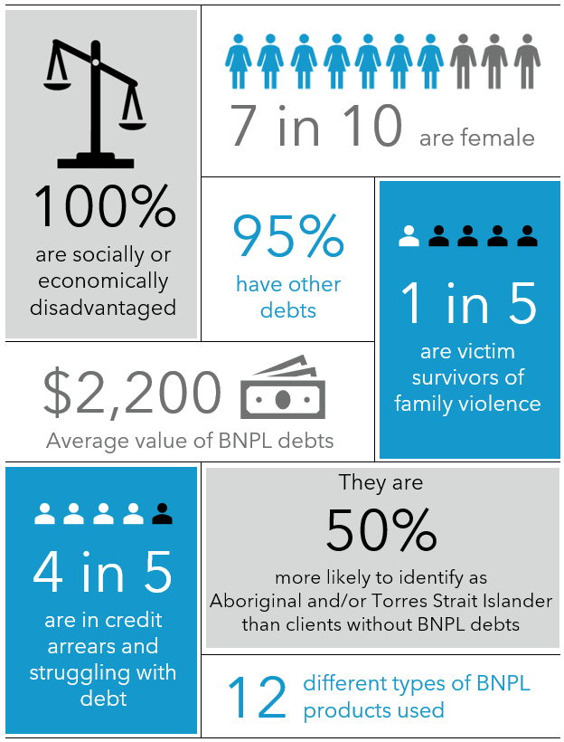

Financial counselling data reveals that …

Clients with Buy Now Pay Later debts are often struggling with multiple, sometimes unmanageable debts.

Clients with BNPL debts
With credit or debt issues or arrears | 80%
Considering or pursuing bankruptcy | 15%
With more than one BNPL debt | 50%
With non-BNPL debts in addition to BNPL debts | 95%
With more than one non-BNPL debt | 84%
Different BNPL products used | 12 products
Average value of BNPL debts | $2,200
Average number of BNPL debts | 2 debts
Average value of non-BNPL debts | $14,400
Average number of non-BNPL debts | 4 debts
Different types of non-BNPL debts | 16 debt types

What we recommend
BNPL products can be harmful for people who are in financial stress or experiencing social and economic disadvantage. Our research has highlighted two problems: inadequate regulation of BNPL and the fact that many people facing social and economic disadvantage are struggling to make ends meet on inadequate income support payments. We also acknowledge the importance of ensuring access to safe, fair and affordable credit options for everyone.
In light of this, we recommend that:
- The Australian Government increase income support payments above the poverty line as a matter of urgency, in order to reduce recipients’ risk of experiencing financial stress and exposure to unmanageable debt accrued from BNPLs and high-cost credit products.
- Treasury regulate BNPL in accordance with Option 3 in their Options Paper – bringing BNPL under the National Consumer Credit Protection Act 2009.
- For people facing financial stress or disadvantage, improve access to services such as the No Interest Loan Scheme (NILS) which have promotion of the interests and wellbeing of the ‘borrower’ as their primary aim. This includes:
- exploring options to integrate features of fintech into such credit products
- expanding the funds available for the No Interest Loan Scheme (NILS)
- regulatory and funding support from the public sector to support expanded access
- appropriate partnerships with commercial credit providers.
- Treasury acts to reduce financial abuse by perpetrators of family violence by:
- exploring options to better protect people from abuse by perpetrators using fintech products, including BNPL
- making ‘reduced financial abuse’ an outcome of the National Financial Capability Strategy
- developing and implementing initiatives under the Strategy to help young people to understand and avoid perpetrating or experiencing financial abuse.

1. Financial counselling and Buy Now Pay Later

1.1 Aims and benefits of financial counselling
In Australia, financial counselling refers to charitable or government-funded free interventions for people experiencing financial difficulties. Emerging in the 1970s, financial counselling has its roots in social justice and community development principles, reflected in its mix of advocacy, empowerment and education (Brackertz 2012; Livingstone et al. 2008). Financial counselling is designed to address financial stress arising from a range of different factors, including low income, rising living costs, and/or major life events such as relationship breakdown, illness or bereavement.
Financial counsellors undertake a range of activities with clients, including:
- helping with budgeting or income and expense management
- assessing eligibility for government assistance or rebates
- negotiating repayment arrangements with creditors
- explaining options and consequences of processes such as debt recovery
- assisting with applying for bankruptcy
- assisting with applying for hardship variations with creditors
- providing a referral to other services
- lodging disputes with external bodies (Sylvan 2019).
Refer to Box 1 below for a description of Anglicare Tasmania’s financial counselling services.
Australian research has found that financial counselling services are highly valued by clients (Pollard et al. 2020) and also effective, generating positive outcomes for clients, including for their financial wellbeing and mental health (Brackertz 2012). Financial counselling also generates monetary benefits for the broader community including avoidance of bankruptcy and increased debt repayment to businesses (Sylvan 2019). A cost benefit analysis conducted for the Wyatt Trust estimated the value of benefits generated by their financial counselling services to be five times greater than the cost (Mahmoudi et al. 2014).
Box 1: Anglicare Tasmania’s financial counselling services
For 40 years, Anglicare Tasmania has been delivering free and confidential financial counselling services to Tasmanians. These services are accessed by contacting Anglicare Tasmania or the National Debt Helpline (Anglicare Tasmania is also the service provider for callers based in Tasmania) or via referrals from other agencies. These services are funded by the Australian Government and the Tasmanian Government. In 2022, Anglicare Tasmania’s Financial Counsellors delivered over 4,700 service hours to more than 2,100 active clients.

Financial counselling providers also play a policy role in the financial services sector, by “bringing issues to the attention of the regulator, and providing a balancing consumer voice in policy development” (Commonwealth of Australia 2019). Additionally, these organisations can play a role in social justice or policy advocacy, including by providing evidence and arguments for the harms of particular financial products, including BNPL, for low-income or vulnerable people (e.g. Good Shepherd 2022; Way Forward 2022).

1.2 Anglicare Tasmania’s growing awareness of Buy Now Pay Later use by people in financial stress
Some of Anglicare Tasmania’s Program Managers raised with us the possibility that Buy Now Pay Later (BNPL) products may be causing harm to people who are presenting to financial counselling services in financial stress, which is defined as an inability to pay regular bills or to meet one’s basic needs (Botha et al. 2022).
BNPL products are a type of financial product marketed to consumers at the point of sale. There is significant variation in BNPL products in Australia and new models are being developed all the time, which makes defining them difficult. However, most have a set of features which distinguish them from other consumer credit products, as shown in Box 2 below (Close Lending Loopholes Coalition 2022; Treasury 2022b).
Box 2: What are the distinguishing features of Buy Now Pay Later products?
In general, Buy Now Pay Later products:
- involve a third-party financing entity
- provide consumers with finance to purchase goods and services
- do not provide cash to consumers
- do not charge interest on the finance used
- may charge consumers low, fixed fees (and/or late or missed payment fees)
- charge merchants service fees for accepting BNPL
- pay merchants the value of the purchase, less any fees.
- collect repayments from consumers by means of pre-scheduled electronic deductions from their bank accounts (Treasury, 2022).

In response, Anglicare Tasmania decided to conduct a short-term research project to explore how BNPL use impacts our financial counselling clients. A mixed-methods research design was developed in consultation with Mary Bennett, Mat O’Brien and Lynne Watson of Anglicare Tasmania, as well as John Hooper of NILS Tasmania. The research was carried out from December 2022 – March 2023. It primarily entailed a survey of Anglicare Tasmania’s Financial Counsellors and extracting, coding and analysing qualitative and quantitative data recorded in Anglicare’s client data management system. (Refer to Appendix A for the project’s research design, methods and activities.)
This is the first research to explore the impacts of Buy Now Pay Later on Tasmanians accessing financial counselling services, almost all of whom are in financial stress and facing social and economic disadvantage.

2. Buy Now Pay Later: Current issues

2.1 The rise of Buy Now Pay Later in Australia
The Australian consumer credit market is evolving and new fintech products are rapidly emerging. These products rely on lower levels of human involvement, developed on the back of technological changes in the finance sector, including electronic banking (Camp 2022; Johnson et al. 2021). Buy Now Pay Later is one of these new products. In Australia, the BNPL market has grown rapidly in recent years: new providers have entered the market, and some established credit providers are now also offering BNPL options (ASIC 2020). In Australia in 2021-22, there were approximately 7 million active BNPL accounts and $16 billion in transactions, an increase of 37 per cent on the previous financial year (Treasury 2022b).

2.2 Recent moves to strengthen regulation of Buy Now Pay Later
In recent years, BNPL products have come under increasing scrutiny from governments in Australia and internationally, including New Zealand, the European Union, US and UK (Camp 2022). BNPL products sit at the “regulatory perimeter”, effectively avoiding the regulatory requirements imposed on more traditional credit products (Close Lending Loopholes Coalition 2022). This situation has been criticised as an example of “regulatory failure” by governments (Johnson et al. 2021).
In November 2022, the Australian Treasury released an Options Paper for further regulating Buy Now Pay Later, and launched a consultation process which closed in late 2022 (Treasury 2022b). The Options Paper identified potential benefits to consumers from using BNPL products, including greater financial inclusion by offering a (potentially) cheaper and easier-to-access form of credit compared to credit cards, payday loans and consumer leases (Treasury 2022b). Wider benefits to the economy were also identified, including increasing competitive pressure on traditional forms of credit, and driving increased business for merchants because consumers can access additional credit to purchase goods and services (Treasury 2022b).
However, Treasury also noted several disadvantages or concerns about BNPL which they had already heard about during preliminary consultations:
- Unaffordable or inappropriate lending practices which are contributing to financial stress and hardship, and other types of consumer harm.
- Poor complaints handling processes and a lack of hardship assistance for consumers leading to delayed or unsatisfactory remediation.
- Excessive or disproportionate consumer fees and charges including default fees, relative to the size of the consumer’s debt.
- Non-participation in Australia’s credit reporting framework means some BNPL credit information is not available for use in credit checks by other lenders.
- Poor product disclosure practices and a lack of warning requirements, which means consumers may not have sufficient information to make informed choices about BNPL products.

- Unsolicited selling and advertising practices targeting consumers at the checkout or encouraging the use of BNPL for essentials such as groceries.
- Frictionless sign-up to BNPL products may enhance other consumer harms, such as scamming, overselling and financial abuse.
- Inadequate reverse-charging provisions experienced by consumers when returning to a merchant an item they purchased with a BNPL product (Treasury 2022b).
In November 2022, Treasury sought views on three broad options for regulating BNPL in Australia, which are reproduced in Box 3 below.
Box 3: Treasury’s three proposed options for regulating Buy Now Pay Later
The Options Paper outlines three options for regulating Buy Now Pay Later, as follows:
- “Option 1: Strengthening the BNPL Industry Code plus an affordability test. This option will impose a bespoke affordability assessment for BNPL providers under the Credit Act and address any other regulatory gaps in a strengthened Industry Code to make it fit-for-purpose.
- Option 2: Limited BNPL regulation under the Credit Act. This approach would require BNPL providers to obtain and maintain an ACL [Australian Credit Licence], plus introduce modified Responsible Lending Obligations (RLOs) under the Credit Act to determine unsuitability, combined with a strengthened Industry Code.
- Option 3: Regulation of BNPL under the Credit Act, with full RLOs. Under this option, BNPL providers would need to obtain and maintain an ACL. The existing RLOs in the Credit Act will be applied to all BNPL credit, including requirements around reasonable inquiries into a consumer’s financial situation and taking reasonable steps to verify this information (Treasury 2022b, p.5).”

Over 50 organisations and individuals made submissions to the consultation process; these have been published on the Treasury website: Regulating Buy Now Pay Later in Australia. The Close Lending Loopholes alliance, consisting of 22 not-for-profit and advocacy organisations including Anglicare Australia, made a submission to the Treasury consultation, which is available here: Close Lending Loopholes Submission. In that submission, the alliance argued: “BNPL is a credit product and should be regulated in the same way as other credit products, including credit cards and personal loans” (Close Lending Loopholes Coalition 2022).
The alliance noted that BNPL has “unique characteristics that make it likely that its use will increase a consumer’s overall debt levels and contribute to financial over-commitment”, including:
- Payments are structured over varying instalments which are not always traceable back to particular purchases.
- BNPLs feature an “ease of on-boarding and general lack of ‘friction’ for customers”.
- Minimal information is required to open and use most BNPL accounts.
- BNPL providers rely heavily on digital channels for engaging with customers.
- Opening and using multiple BNPL accounts simultaneously, or making multiple purchases with one BNPL account, is relatively easy.
- BNPL is being promoted by providers to pay for essentials (Close Lending Loopholes Coalition 2022).
Accordingly, the alliance concluded: “BNPL providers are causing significant harm and full regulation of BNPL in line with Option 3 is the only way to effectively address those harms” (Close Lending Loopholes Coalition 2022).

2.3 Emerging evidence of harms from Buy Now Pay Later debts for financial counselling clients
In recent years, several Australian not-for-profit and advocacy organisations have researched how using Buy Now Pay Later can impact people in financial stress. A national survey of financial counsellors conducted by Financial Counselling Australia found that:
- There has been a sharp increase in the number of people presenting to financial counselling services with BNPL debts in the past 12 months.
- Many clients are prioritising BNPL repayments over other essential expenses, like food and rent, to keep their BNPL accounts open.
- A general lack of affordability assessments and credit checks makes BNPL easy to access by people in financial stress.
- People are becoming overcommitted with multiple BNPL accounts.
- BNPL is being used to pay for essentials.
- BNPL companies are falling short in their support to customers in hardship.
- BNPL needs to be regulated to safeguard consumers (Financial Counselling Australia 2021).
Good Shepherd’s research into the impacts of BNPL on clients of their financial counselling services and No Interest Loans Scheme (NILS) in NSW found that:
- BNPL use is pervasive and growing rapidly.
- People on low incomes are using BNPL to pay for essentials.
- Clients have missed other essential payments, or cut back on or gone without essentials, in order to service BNPL debts.
- BNPL has become “an avenue for financial abuse” via “coercive debt”.
- Financial precarity, especially among women, is fuelling the growth of BNPL use.
- BNPL use is arguably taking the place of adequate social security payments (Good Shepherd 2022).
Recently, Way Forward, an Australian debt management charity, surveyed its clients and found that:
- Many people in financial difficulty use BNPL on top of their existing debts, and when no other source of credit is available to them.
- People in financial difficulty are mainly positive towards BNPL and appreciate its simplicity and ease of access.
- Worrying over essentials means poorer mental health outcomes for those in financial difficulty (Way Forward 2022).

3. Financial Counsellors’ experiences of Buy Now Pay Later: Survey results

Key findings
Responding to Anglicare Tasmania’s survey about the impacts of Buy Now Pay Later (BNPL) on clients, Financial Counsellors told us:
- Most of their clients are presenting with one or more BNPL debts, and more clients are presenting with BNPL debts than 12 months ago.
- Few clients with BNPL debts recognise them as a type of credit.
- The most common item that clients purchased with BNPL was food and groceries.
- Some Financial Counsellors observed that clients were using BNPL products to purchase more items or more expensive items than they otherwise would have.
- Some clients had cut back on or gone without essentials in order to make BNPL repayments.
- BNPL products are thought to be causing clients the most severe financial difficulties, followed by ‘payday’ loans and utilities bills.
- Some clients may have been coerced into taking out BNPL debts or may have had them taken out without their knowledge, by their current or former intimate partner.
- Hardship policies and practices of BNPL providers are sometimes helpful for clients.
- BNPL products are sometimes helpful for clients, although this isn’t common.
- BNPL products need to be better regulated in Australia.

3.1 Introduction
In December 2022, we conducted a survey of Anglicare Tasmania’s Financial Counsellors. Anglicare Tasmania employs 15 Financial Counsellors, all of whom were invited to participate in the survey. The replies and comments we received reflect thousands of hours of service delivery to thousands of clients; in 2022 alone, Anglicare Tasmania’s Financial Counsellors delivered over 4,700 hours of services to more than 2,100 active clients.
Refer to Appendix A for the survey methodology, Appendix B for the survey and Appendix C for the quantitative results of the survey.

BNPL debts are more common than 12 months ago
Seventy per cent of respondents said that clients were presenting with BNPL debts either ‘more now’ or ‘a lot more now’ compared to 12 months ago. Less than one-third answered, ‘about the same now’ compared to 12 months ago. No one agreed that ‘fewer’ or ‘a lot fewer’ clients were presenting with BNPL debts compared to 12 months ago.
Financial Counsellors told us:
“It is very rare now for a client to present without at least one BNPL debt.”
“I was almost prepared to say ‘all’, however there are still a few who do not.”
“Most of my clients have at least 1 BNPL product but many of them have up to 4 or 5.”
“Twelve months ago, it was rare to have someone with a BNPL debt. … There has been a proliferation of companies since. Most days, I come across one I have not heard of before.”

Many clients have multiple Buy Now Pay Later debts or accounts
Financial Counsellors told us:
“It is telling that even clients who are managing financially are also presenting with 2 or 3 (or 4 or 5) active BNPL accounts that are currently not in use, however, if they were to use all of these facilities at the same time, they would be grossly overcommitted.”
“Last week, I saw a person who had 12 [BNPL debts]; they had a good paying job but [were] still struggling, having to make payments 12 out of 14 days each fortnight.”
“Many more clients have these accounts… a concerning number of Centrelink income-only clients have 10+ accounts.”

3.2 How clients view Buy Now Pay Later

Many clients don’t recognise Buy Now Pay Later as a type of credit
Half of the respondents said that only ‘a few’ or ‘none’ of their clients with BNPL debts recognise them as a type of credit.
Financial Counsellors told us:
“Some clients don't seem to recognise that [it] is one type [of credit].”
“Most BNPL users seem to see this as a lay-by that you take home today.”
“I have had clients present with issues other than BNPL debt and during the course of the session they reveal they have one or more BNPL debts, or they only reveal it when questioned directly about it. They say they can manage it. Or it is not a problem or even it is not a debt.”

Some clients like using Buy Now Pay Later and don’t want to stop using it
Financial Counsellors told us:
“Clients are presenting with issues such as a large power debt and rent arrears but then say they can pay BNPL and don't want to stop paying the BNPL.”
“… the BNPL user who has accounts that are not actively in use all the time often struggles to see this as a liability (because ‘I only need it for cashflow’).”

3.3 How clients use Buy Now Pay Later

Many clients are using Buy Now Pay Later to buy food and other essentials
According to respondents, the items most commonly purchased by clients using BNPL products were: ‘food and groceries’ (8 responses), followed by ‘clothing and shoes for children’ (5), ‘pet expenses’ (5) and ‘clothing or shoes for adults’ (4).
Financial Counsellors told us:
“Using BNPL to purchase gift vouchers and using those to buy food/petrol.”
“A lot of the clients I have seen are using BNPL for food.”
“Increasingly, BNPL is being used to pay for essentials where they can. (Utilities are not usually able to be paid via a BNPL product.) I had a client tell me he can't afford to do a food shop so he gets gift cards and can do a fortnightly shop and pay it back over 4 fortnightly payments.”
“When it first started, people were using it for non-essential clothing and furniture but there has been a big shift.”

Some clients are using Buy Now Pay Later to spend more than they usually would
Financial Counsellors told us:
“The biggest concern with BNPL (and their main selling point to merchants) is that consumers spend more. And the data shows that (particularly millennials and Gen Alpha) exponentially increase their register spend if BNPL is on offer.”
“Therefore the ‘most common items purchased’ are what the customer was already intending to buy, but a much more expensive version [or] much more than needed now.”
“[Clients are] also using [BNPL] to buy Christmas presents, birthday presents and to have a holiday.”

3.4 Impacts of Buy Now Pay Later on clients

Many clients are struggling to repay their Buy Now Pay Later debts
Half the respondents said that ‘most’ of their clients with BNPL debts have cut back or gone without essentials or missed other payments, including rent, in order to service their BNPL debts.
Financial Counsellors told us:
“The most difficult aspect for debtors to manage the repayment of BNPL is that often they forget that a payment is debited from their account, leaving insufficient funds for essentials. With an unintended consequence being that I am frequently seeing consumers using further BNPL to purchase gift cards for [supermarkets], to afford food, etc.”
“Some have gone without essential medication in order to pay the BNPL lenders.”
“Some clients rely on using BNPL, so they see keeping it up to date as more important than utilities or phone [bills].”

Buy Now Pay Later debts are thought to be causing clients the most severe difficulties, compared to other debts
BNPL debts were seen as the type of debt causing clients the most severe difficulties (8 responses), followed by ‘payday loans’ (6) and ‘utility debts – e.g., gas, water and electricity’ (6).
Financial Counsellors told us:
“BNPL causes the most severe difficulties (for the most vulnerable Australians) because: it is so easily accessible (I signed up (unused) to almost $5k in an hour); it is unregulated; and it is becoming rare to see a BNPL user with only one manageable account and it is becoming alarmingly frequent [for] users [to] have multiple accounts (10+).”
“The BNPL debt is probably causing the most problems, but clients don't see it that way and state the problem is the cost of power or rent or other essential items. If they have other debt, they see their credit card or personal loan as the issue and want that dealt with. They often see things that can't be paid using BNPL as causing their financial difficulty.”

Some clients may have been coerced into Buy Now Pay Later debts by their intimate partners
Eighty per cent of respondents reported they have ‘sometimes’ or ‘often’ worked with a client who may have been either coerced into taking out a BNPL or a BNPL debt was taken out without their knowledge, by their intimate partner or former intimate partner. Where financial abuse is suspected, Financial Counsellors generally advise clients to contact the Police, who can investigate and may provide reports to support negotiations with credit providers.

Hardship policies and practices of Buy Now Pay Later providers are sometimes helpful
Eighty per cent of respondents reported that hardship policies and practices of BNPL providers were ‘sometimes’ or ‘occasionally’ helpful, overall. Only a fifth of Financial Counsellors reported that hardship policies and practices of BNPL providers were ‘mostly’ helpful.
A Financial Counsellor told us:
“The practices vary from company to company. I have been able to obtain an arrangement of 6 months with no payment or charges and reduced payments until the loan has been paid in full. … I am currently [working with another] creditor as they agreed to a hardship arrangement then said they had cancelled it due to not receiving documents they requested. There was never any request for those documents. They have been overdrawing the client’s bank account and not leaving money for him to pay other creditors.”

Clients are sometimes benefiting from using Buy Now Pay Later
Eighty per cent of respondents said they have ‘sometimes’ or ‘occasionally’ seen clients who benefit from using BNPL products. None of the Financial Counsellors said they had seen this ‘most of the time’ or ‘all the time’.
Financial Counsellors told us:
“This … only works if the user has the capacity to stick to their known credit limit. (Which is often a lot less than what their BNPL providers have approved them for.)”
“As always, there are those users who know their affordable spend limit and are able to stick to it.”
“I think the issue is we only see those who are struggling and have reached a point that they cannot cope anymore. By that stage, they have taken out various credit options including BNPL, so they are not gaining any benefits.”
“Mostly it helps the client in the short-term but gives long-term financial pain.”

3.5 Buy Now Pay Later and the need for better regulation

Financial Counsellors think Buy Now Pay Later should be better regulated
All respondents agreed that BNPL products need to be better regulated in Australia. Eighty per cent of respondents said that BNPL products should be regulated to a ‘high level’, involving regulation under the National Consumer Credit Protection Act 2009 (the ‘Credit Act’). The remaining two respondents opted for a ‘moderate level – partial regulation under the Credit Act’.
Financial Counsellors told us:
“Many vulnerable Australians rely on BNPL to manage crises. BNPL should have initially been ‘High – Regulation under the Credit Act like other credit products’, to prevent the tsunami of financial hardship that [is in] the current market.”

“It has been shown through payday lending that low regulation does not stop people getting into trouble with credit. Several amendments to the credit law have yet to rein in bad practice and clients don't check to see if a creditor complies with regulations. They don't even look at what fees, charges or interest is attached to the loan. They just want money when they are desperate and will go to the first lender that will lend to them.”
“No one could have predicted the perfect storm that would allow BNPL to take hold as it has in Australia. It appeals to the most vulnerable in society and is often their only option for credit … And if it’s credit, then it needs to be a regulated product.”
“I think this needs to be handled moderately as there are people that can use BNPL very well and not cause financial harm but [it] needs to have a few checks and balances...”

4. Characteristics of clients: Financial counselling data

Key findings
- 71% of clients with BNPL debts identified as female and 29% identified as male. Clients with BNPL debts were twice as likely to be female than clients with no BNPL debts (36%).
- 18% of clients with BNPL debts were young people aged under 25 years, and 5% were aged 60 years and above. Only 7% of clients with no BNPL debts were aged under 25 years, while 18% were aged 60 years and over.
- 20% of clients with BNPL debts identified as Aboriginal and/or Torres Strait Islander, compared to 12% of clients with no BNPL debts.

4.1 Overview
Between 1 January – 31 December 2022, 100 clients of Anglicare’s financial counselling service (who had Case File Notes and attended an Intake Appointment in 2022) reported one or more BNPL debts, either during their Intake Appointment or during preparation of their first complete Budget and/or Creditors Sheet. For the same period, 234 clients (who had Case File Notes and attended an Intake Appointment in 2022) reported no BNPL debts at the same stage of their engagement with financial counselling. We then excluded prisoners from both groups (see Box 4 below), resulting in 94 clients with BNPL debts and 179 clients with no BNPL debts. We compared key characteristics of these two groups of clients.
Box 4: Clients who are current prisoners
Anglicare Tasmania’s financial counselling service conducts outreach to people imprisoned in facilities of the Tasmanian Prison Service. This service model is reflected in the high proportion of prisoners amongst financial counselling clients: 6 clients (6%) with BNPL debts and 55 clients (24%) with no BNPL debts were current prisoners. Both these figures are much higher than Tasmania’s imprisonment rate in 2021, which was 149 prisoners per 100,000 or 0.15% of the adult population (ABS 2021).
Financial counselling enables people to manage their financial affairs while in prison and the high level of engagement with people in prison reflects the value of this service to people who are incarcerated. It is an important part of Anglicare’s financial counselling work.
However, in order to compare the characteristics of people with and without BNPL debts who seek assistance from Anglicare’s Financial Counsellors, the data for current prisoners has been excluded to avoid skewing results. The experiences of people in prison have been included in all other areas of this research.

4.2 Gender
We found that clients with BNPL debts were more likely to be young, female and Aboriginal and/or Torres Strait Islander, compared to clients with no BNPL debts.
BNPL use is widely thought to be more prevalent among females than males (Good Shepherd 2022). Clients with BNPL debts (n = 94) were more likely to be female, with 71% identifying as female and 29% identifying as male. In comparison, for clients with no BNPL debts (n = 179), 36% identified as female and 64% as male.⁶
Clients with BNPL debts were more than twice as likely to identify as female than clients with no BNPL debts.
Figure 1: Gender of clients

4.3 Age profile
BNPL use is thought to be more prevalent amongst younger people than older people in Australia. Our findings support that view. For clients with BNPL debts (n = 94), 18% were aged under 25 years, and 5% were aged 60 years and over. In comparison, for clients with no BNPL debts (n = 179) only 7% of clients were aged under 25 years and 18% were aged 60 years or over. For the Tasmanian population in 2021, 28% were aged under 25 years and 28% were aged 60 years and over (ABS 2022a).
Clients with BNPL debts were more than twice as likely to be aged under 25 years than clients with no BNPL debts.

Table 1: Age profile of clients
Age (years) | Clients with BNPL debts |  | Clients with no BNPL debts
Age (years) | No. | % | No. | %
15-19 | 0 | 0% | 3 | 2%
20-24 | 18 | 18% | 9 | 5%
Aged under 25 years | 18 | 18% | 12 | 7%
25-29 | 12 | 14% | 24 | 14%
30-34 | 18 | 19% | 19 | 11%
35-39 | 14 | 15% | 18 | 10%
40-44 | 8 | 9% | 19 | 11%
45-49 | 7 | 7% | 25 | 14%
50-54 | 10 | 11% | 12 | 7%
55-59 | 2 | 2% | 15 | 9%
60-64 | 4 | 4% | 13 | 7%
65-69 | 1 | 1% | 9 | 5%
70-74 | 0 | 0% | 3 | 2%
75 + | 0 | 0% | 7 | 4%
Aged 60 years and over | 5 | 5% | 32 | 18%
Subtotal | 94 | 100% | 176 | 100%
Unknown | 0 |  | 3
TOTAL | 94 |  | 179

Figure 2: Age profile of clients

4.4 Country of birth and languages spoken
Almost all clients with BNPL debts were born in Australia (96%) and all spoke English. Similarly, for clients with no BNPL debts, almost all clients were born in Australia (92%), and all spoke English. These figures are higher than for the Tasmanian population, 79% of whom were born in Australia and 91% of whom speak English at home (ABS 2022b).

4.5 Aboriginal and/or Torres Strait Islander
Of clients with BNPL debts who answered this question (n = 87), 20% identified as Aboriginal and/or Torres Strait Islander. For clients with no BNPL debts who answered this question (n = 171), 12% identified as Aboriginal and/or Torres Strait Islander. Both these figures were much higher than the figure for the Tasmanian population, 5.4% of whom identified as Aboriginal and/or Torres Strait Islander in 2021 (ABS 2022b).
Clients with BNPL debts were approximately 1.5 times more likely to identify as Aboriginal and/or Torres Strait Islander than those with no BNPL debts.

Figure 3: Aboriginal and Torres Strait Islander identity of clients

4.6 Educational attainment
Low educational attainment is a risk factor for financial stress, due to an association between educational attainment and income (Department of Education 2022). For clients with BNPL debts who answered this question (n = 93), 67% nominated primary or secondary school as their highest level of educational attainment. and only 4% had attained a Bachelor degree and above. Similarly, 60% of clients with no BNPL debts who answered this question (n = 172) attained primary or secondary school education, and 8% had a Bachelor degree and above. In comparison, in 2021, 52% of the Tasmanian population aged 15 years and over had attained primary or secondary education as their highest level of education, and 22% had attained a Bachelor degree and above (ABS 2022a).

5. Circumstances of clients: Financial counselling data

Key findings
- 100% of clients with BNPL debts were classified as experiencing at least one type of social or economic disadvantage, compared to 83% of clients with no BNPL debts.
- 40% of clients with BNPL debts were single parents to children under 18 years or dependent adult children, compared to 18% of clients with no BNPL debts.
- 81% of clients with BNPL debts received income support payments, compared to 48% of clients with no BNPL debts.
- More than 1 in 10 (14%) of clients with BNPL debts were homeless, which was similar to the figure for clients with no BNPL debts (9%).
- For clients with BNPL debts, only 13% of clients fully owned or were buying their home, compared to 28% of clients with no BNPL debts.
- 21% of clients with BNPL debts were estimated to be victim survivors of family violence, compared to 12% of clients with no BNPL debts.
- For clients with BNPL debts, 50% had either self-reported ‘psychiatric disability’ or mental illness or difficulties.

5.1 Primary Groups: an indicator of disadvantage
Financial Counsellors can classify each client to a Primary Group. This is a target group for financial counselling services which provides an indication of the pre-eminent social or economic disadvantage faced by a client. (See Table 2 below for these Primary Groups.)
A key difference between clients with BNPL debts and those with no BNPL debts is apparent in the category of ‘not applicable’. This category is used by Financial Counsellors when a client does not fit into a Primary Group. While none of the clients with BNPL debts were marked as ‘not applicable’, 17% of clients with no BNPL debts were categorised this way by Financial Counsellors (and it was the third most common category). As such, everyone with BNPL debts was classified as disadvantaged, compared to 83% of clients with no BNPL debts.

Table 2: Primary Groups of clients
 | Clients with BNPL |  | Clients with no BNPL debts
Primary Groups | No. | % | No. | %
Prisoners and former prisoners | 6 | 8% | 58 | 27%
A person affected by mental illness | 21 | 27% | 46 | 21%
People on income support | 21 | 27% | 24 | 11%
People with disabilities | 10 | 13% | 26 | 12%
Family violence | 7 | 9% | 3 | 1%
Homeless people | 4 | 5% | 2 | 1%
Gambling | 3 | 4% | 1 | 0%
Relationship difficulties | 3 | 4% | 5 | 2%
Seniors | 1 | 1% | 7 | 3%
Indigenous communities | 1 | 1% | 3 | 1%
New arrivals/new and emerging communities | 0 | 0% | 1 | 0%
People affected by GFC | 0 | 0% | 1 | 0%
Other | 0 | 0% | 1 | 0%
Not applicable | 0 | 0% | 37 | 17%
Subtotal | 77 | 100% | 215 | 100%
Inadequately described/not completed | 23 |  | 19
TOTAL | 100 |  | 234

5.2 Other measures of social and economic disadvantage
In order to learn more about the social and economic disadvantage of clients, we collected and analysed additional data from each client’s Case File and Client Profile, for both clients with BNPL debts (n=100) and clients with no BNPL debts (n=234). (Refer to Appendix A for the methods we employed to extract and analyse these data.) This data reveals a stark picture of multi-layered social and economic disadvantage experienced by the majority of Financial Counselling clients, whether or not they had BNPL debts. For many clients, this disadvantage is measurable across multiple life domains.
While almost all of Anglicare Tasmania’s Financial Counselling clients face social and economic disadvantage, clients with BNPL debts are even more likely to face disadvantage than clients with no BNPL debts.

Relationship status
Being divorced or separated is generally associated with a greater risk of financial stress. Each client’s relationship status is recorded in their Client Profile. For those with BNPL debts (n = 94), 38% were ‘divorced or separated’, which was similar for clients with no BNPL debts (n = 179) (34%). Both figures are more than double the figure for the Tasmanian population aged 15 years and over, 14% of whom were ‘divorced or separated’ in 2021 (ACOSS 2022a). Clients with BNPL debts were more likely to be ‘never married’ (46%) than clients with no BNPL debts (36%), compared to 36% of the Tasmanian population aged 15 years and over in 2021.

Figure 4: Relationship status

Parenting and other caring responsibilities
Being a single parent or providing financial support to vulnerable adult children is an obvious risk factor for financial stress. Our Case File Review found that 40% clients with BNPL debts (n = 94) were either a single parent of children under 18 years or a single parent of vulnerable adult children, many of whom were depending on them for housing and living costs. In comparison, 18% of clients with no BNPL debts (n = 179) were classified as a single parent of children under 18 years or a single parent of dependent, vulnerable adult children, based on information recorded in Case File Notes.

Box 5: Case study – Struggling with Buy Now Pay Later debts, family caring responsibilities and loss of income
Luke (32 years) is caring for his primary school-age daughter and his mum with a terminal illness, as well as managing his own mental illness. Recently, Luke was injured at work and has been unable to return to work. He receives Carers Allowance and Family Tax Benefit, and his gross annual income is currently below $20,000. Luke says he is struggling to make ends meet, even though his mum helps out with the rent. As well as having multiple BNPL debts amounting to around $2,000, Luke also owes $5,000 on a personal loan for his car and a credit card (which has been referred for debt collection). Luke told his Financial Counsellor he would like help with negotiating repayment terms on his personal loan from a major bank.
During the Case File Review, we estimated that 13% of clients with BNPL debts (n = 94) had children with disabilities or serious health conditions, according to information recorded in their Case Files. Parenting children with disabilities or serious health conditions can place financial pressure on families through increased health care and travel costs, delays in receiving funding from the National Disability Insurance System, or reductions in parental paid work hours. In comparison, only 2% of clients with no BNPL debts reported being a parent to one or more children with disabilities or serious health conditions.

Sources of income
Receiving a wage from paid work, rather than receiving an income support payment, is generally protective against financial stress, partly because rates of income support are low. In recent years, Anglicare Tasmania and other organisations have expressed concern about the inadequacy of income support payments, especially given high residential rents and rising living costs (ACOSS 2022). These concerns have given rise to the Raise the Rate campaign.
For clients with BNPL debts (n = 94), 81% received full or part income support payments from the Department of Social Services. The most common Centrelink payments were Jobseeker and Disability Support Pension, followed by Parenting Payment, Carers Allowance and Age Pension. In comparison, 48% of clients with no BNPL debts (n = 179) were receiving part or full income support payments.

Figure 5: Income support payments

Employment status
For clients with BNPL debts (n = 94), 69% were not doing paid work; most commonly, they were classified as ‘unemployed’ (24%) or ‘not working and not looking for work’ (21%). Similarly, 71% of clients with no BNPL debts (n = 179) were not in paid work; they were most commonly ‘not working and not looking for work’ (27%) or ‘unemployed’ (21%).

Homelessness
For this research, being homeless is defined as: staying in a homelessness or women’s shelter, ‘rough sleeping’ or ‘couch surfing’. For clients with BNPL debts (n = 94), 14% were estimated to be homeless, based on information in their Case Files. For clients with no BNPL debts (n=179), 9% were estimated to be homeless. Homeless clients in both groups were over-represented compared to the Tasmanian population, which had an estimated homelessness rate of 42 per 10,000 (or 0.4%) in 2021 (ABS 2023).

Housing tenure
For clients with BNPL debts (n = 94), 24% were renting public or social housing, and 33% were renting privately. As such, the percentage of clients with BNPL debts who were renting was 57%. In comparison, 17% of clients with no BNPL debts (n = 179) were renting public or social housing and 31% were renting privately, amounting to 48% who were renting. Both these figures were higher than the proportion of the Tasmanian population who were renting in 2021, which was 26% (ABS 2022a).
For clients with BNPL debts, 11% were purchasing their home, compared to 22% of clients with no BNPL debts. Only 2% of clients with BNPL debts fully owned their home, compared to 6% of clients with no BNPL debts. In comparison, 33% of Tasmanian private dwellings were owned with a mortgage and 37% were owned outright in 2021 (ABS 2022a).

Figure 6: Housing tenure

Family violence
In Tasmania, family violence refers to “violent, abusive or controlling behaviour by a person against their current or former intimate partner” (Tasmanian Government 2019). For this research, family violence is defined more broadly to include violence, abuse or controlling behaviour by a family member or immediate relative (e.g., an adult child against their parent, a parent against their adult child, or between siblings), as well as by a current or former intimate partner. Family violence extends beyond physical and sexual violence and abuse to include economic or financial abuse, emotional abuse or intimidation, and property damage (Tasmanian Government 2019). Family violence can have serious and long-lasting physical, psychological, social, economic and financial impacts on victim survivors and their children (Tasmanian Government 2019).
Based on information in Case Files, we estimated that 21% of clients with BNPL debts (n = 94) were recent victim survivors of family violence. (Refer to Figure 7 below.) All of these clients were female. Almost all had experienced intimate partner violence, with a few clients reporting family violence perpetrated by adult children, parents or siblings. In comparison, we estimated that 12% of clients with no BNPL debts (n = 179) were recent victim survivors of family violence, based on information in their Case Files. All but one of these clients was female.
Box 6: Case study – Struggling with Buy Now Pay Later debts and family violence
Stephanie is 31 years old. She receives the Disability Support Pension and is at risk of homelessness. Her annual income is $20,001 – $40,000 and she is paying 55% of her net income on board. Stephanie is a victim survivor of intimate partner family violence and she has been diagnosed with post-traumatic stress disorder. Stephanie has asked her Financial Counsellor for help with debts that her ex-husband made her take out in her name. She owes about $250 to a BNPL provider and nearly $3,000 in credit card debts and payday loans. Some repayments are being automatically deducted from Stephanie’s bank account, leaving her with insufficient funds for other essential expenses, including $700 per month on medication.

Figure 7: Victim survivors of family violence

Disabilities
As part of data collection, Financial Counsellors ask their clients about any disabilities. Almost half (48%) of clients with BNPL debts who answered this question (n = 67) reported at least one disability, with ‘psychiatric disability’ the most commonly reported. Psychiatric disability may be associated with schizophrenia, affective disorders, anxiety disorders, addictive behaviours, personality disorders, stress disorders, psychosis, depression and adjustment disorders. (AIHW 2022b). For clients with BNPL debts who answered this question (n = 144), 38% reported psychiatric disability (with or without another disability), the same figure as for clients with no BNPL debts. Both figures are more than four times higher than the prevalence of psychosocial disability in Tasmania’s population, which was 8.3% in 2018 (ABS 2020).
Table 3: Self-reported disabilities of clients
Self-reported disabilities | Clients with BNPL debts |  | Clients with no BNPL debts
Self-reported disabilities | No. | % | No. | %
Psychiatric | 24 | 33% | 43 | 30%
Psychiatric and intellectual/learning | 1 | 1% | 3 | 2%
Psychiatric and physical/diverse | 3 | 4% | 8 | 6%
Intellectual/learning | 0 | 0% | 8 | 6%
Physical/diverse | 7 | 10% | 17 | 12%
Physical/diverse and Intellectual/learning | 0 | 0% | 0 | 1%
Sensory/speech | 0 | 0% | 0 | 0%
All disability | 35 | 48% | 79 | 55%
Subtotal | 67 | 100% | 144 | 100%
Not stated/inadequately described or not completed | 27 |  | 35
TOTAL | 94 |  | 179

Mental illness and mental health difficulties
For the purposes of this research, mental illness is defined as “a clinically diagnosable disorder that significantly interferes with a person’s cognitive, emotional or social abilities” (AIHW 2022a). This definition covers a range of illnesses, including anxiety disorders, affective disorders, psychotic disorders and substance use disorders (AIHW 2022a). It is also possible to experience harm from mental health difficulties which don’t meet the threshold for a diagnosis of mental illness (AIHW 2022a).
In addition to those who reported ‘psychiatric’ disability, we estimated that 13% of clients with BNPL debts (n = 94) reported mental illness or difficulties, based on information recorded in their Case Files. These clients most frequently reported depression or anxiety, or referred more broadly to experiencing mental health difficulties. For clients with no BNPL debts, we classified 12% of clients as reporting mental illness or difficulties, in addition to those who reported psychiatric disability.
Box 7: Case study – Struggling with Buy Now Pay Later debts and mental illness
Sarah is 45 years old and a single parent. She reports that she has bipolar disorder and two children with physical or neurocognitive disabilities. Sarah performs caring and home duties, and receives Disability Support Pension and Carers Allowance. Her gross annual income is below $40,000. Sarah says that during her manic episodes she makes poor spending decisions, including paying for items with BNPL. She owes $17,500 on two credit cards and several BNPL accounts. Sarah says she opened these BNPL accounts easily as the providers didn’t do any credit or income checks on her. Sarah told her Financial Counsellor that she has been struggling with unmanageable debt for about a year; she continues to enter into hardship arrangements with credit providers, but is unable to catch up and always struggles financially.

Gambling harm
Gambling harm is defined as “any negative consequence experienced by an individual or members of their social network because of participation in gambling” (Boyle et al. 2021). For this research, clients were classified as experiencing gambling harms if their Case File included information that they: had reported gambling harm themselves; were engaged with a gambling support service; had suffered significant financial loss arising from an intimate partner’s gambling behaviour; or had been imprisoned for gambling-related crimes.
For clients with BNPL debts, we estimated that 7% had experienced gambling harm, based on information recorded in their Case Files. In comparison, only 4% of clients with no BNPL debts had experienced harms from their own or their intimate partner’s gambling behaviour, based on information recorded in their Case Files.

6. Buy Now Pay Later debts and other debts reported by clients: Financial counselling data

Key findings
- Four in five clients with BNPL debts were struggling with credit and debt issues.
- Clients had accrued BNPL debts using 12 different BNPL products.
- Half the clients with BNPL debts presented with more than one BNPL debt.
- The average number of BNPL debts was two and the highest number was 12.
- The average combined value of BNPL debts was $2,100 per client.
- The highest value of BNPL debts owed by a client was $7,900.
- 95% of clients with BNPL debts presented with non-BNPL debts too.
- Clients with BNPL debts had an average of four non-BNPL debts, and the highest number of non-BNPL debts reported by a client was 15.
- The average number of debts owed by clients with no BNPL debts was two, with a range of 1 – 10 debts.
- Many different types of debt were reported by clients with BNPL debts. The most common was ‘payday’ loans, followed by credit cards and Centrelink advance payments.

6.1 Credit and debt issues
For each client, Financial Counsellors can tick one or more Causes of Financial Difficulties from a list in the Client Profile Form. Where recorded for clients with BNPL debts (n = 91), the most common cause was ‘credit/debt issue/arrears’ (80%). Nearly one third (31%) of clients with BNPL debts were classified as receiving ‘inadequate income’ and 15% were considering or pursuing ‘bankruptcy’ (as the 5th-ranked cause). In comparison, 58% of clients with no BNPL debts had ‘credit/debt issues/arrears’ and only 4% were considering or pursuing ‘bankruptcy’ (as the 12th-ranked cause). It appears that having BNPL debts is associated with more prevalent credit or debt issues amongst clients, and for some, these debts have become so unmanageable they are considering or pursuing bankruptcy.
Table 4: Causes of Financial Difficulties – top 5 causes for clients with BNPL debts
Clients with BNPL debts |  |  |  |  | Clients with no BNPL debts
Rank | Causes | No. | % |  | Rank | Causes | No. | %
1 | Credit/debt issues/arrears | 73 | 80% |  | 1 | Credit/debt issues/arrears | 125 | 58%
2 | Budgeting | 58 | 64% |  | 3 | Budgeting | 95 | 38%
3 | Financial literacy | 46 | 51% |  | 2 | Financial literacy | 83 | 44%
4 | Inadequate income | 28 | 31% |  | 5 | Inadequate income | 56 | 25%
5 | Bankruptcy | 14 | 15% |  | 12 | Bankruptcy | 9 | 4%
Figure 8: Credit/debt issues/arrears and bankruptcy

6.2 Characteristics of Buy Now Pay Later debts
Anglicare’s financial counselling clients reported owing BNPL debts with 12 different products.
For clients with BNPL debts, the average number of BNPL debts was two, with a range of 1 – 12 debts per client. Half of clients with BNPL debts had debts to more than one BNPL provider. Known as “loan stacking”, this practice entails clients using multiple BNPL accounts across multiple concurrent lenders (Close Lending Loopholes Coalition 2022). Loan stacking creates complexity because clients have multiple creditors and may be required to make different repayments across different days, weeks and months (Close Lending Loopholes Coalition 2022).
The combined value of the BNPL debts owed by clients was $169,068. For clients whose debt values were recorded in Case Files, the average value of their debts was $2,100 and the range of BNPL debts for individual clients was $90 – $7,900. While larger debts are concerning, even a relatively small BNPL debt can become unmanageable for a client with low income, high living costs or other debt obligations.

6.3 Characteristics of non-Buy Now Pay Later debts
For this research, the definition of non-BNPL debts excludes mortgage amounts owing. While mortgages were counted as a type of debt, the value of these debts were not included in our calculations. However, where it was recorded, we included the value of owner-occupier mortgage arrears (late mortgage payments) reported by clients.
For clients with debt information recorded in Case Files, only one client with BNPL debts had no other non-BNPL debts. The average number of non-BNPL debts clients had was four, but the range was 1 – 15 debts per client. In comparison, the average number of non-BNPL debts owed by clients with no BNPL debts was two, with a range of 1 – 10 debts. For both client groups, these figures are very likely to be an under-estimate. For example, if multiple debts owed by a single client had already been referred to a debt collection agency, details of each individual debt may not have been recorded in their Case File, and thus what might have been two or three debts might only be counted as one.
Some clients with no BNPL debts reported no debts at all, having presented for financial counselling to address other financial difficulties. For example, many prisoners requested assistance with their Individual Tax Returns, Child Support Assessments or bank accounts. That said, most clients in both groups reported many different types of non-BNPL debts. (Refer to Box 8 below for those identified during the Case File Review.) For clients with BNPL debts, the most common type of non-BNPL debt was a high-cost credit product such as a ‘payday’ loan. The next two most common types of debt were credit cards and Centrelink advance payments.
For clients with BNPL debts whose debt values were recorded in Case Files, the average combined value of their non-BNPL debts was $14,400. For clients with no BNPL debts, where the values were recorded in Case Files, the average combined value of their non-BNPL debts was slightly lower at $12,700.
The high number of different types of debt reported by clients with BNPL debts is noteworthy. Referring to Box 8 below, it is evident that in the modern economy, there are numerous ways for people to become indebted, all with different rates of interest, fees and charges, repayment terms and consequences if those debts are not repaid on time. In recent years, there has been a proliferation of credit products available in Australia, which is reflected in the high number of credit products used by clients, many of which offer high-cost credit.

Box 8: Other types of debt reported by financial counselling clients
Debts from credit or loan products
- Credit cards
- Bank account overdrafts
- High-cost credit – payday loans, consumer loans, rent-to-buy arrangements
- Loans – personal, business, car, motorbike, No Interest Loan Scheme (NILS)
- Emerging fintech credit products – e.g. wage advance
Debts for goods and services
- Education or child care – after or before school care, early education, training courses
- Health – medical fees, dental fees or pharmacy accounts
- Housing – public or social housing arrears or damage costs, private rental arrears, Council rates, mortgage arrears or mortgages
- Insurance – premiums, liabilities to insurers arising from vehicle accidents
- Services – veterinary services, gym memberships, storage rentals, legal fees
- Telecommunications – internet, telephone, mobile phones or other devices
- Utilities – water, electricity or gas
Debts to family and friends or government agencies
- Personal debts – money owed to family members or friends
- Centrelink advances or overpayments
- Fines – infringements, criminal penalties or Court costs
- Australian Tax Office – income tax, capital gains tax, employee superannuation, GST

7. Impacts of Buy Now Pay Later for people experiencing disadvantage

7.1 The rise of fintech and Buy Now Pay Later
In 2019, the Commissioners of the Banking Royal Commission observed that:
Financial products and services have grown ever more complicated, numerous, and difficult to distinguish. … And the laws governing the relationship between customers and entities are frequently opaque (Commonwealth of Australia 2019).
Since then, the growth of fintech products has accelerated, exposing people in financial stress to new and more complex credit arrangements and potential harms from unmanageable debt. BNPL is part of “an emerging mixed economy of credit which targets the financially vulnerable” (Pollard et al. 2020). In some ways, this isn’t new – five years ago, Anglicare Tasmania warned about the potential harms of ‘payday’ loans (Anglicare Tasmania 2018). The emergence of BNPL products represents another attempt by credit providers to operate on the margins of credit regulation in Australia; in doing so, they risk causing harm to their more vulnerable customers.

7.2 Clients with Buy Now Pay Later debts are more likely to experience disadvantage across multiple life domains
Our research has revealed that clients with BNPL debts who accessed Anglicare Tasmania’s Financial Counselling service in 2022 were more likely to be young, female, Aboriginal and/or Torres Strait Islander, and experience social or economic disadvantage across a range of measures. While almost all the clients across both groups were disadvantaged, our research found that clients with BNPL debts were, on average, even more disadvantaged than those with no BNPL debts, and this was often evident across multiple life domains.
For an overview of these findings, refer to Our Research & Findings, or for more detailed information, refer to chapters 4 and 5.

7.3 Buy Now Pay Later products are targeted to young people and adding to their debt levels
Our research has found that Financial Counselling clients with BNPL debts are much more likely to be under 25 years old than clients with no BNPL debts. Young people are thought to be the primary target demographic of BNPL products and other emerging fintech credit products (Coffey et al. 2023). This targeting has implications for young people’s financial lives and everyday decision-making: “through the ubiquity of consumer credit, debt becomes a routine, normalised and highly accessible aspect of everyday life, central to how young people manage their lives and plan for their futures” (Coffey et al. 2023).

Concern about potential harms to young people from using BNPL products motivated research by the NSW Council of Social Service. Their survey of young people aged 18-24 years found that BNPL products were popular in this age group. Almost two thirds of respondents only made positive statements about BNPL, including that it was “easy to use”, “useful”, “convenient”, “good for when you were low on money or for purchasing unaffordable items” and “helpful with budgeting” (NSW Council of Social Service 2021). BNPL appealed more to some young people than others: they were more likely to report using BNPL if they had disabilities, were living in regional or low-to-medium socioeconomic areas, or living independently from family (NSW Council of Social Service 2021).
Qualitative research into experiences of indebtedness found that young people see BNPL as likely to be attractive to “naïve” young people, “who are drawn to its ‘cheeky’ and ‘fun’ appeal as a way of meeting their consumption desires” (Coffey et al. 2023). However, these researchers also identified adverse impacts of indebtedness, and BNPL debts in particular, on young people’s wellbeing: they reported feelings of shame, anxiety, helplessness and isolation when in debt (Coffey et al. 2023). The appeal of BNPL for young people and its risk of harm has particular significance given young people’s relative economic and social precarity in Australia, including higher rates of poverty and unemployment, during a critical life stage. Unmanageable debt is not conducive to a young person moving toward their adult life with optimism and confidence.

7.4 Buy Now Pay Later debts are adding to an already complex picture of indebtedness for clients
Our research provides evidence of the extent and complexity of the indebtedness experience by many clients of Anglicare Tasmania’s Financial Counselling services. While clients hadn’t generally accrued higher BNPL debts compared to their non-BNPL debts, their BNPL debts added another layer of complexity and difficulty to an already complex picture of indebtedness experienced by many clients in financial stress, and possibly delayed their seeking assistance to address debt issues. As well, recent research has found that, especially for low-value debts, the effective rates of interest for BNPL products (once late fees or other charges kick in) can be higher than for credit cards, and quickly grow someone’s debt levels (Duong et al. 2022).
Information is not routinely recorded in Anglicare Tasmania’s Case Files about when clients incurred each debt they report. As such, it wasn’t possible for us to determine whether clients with BNPL debts accrued them before or after accruing other types of debt or credit. However, most BNPL products do not require credit checks prior to approval, so it is certainly possible for someone to have a large number of debts and/or a high value of debts relative to their income, and still be approved for a BNPL account. In research by debt management charity Way Forward, 63% of their clients who use BNPL said they had used these credit products “when no other sources of credit were available” (Way Forward 2022). Due to their ‘frictionless’ nature, there’s every opportunity for people in financial stress to accrue BNPL debts which quickly become unmanageable for them.
BNPL is a fintech product which relies on electronic banking: repayments are made by means of pre-scheduled, electronic deductions from clients’ bank accounts. As such, clients can find themselves in a situation where, almost immediately after receiving income in their bank account, they find they have insufficient funds to meet other essential needs or financial commitments, because their BNPL provider has withdrawn one or more repayments from their bank account. For some clients, this means going without essentials or entering (or travelling further down) a debt spiral. While ‘problem’ or unmanageable debt does not in itself cause poverty, it can push people further into it: “the consequences of problem debt can adversely affect standards of living and well-being, because servicing debt reduces disposable income. This can deepen people’s poverty…” (Hartfree & Collard 2015).
Not all the debts that Financial Counselling clients reported were inherently harmful – either because they reflect a long-term asset-building strategy (e.g. paying off a mortgage on a place of residence) or because those debts are taken out with fair or affordable repayment terms (e.g. loans provided by NILS or Centrelink advance payments). However, those debts still add to the total picture of indebtedness for a Financial Counselling client, and need to be considered in negotiating repayment terms with creditors.

7.5 Buy Now Pay Later debts complicate financial stress and mental illness
More than half of clients with BNPL debts reported either ‘psychiatric disability’ or mental illness or mental health difficulties. As well, almost all of them were likely to be experiencing financial stress, which is defined as “an inability to pay regular bills or to meet basic needs” and is also characterised by worry or stress (Botha et al. 2022).
Financial stress has negative impacts on a person’s social participation, physical health, mental health and overall life satisfaction (Guan et al. 2022; AIHW 2021; Best 2022). Australian research interrogating the HILDA dataset found that the relationship between financial difficulties and mental health was cumulative and operated in two directions, such that: “financial challenges can cause a decline in mental health, and mental health challenges can cause a decline in financial wellbeing” (Heartward Strategic 2022).
Problems with debt, such as falling behind on loan repayments and bills, and having credit card debt and ‘payday’ loans, is associated with developing new mental health conditions or the worsening of existing conditions, thought to be driven by greater anxiety, low self-esteem and feelings of hopelessness (Botha et al. 2022). In turn, some mental illnesses, especially those associated with ‘psychosocial disability’ or ‘psychiatric disability’, may contribute to financial stress via reduced income earning capacity and/or greater reliance on inadequate income support payments (Botha et al. 2022). As well, the cognitive effects of particular mental health conditions may create difficulties with making considered spending decisions, advocating effectively with creditors or keeping on top of their bills (Heartward Strategic 2022).
Therefore, BNPL products, alongside other credit products, are a complicating factor in increasing people’s financial stress and placing downward pressure on their mental health. Observing the mental health impact of unmanageable debt on their clients, the charity Way Forward has argued that “all lenders must recognise that debt in all its forms, be it credit cards, payday loans or BNPL repayments, has the potential to create adverse mental health outcomes for individuals” (Way Forward 2022).

7.6 Buy Now Pay Later debts can add to financial stress for victim survivors of family violence
Research conducted by Good Shepherd found a link between BNPL and financial abuse in the context of family violence: some of their clients had been coerced into taking out BNPL debts or had accrued BNPL debts without their knowledge or received no benefit from them (Good Shepherd 2022). Their practitioners reported seeing “coercive debt” in at least half of their clients with BNPL debts (Good Shepherd 2022).
The frictionless nature of BNPL products make them susceptible to being used by family violence perpetrators: many of the BNPL products can be initiated and used after providing only a small amount of personal information, which makes it easier for perpetrators to open a BNPL account in someone else’s name without their knowledge (Good Shepherd 2022).
At present, the National Financial Capability Strategy addresses financial abuse under its initiatives for adult women; understanding financial abuse is not included in the basic financial literacy curriculum for young people (Treasury 2022a). Understanding and reducing financial abuse should be a specified outcome of the Strategy, with targeted initiatives developed and implemented for young people.
In our research, we identified another potential avenue for harm arising from BNPL use by victim survivors of family violence. In the Case Files, there was evidence of a few women who were escaping family violence using BNPL to purchase essential household goods and items for children, despite often having very low incomes and high levels of indebtedness, which meant that other credit options were most likely not available to them. With easy application processes and ‘frictionless’ usage, BNPL may have helped those victim survivors to meet their urgent needs, but it has also saddled them with unmanageable and rapidly growing debts, adding to an already stressful situation.
The Federal Government-funded Escaping Violence Payment (EVP) offers eligible family violence victim survivors up to $5,000 in financial assistance, consisting of good and services, and up to $1,500 in cash, as well as case management support. However, family violence practitioners have expressed concerned about long approval wait-times and the small cash portion of the EVP, which constrains women’s choices during a crisis (Taylor 2022). The Tasmanian Government also offers funding to victim survivors of family violence under its Flexible Support Packages.

7.7 Credit needs to be available and fair for people on low incomes or experiencing disadvantage
Our survey of Financial Counsellors confirmed that BNPL products are much more widely used than 12 months ago, and many clients with BNPL debts were not aware that BNPL was a type of credit. While Financial Counsellors reported seeing few, if any, clients who were benefiting from using BNPL, many clients valued their access to BNPL products and didn’t want to stop using them. Similarly, Way Forward’s survey found that “people in financial difficulty are mainly positive towards BNPL and appreciate its simplicity and ease of access” (Way Forward 2022).

BNPL is a low-stigma and readily accessible type of credit, and it is perhaps unsurprising that it appeals to people in financial stress. As Good Shepherd has observed, “BNPL has done a great job to remove the stigma of ‘bad credit’, when that is exactly what BNPL is” (Good Shepherd 2022). And, as one of Anglicare Tasmania’s Financial Counsellors has observed, “Mostly it helps the client in the short term, but gives long-term financial pain”.
However, excluding disadvantaged people from access to credit isn’t necessarily the solution. Doing so risks pushing already vulnerable people into a state of financial exclusion, in which “individuals lack access to appropriate and affordable financial services and products” (Connolly 2014). Being excluded from these financial services and products can have adverse consequences for someone’s social inclusion by reducing their ability to participate in valued social and economic activities (Pollard et al. 2020). In Tasmania, as elsewhere in Australia, the No Interest Loans Scheme (NILS) reflects one response to the need to make safe, fair and affordable credit available to low income and other vulnerable people. (Refer to Box 9 below.)

Box 9: No Interest Loans Scheme, Tasmania
The No Interest Loans concept was developed by Good Shepherd in Victoria and operates across Australia. Community lending started in Tasmania in 2002, when the NILS (No Interest Loans) Network of Tasmania Ltd was first established. Since 2002, NILS Tasmania has issued more than 31,000 loans totalling more than $30 million.
NILS Tasmania offers two types of loans (free from interest, fees or charges):
- Essentials Loans – up to $2,000 for the purchase of new items and services, for Household Essentials, Education Essentials, Family Violence Support, Car Care Essentials, Medical and Dental Essentials, Family Violence Support or Refugee Family Reunion.
- MicroBusiness Loans – up to $3,000 to start a new business or boost an existing one, for start-up costs, insurance/registration costs or equipment purchases.
For more details, see NILS Tasmania.

8. Recommendations
Our research has found that Buy Now Pay Later (BNPL) can be harmful for people in financial stress, particularly those who are facing social or economic disadvantage. BNPL products promise convenient and immediate access to goods without paying for them in full at the time of purchase. But these products also expose people to the risk of “Buy Now, Struggle Later”. Using BNPL can leave disadvantaged people short of funds to pay for essentials, add further to their indebtedness and undermine their efforts to manage their already challenging circumstances.
Our research has identified two problems: inadequate regulation of BNPLs and disadvantaged people who are struggling to make ends meet on inadequate income support payments. We also acknowledge the importance of ensuring access to safe, fair and affordable credit options for everyone.
Responding effectively to the risks of harm for people in financial stress from using BNPL and other new fintech products requires effective responses from the Australian Government, as well as not-for-profit organisations.
In light of this, we recommend that:
- The Australian Government increase Income Support Payments to above the poverty line as a matter of urgency, in order to reduce recipients’ risk of experiencing financial stress and exposure to unmanageable debt accrued from Buy Now Pay Later and high-cost credit products.
- Treasury regulate BNPL in accordance with Option 3 in their Options Paper – bringing BNPL under the National Consumer Credit Protection Act 2009.
- For people facing financial stress or disadvantage, improve access to services such as the No Interest Loan Scheme which have promotion of the interests and wellbeing of the ‘borrower’ as their primary aim. This includes:
- exploring options to integrate features of fintech into such credit products
- expanding the funds available for the No Interest Loan Scheme (NILS)
- regulatory and funding support from public sector to support expanded access
- appropriate partnerships with commercial credit providers.
4. Treasury act to reduce financial abuse by perpetrators of family violence by:
- exploring options to better protect people from abuse using fintech products, including Buy Now Pay Later
- making ‘reduced financial abuse’ an outcome of the National Financial Capability Strategy
- developing and implementing initiatives under the Strategy to help young people to understand and avoid perpetrating or experiencing financial abuse.

Appendix A: Research Methodology
A1. Research goal and aims
The project’s goal is to research the impacts of Buy Now Pay Later (BNPL) products on consumers, which aims to:
- Generate service-level Tasmanian evidence about the impacts of BNPL products on Anglicare’s Financial Counselling clients.
- Develop a robust evidence base to enable advocacy, either independently or with other organisations, about (a) regulation of BNPL products, and possibly also (b) Raising the Rate.
- Develop a robust evidence base to inform practice and/or data collection within Anglicare’s financial counselling programs (and any future tenders of grant applications, if applicable).
- Develop a robust evidence base that is available for potential use in communications targeting people vulnerable to harm from these products with the aim of preventing harm.
This report addresses research aims 1 and 2.
A2. Research questions
The research questions are open, exploratory questions, as follows:
- How are Anglicare’s financial counselling clients using BNPL products?
- What are the impacts of BNPL on Anglicare’s financial counselling clients?
- If BNPL use is resulting in harm, what policy changes could reduce that harm and which of those options would deliver the greatest net benefit?
- What are the policy implications for BNPL regulation and, possibly, income adequacy (e.g. wages, income support)?
- What are the practice implications for Anglicare’s financial counselling programs, if any?
This report addresses research questions 1 – 4.
A3. Research methods
A mixed-methods research design was developed in consultation with Mary Bennett, Mathew O’Brien and Lynne Watson of Anglicare Tasmania, as well as John Hooper of NILS Tasmania. The research was conducted from December 2022 to February 2023. It employed qualitative and quantitative methods:
- A brief literature review to inform the survey design, data analysis and discussion of findings.
- Meta-analysis of financial counselling data collection. (This analysis and findings are reported elsewhere.)

- Extraction, coding and analysis of qualitative and quantitative data from Anglicare’s Client Management System, for two samples of Financial Counselling clients:
  - Clients with BNPL debts (n = 100)
  - Clients with no BNPL debts (n = 234).
- A survey of Anglicare Tasmania’s Financial Counsellors, which contained a mix of multiple choice and open questions.
- Illustrative case studies of clients’ experiences with BNPL, informed by discussions with Financial Counsellors and Case File Notes.
A4. Description of research activities
Survey of Anglicare’s Financial Counsellors
A survey was developed in Microsoft Forms for Anglicare Tasmania’s Financial Counsellors, seeking their views and experiences of providing financial counselling services to clients with BNPL debts. The survey consisted of 27 questions which were a mix of multi-choice questions and open comment boxes. (Refer to Appendix B for the survey.)
The survey was distributed by email to all 15 of Anglicare Tasmania’s Financial Counsellors, with a Project Information Sheet attached. The survey was open for responses from 23 December 2022 to 27 January 2023. By the closing date, 10 responses had been received from Financial Counsellors.
The numerical and text data from the surveys was automatically analysed and presented by Microsoft Forms in an Excel spreadsheet. We did not conduct any further analysis of the quantitative data. We did basic analysis of the qualitative data, to better align some of the text responses to pre-identified themes. Minor edits were made to qualitative data to improve clarity.
Data from Anglicare’s Case Management System
Anglicare Tasmania’s Financial Counsellors record information about clients, their service contacts and relevant documents in Anglicare Tasmania’s Client Management System, which is called CASEY. We were granted access to this data for the purposes of research. Clients had previously consented to their data being available for research.
For each client, Financial Counsellors collect demographic information and contact details in a Client Profile. Additionally, each client has one or more Service Files. Where there is more than one Service File for a client, this reflects multiple sets of engagement with the Financial Counselling service over time. A client’s Service File contains Case File Notes made by the Financial Counsellor, as well as Documents uploaded by Financial Counsellors. This includes Excel files for Budgets or Statements of Financial Position, medical certificates or correspondence, emails between Financial Counsellors and clients or credit providers, and lists of debts recorded in Creditors Sheets.

Identification of the primary sample and the comparison sample
Three steps were undertaken to identify clients with Buy Now Pay Later debts (the primary sample) and clients with no BNPL debts (the comparison sample). Refer to the diagram below.
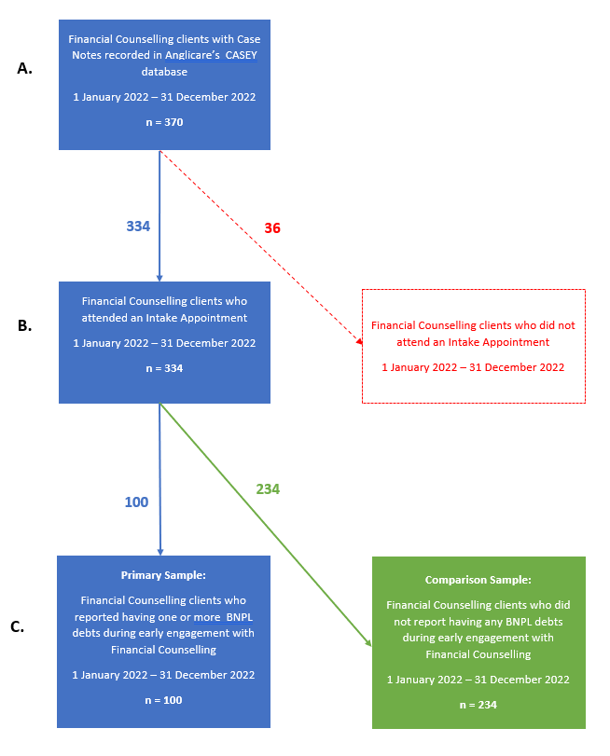
- Using CASEY, we generated a report of all financial counselling clients with Case File Notes in CASEY during 1 January – 31 December 2022. This time period was selected because it captures the most recent and complete 12-month dataset available. The resulting Case File List report was saved as an Excel spreadsheet, including each client’s name and their Case File Notes, including the type of each appointment. This report generated a list of 370 clients.
- Using Excel, the report generated by Step A above was searched for clients who had attended an Intake Appointment during 1 January – 31 December 2022, which identified 334 clients. The remaining 36 clients did not attend an Intake Appointment during this period, and were excluded.
- We conducted a manual review of each Case File (n =334) to determine if the client had one or more Buy Now Pay Later debts, either during their Intake Appointment or during preparation of their first Budget or Creditors Sheet. For each client, we read their Case File Notes, Budgets, Creditors Sheets and other Documents. This initial review identified 109 clients with one or more BNPL debts. Subsequently, we revised down the number of clients with BNPL debts to 100, forming the primary sample. The remaining 234 clients had no BNPL debts; and these clients formed the comparison sample.
Data extraction
For each client in the primary sample (n = 100) and comparison sample (n = 234), we copied the following information from CASEY, saving it in Excel spreadsheets:
- Type of each debt recorded in Case File Notes and Documents
- Current value of each debt, where the information was available
- Each client’s circumstances, sourced from their Case File Notes and Documents.
For each client, we also generated a Client Details Report and copied the data into Excel.
Quantitative data analysis
For both samples, we analysed data for selected data fields in Excel, after excluding prisoners. For each data field, simple counts were performed and percentages were calculated, with data cells that were not completed excluded from percentage calculations. For data about client’s BNPL debts and non-BNPL debts, total and average values were calculated, excluding clients where information was not recorded in CASEY. For each client, a simple count was conducted of their BNPL and non-BNPL debts, and totals, average values and ranges were calculated.
Coding and analysis of data about clients’ circumstances
For all clients (n = 334), their circumstances were analysed as a simple count for the presence of one or more circumstances. These circumstances had been earlier identified as frequently occurring for clients, informed by repeated manual reviews of clients’ Case Files conducted prior to coding. After conducting a simple count in both samples, and excluding prisoners, percentages were calculated.
Method for case study illustrations
Three case study illustrations of clients with BNPL debts were developed by collating quantitative and qualitative data from three client’s Client Profiles and Case File Notes, to present a holistic picture of their demographic characteristics, life circumstances, debts and expressed needs. Their names, exact ages and identifying details were changed to protect their identities.

Appendix B: Survey of Anglicare Tasmania's Financial Counsellors
This survey is being conducted for a SARC research project exploring the impacts of Buy Now Pay Later (BNPL) products on Anglicare’s Financial Counselling clients.
Please refer to the Participant Information Statement for information about the research. Or contact Dr Alexandra King, Social Action & Research Centre..
This survey will take approximately 15-20 minutes to complete.
1. How many of your clients are currently presenting with one or more BNPL debts?
None
A few
About half
Most
All
Don't know
2. Tell us more, if you wish:

3. How many of your clients are currently presenting with BNPL debts compared to 12 months ago?
A lot fewer now
Fewer now
About the same now
More now
A lot more now
Don't know
Not applicable - e.g. I was not working as a financial counsellor at Anglicare 12 months ago.
4. Tell us more, if you wish:

5. Thinking about your clients with BNPL debts, how many of them recognise BNPL as a type of credit?
None
A few
About half
Most
All
Don't know
6. Tell us more, if you wish:

7. Thinking about your clients with BNPL debts, how many of them have cut back or gone without essentials or missed other payments in order to service their BNPL debts?
None
A few
About half
Most
All
Don't know
8. Tell us more, if you wish:

9. Thinking about your clients with BNPL debts, what are the most common items purchased using BNPL products?
Please select at most 3 options.
Furniture
Educational expenses
Transport or petrol
Utilities - e.g. water, gas, electricity, telephone, internet
Clothing or shoes for adults
Household appliances
Clothing or shoes for children, or baby products
Don't know
Pet expenses
Food and groceries
Health or medical goods and services
Other:
10. Tell us more, if you wish:

11. Thinking about your clients overall, which type of debt is causing them the most severe difficulties?
Please select at most 3 options.
Consumer loans
Buy Now Pay Later products
Utility debts - e.g. water, gas, electricity, telephone, internet
Credit cards
Fines (e.g. traffic or other offences)
Mortgages
Payday loans
Personal loans
Don't know
Centrelink advances or overpayments
Rental arrears
Other:
12. Tell us more, if you wish:

13. How often have you seen clients use BNPL products in a way that benefits them?
Never
Occasionally
Sometimes
Most of the time
All of the time
Don't know
14. Tell us more, if you wish:

15. Thinking about your clients with BNPL debts, how many have taken out another BNPL loan in order to make BNPL repayments?
None
A few
About half
Most
All
Don't know
16. Tell us more, if you wish:

17. Thinking about the hardship policies and practices of BNPL providers, how helpful are they overall?
Never
Occasionally
Sometimes
Mostly
Always
Don't know
18. Tell us more, if you wish:

19. Thinking about your clients with BNPL debts, how often have you worked with a client who was coerced into taking out a BNPL debt, or a BNPL debt was taken out without their knowledge, by their intimate partner or former intimate partner?
Never
Very rarely
Sometimes
Often
Most of the time
Don't know
20. Tell us more, if you wish:

21. How many of your clients are using wage advance products?
Wage advance or “pay on demand” products (e.g., [brand name]) allow consumers to take out a loan for a proportion of their next pay for a fee and then repay the loan in instalments over future pay cycles.
None
A few
About half
Most
All
Don't know
22. Tell us more, if you wish:

23. Do you think BNPL products need to be better regulated in Australia?
Yes
No
Maybe
Don't know
24. Tell us more, if you wish:

25. How should BNPL products be regulated in Australia?
Australia's Treasury is currently considering how to better regulate BNPL in Australia and has proposed three options, from low (Option 1) to moderate (Option 2) to high (Option 3):
- Low – This option proposes a co-regulation approach, whereby the Government would introduce a modified affordability obligation under the Credit Act for BNPL providers, without imposing a requirement to hold and maintain an Australian credit licence; and the Australian Finance Industry Association (AFIA) would work with industry to strengthen the BNPL Industry Code, with certain provisions enforceable by ASIC.
- Moderate – This option proposes to apply some elements of the Credit Act to BNPL providers, including a modified licensing regime, with a reprieve from some elements of the responsible lending regime (such as the need to verify a customer's financial documentation and check that the BNPL product aligns with the customer's requirements and objectives). This option also proposes to strengthen the BNPL Industry Code as per Option 1.
- High – This option proposes to treat BNPL as a credit product regulated under the Credit Act, and the BNPL Industry Code would be revised to address industry-specific issues that are not considered within the scope of the Credit Act. (Sources: Treasury and Allens Linklaters.)
Low – Co-regulation
Moderate – Partial regulation under the Credit Act
High – Regulation under the Credit Act, like other credit products
Don't know
Other:
26. Tell us more, if you wish:
27. Please tell us anything more, if you wish, about BNPL debts or other debt issues experienced by your clients:

Appendix C: Quantitative Results of Survey of Financial Counsellors
The quantitative data generated by the survey is provided below.
Q1. How many of your clients are currently presenting with one or more BNPL debts?
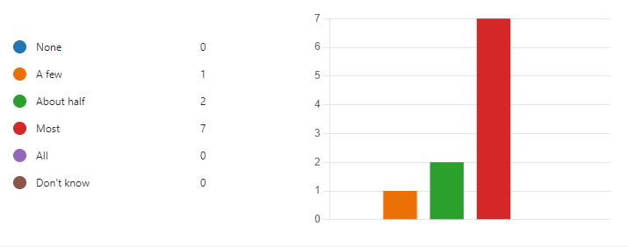

Q3. How many of your clients are currently presenting with BNPL debts compared to 12 months ago?
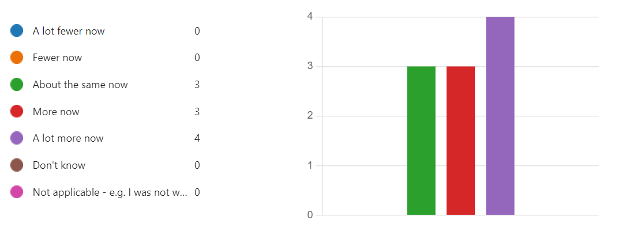

Q5. Thinking about your clients with BNPL debts, how many of them recognise BNPL as a type of credit?
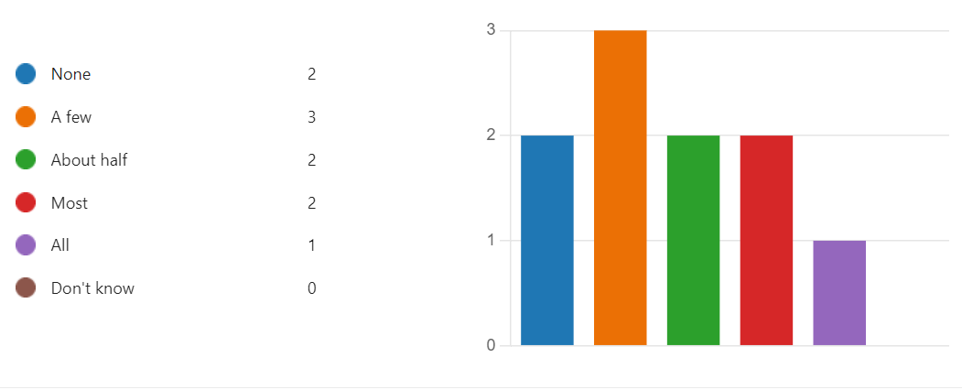
Q7. Thinking about your clients with BNPL debts, how many of them have cut back or gone without essentials or missed other payments in order to service their BNPL debts?
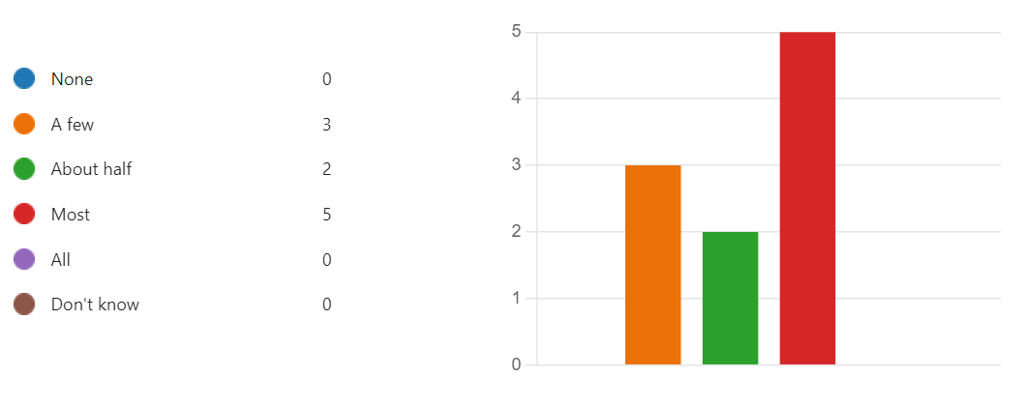

Q9. Thinking about your clients with BNPL debts, what are the most common items purchased using BNPL products?
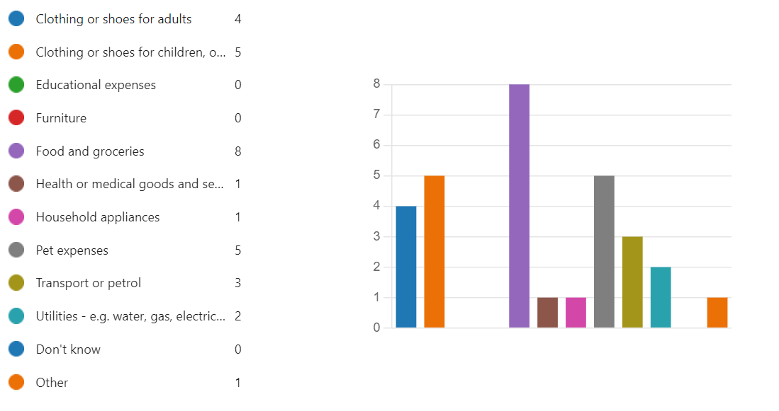

Q11. Thinking about your clients overall, which type of debt is causing them the most severe difficulties?
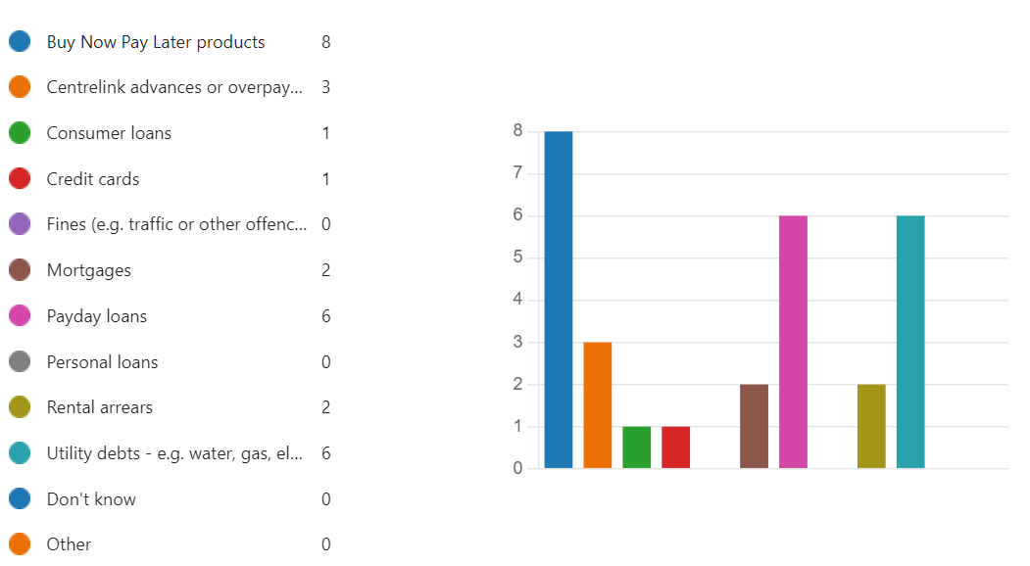

Q13. How often have you seen clients use BNPL products in a way that benefits them?
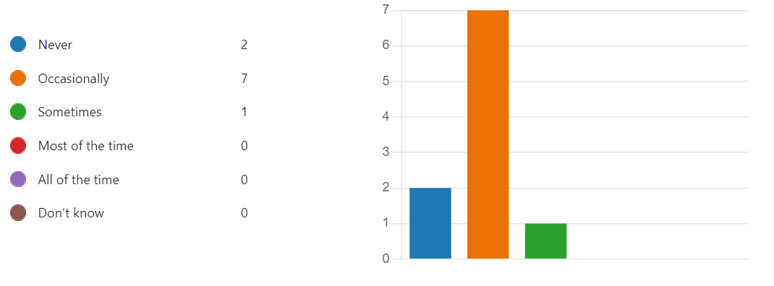
Q15. Thinking about your clients with BNPL debts, how many have taken out another BNPL loan in order to make BNPL repayments?
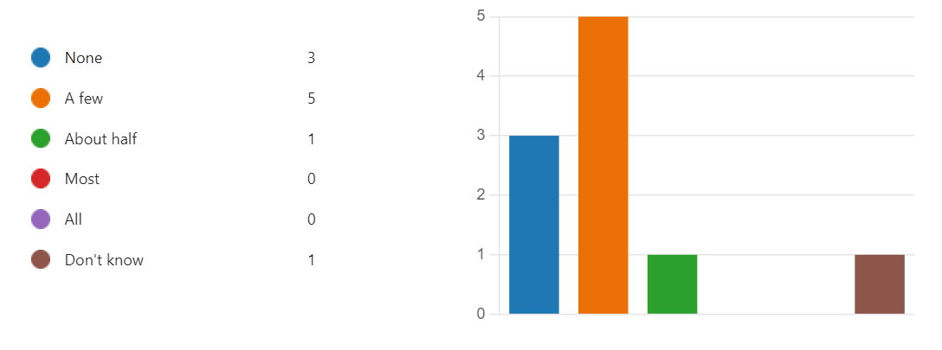

Q17. Thinking about the hardship policies and practices of BNPL providers, how helpful are they overall?
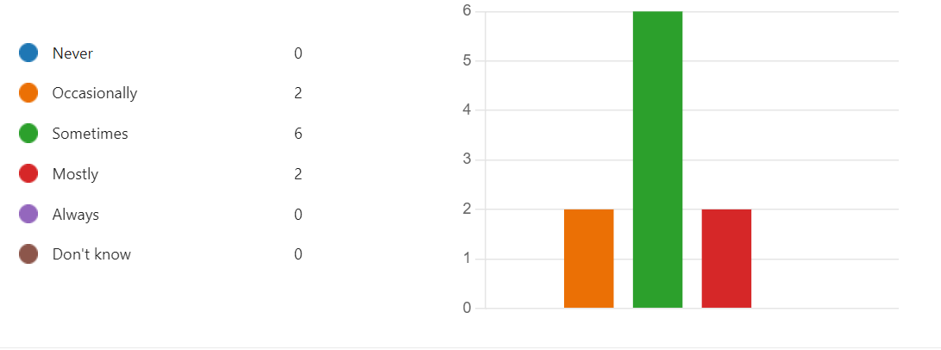
Q19. Thinking about your clients with BNPL debts, how often have you worked with a client who was coerced into taking out a BNPL debt, or a BNPL debt was taken out without their knowledge, by their intimate partner or former intimate partner?
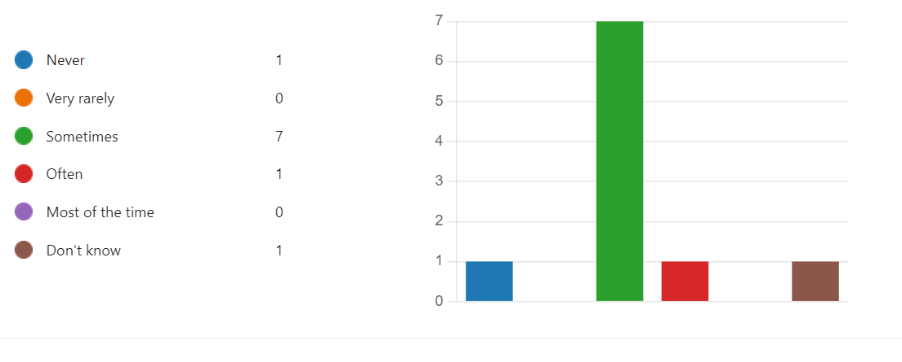

Q21. How many of your clients are using wage advance products?
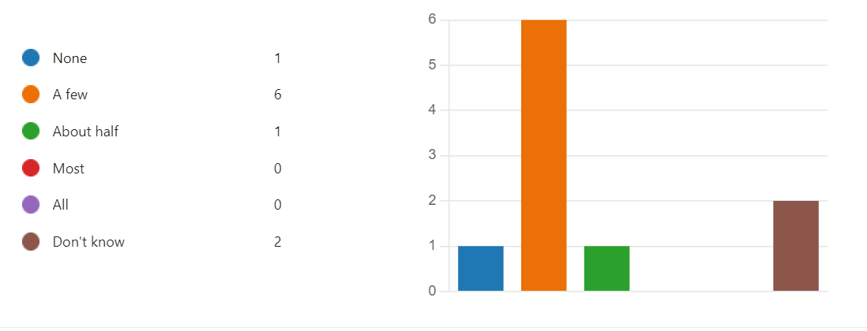

Q23. Do you think BNPL products need to be better regulated in Australia?

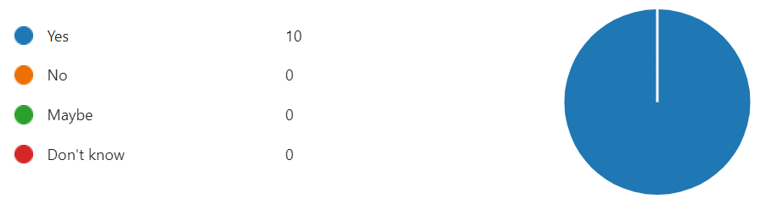

Q25. How should BNPL products be regulated in Australia?
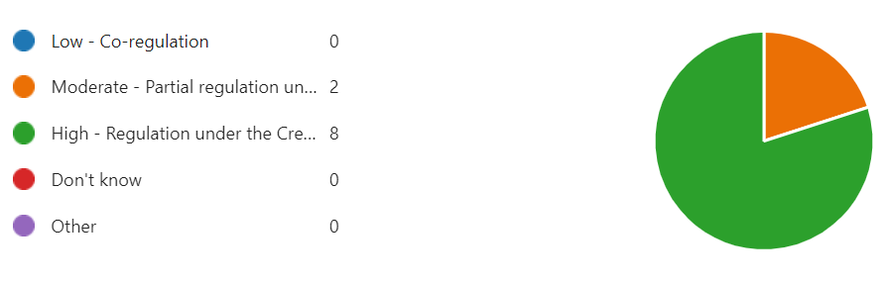

References
ABS see Australian Bureau of Statistics

ACOSS see Australian Council of Social Services

AIHW see Australian Institute of Health and Welfare

Anglicare Tasmania 2018, Submission to the Senate Standing Economics References Committee Inquiry into Credit and Financial Services Targeted Australians at Risk of Financial Hardship, Anglicare Tasmania, Hobart.

ASIC see Australian Securities and Investment Commission

Australian Bureau of Statistics 2020, Psychosocial disability: 2018 Survey of Disabilty, Ageing and Carers (SDAC), viewed March 2023, https://www.abs.gov.au/articles/psychosocial-disability.

--- 2021, Prisoners in Australia, viewed March 2023, https://www.abs.gov.au/statistics/people/crime-and-justice/prisoners-australia/2021.

--- 2022a, Tasmania: 2021 Census All persons QuickStats, viewed March 2023, https://www.abs.gov.au/census/find-census-data/quickstats/2021/6.

--- 2022b, Tasmania: Aboriginal and Torres Strait Islander population summary, viewed March 2023, https://www.abs.gov.au/articles/tasmania-aboriginal-and-torres-strait-islander-population-summary.

--- 2023, Estimating Homelessness: Census 2021, viewed March 2023, https://www.abs.gov.au/statistics/people/housing/estimating-homelessness-census/2021.

Australian Council of Social Services 2022, How JobSeeker and other income support payments are falling behind the cost of living, ACOSS, Sydney.

Australian Institute of Health and Welfare 2021, Australia's youth: Material deprivation and financial stress, viewed March 2023, https://www.aihw.gov.au/reports/children-youth/material-deprivation-and-financial-stress.

--- 2022a, Mental health: Prevalence and impact, viewed March 2023, https://www.aihw.gov.au/reports/mental-health-services/mental-health.

--- 2022b, Psychosocial disability support: Key concepts, viewed March 2023, https://www.aihw.gov.au/mental-health/topic-areas/psychosocial-disability-support.

Australian Securities and Investment Commission 2020, Buy now pay later: An industry update, ASIC, Canberra.

Best, R 2022, "Refining policies for financial stress", Australian Journal of Public Administration, vol. 81, no. 4, pp. 531-548.

Botha, F, Butterworth, P & Wilkins, R 2022, "Protecting mental health during periods of financial stress: Evidence from the Australian Coronavirus Supplement income support payment", Social Science & Medicine, vol. 306, p. 115158.

Boyle, CM, Joshi, A & Jenkinson, R 2021, Understanding gambling harm and ways to identify those at risk, viewed March 2023, https://aifs.gov.au/resources/short-articles/understanding-gambling-harm-and-ways-identify-those-risk.

Brackertz, N 2012, I wish I'd known sooner! The impact of financial counselling on debt resolution and personal wellbeing, Salvation Army, Melbourne.

Camp, M 2022, "Inquire now, regulate later: Australia’s light-touch approach to regulating buy-now-pay-later products", Australian Journal of Competition and Consumer Law, vol. 30, no. 2, pp. 121-128.

Close Lending Loopholes Coalition 2022, Close the Lending Loopholes: Joint Consumer Submission to Treasury

Coffey, J, Senior, K, Haro, A, Farrugia, D, Threadgold, S, Cook, J, Davies, K & Shannon, B 2023, "Embodying debt: Youth, consumer credit and its impacts for wellbeing", Journal of Youth Studies, pp. 1-21.

Commonwealth of Australia 2019, Royal Commission into Misconduct in the Banking, Superannuation and Financial Services Industry: Final Report, Canberra.

Connolly, C 2014, Measuring financial exclusion in Australia, Centre for Social Impact & National Australia Bank, Sydney.

Department of Education 2022, Benefits of educational attainment: Income, viewed March 2023, https://www.education.gov.au/integrated-data-research/benefits-educational-attainment/income.

Duong, L, Taylor, G & Eulaiwi, B 2022, Comparative analysis of credit card interest rates vs BNPL fees in the consumer credit market, Financial Counselling Australia, Melbourne.

Financial Counselling Australia 2021, It’s credit, it’s causing harm and it needs better safeguards: What financial counsellors say about Buy Now, Pay Later, FCA, Melbourne.

Good Shepherd 2022, Safety net for sale: The role of Buy Now Pay Later in exploiting financial vulnerability, Good Shepherd Australia New Zealand.

Guan, N, Guariglia, A, Moore, P, Xu, F & Al-Janabi, H 2022, "Financial stress and depression in adults: A systematic review", Plos ONE, vol. 17, no. 2.

Hartfree, Y & Collard, S 2015, "Locating credit and debt within an anti-poverty strategy for the UK", Journal of Poverty and Social Justice, vol. 23, no. 3, pp. 203-214.

Heartward Strategic 2022, Money and mental health: Social research report, Heartward Strategic.

Johnson, D, Rodwell, J & Hendry, T 2021, "Analyzing the impacts of financial services regulation to make the case that buy-now-pay-later regulation is failing", Sustainability, vol. 13, no. 4, p. 1992.

Livingstone, C, Kotnik, E & King, S 2008, Comparing Australian and international approaches to financial counselling service models: Literature review, Monash University, Melbourne.

Mahmoudi, P, Hordacre, A-L & Spoehr, J 2014, Paying it forward: Cost benefit analysis of the Wyatt Trust funded financial counselling services, University of Adelaide.

NSW Council of Social Service 2021, Young People and BNPL: An NCOSS "Cost of Living in NSW" Report, NCOSS, Sydney.

Pollard, CM, Booth, S, Louth, J, Mackenzie, C & Goodwin‐Smith, I 2020, "'I'd be sleeping in the park, I reckon': Lived experience of using financial counselling services in South Australia", Economic Papers: A Journal of Applied Economics and Policy, vol. 39, no. 4, pp. 353-366.

Sylvan, L 2019, The countervailing power: Review of the coordination and funding for financial counselling services across Australia, Department of Social Services, Canberra.

Tasmanian Government 2019, Safe Homes, Families, Communities: Tasmania's Action Plan for Family and Sexual Violence 2019-2022, Tasmanian Government, Hobart.

Taylor, J 2022, "Women struggle to get federal government’s $5,000 payment to escape domestic violence", The Guardian, 3 April.

Treasury 2022a, National Financial Capability Strategy, Australian Government, Canberra.

--- 2022b, Regulating buy now, pay later in Australia: Options Paper, Australian Government, Canberra.

Way Forward 2022, Balancing Act: Exploring how financially vulnerable people juggle their debt, BNPL and household finances: Client Survey 2022, Way Forward, Melbourne.

Women’s Information and Referral Exchange (WIRE) n.d., Money Problems with Your Partner: WIRE Information Booklet, WIRE, West Melbourne.

Refer to the Glossary for an explanation of this term.
Refer to Box 3 of this report or download Treasury’s Option Paper here: https://treasury.gov.au/consultation/c2022-338372
Respondents could provide more than one answer to this question.
Respondents could provide more than one answer to this question.
No clients identified as any other gender.
Age at 31 December 2022, calculated from date of birth recorded in Client Profiles.
Clients are assigned to only one Primary Group, but they may belong to more than one, given they experience multiple types of disadvantage. As such, these results are likely to be an under-estimate of clients’ disadvantage.
This figure includes 3 former prisoners, as well as 55 current prisoners.
This may be explained by clients with BNPL debts having a higher proportion of people aged under 25 years.
This figure is likely to be an under-estimate because information about dependent adult children is not routinely recorded in Case Files.
This figure is likely to be an under-estimate because this information is not routinely recorded by Financial Counsellors.
This low figure may reflect the higher percentage of prisoners in this client group – it is possible that prisoners are less likely than people living in the community to report having a disabled or unwell child as one of their immediate concerns.
For more information about the Raise the Rate campaign, see: https://www.raisetherate.org.au/.
This result may be explained by the high proportion of prisoners in this sample. These prisoners were overwhelmingly male, and males are less likely to report being a victim survivor of family violence.
Given this is self-reported, we do not know how clients have defined psychiatric disability for themselves; it may differ from this definition from the Australian Institute of Health and Welfare (AIHW).
Latest available figure. The term ‘psychosocial disability’ is used by the Australian Bureau of Statistics and the National Disability Insurance Agency and is conceptually similar to AIHW’s definition of ‘psychiatric disability’.
The severity or duration of these conditions was not usually recorded in Case File Notes.
This is likely to be an under-estimate because mental illness or difficulties are not always recorded in Case File Notes and clients may under-report mental illness or mental health difficulties due to stigma.
These figures are likely to be an under-estimate because not all Financial Counselling clients are screened for gambling harm and there is stigma associated with disclosing harmful gambling behaviours.
Our analysis found that alcohol and other drugs harm was less prevalent in clients with no BNPL debts compared to clients with BNPL debts.
This is an under-estimate because the Case Files do not always contain complete information about the value of BNPL debts reported by clients.
These figures may include late fees or account charges charged in addition to the initial cost of purchases.
Total mortgage amounts were excluded because their value is typically much higher than other debts.
People receiving regular Centrelink payments can apply to the Department of Social Services for a lump-sum advance, and then pay it off interest-free by means of a deduction from their Centrelink payment over 13 fortnights. For more information see: https://my.gov.au/en/services/work/experiencing-financial-hardship/advance-payment
This figure excludes total mortgage debts and business tax debts, as these were usually much higher in value than clients’ other debts (sometimes by a factor of 1,000 or more).
For details, see: Flexible Support Packages, Tasmanian Government.
Refer to Box 3 in this report or access Treasury’s Option Paper here: https://treasury.gov.au/consultation/c2022-338372.

