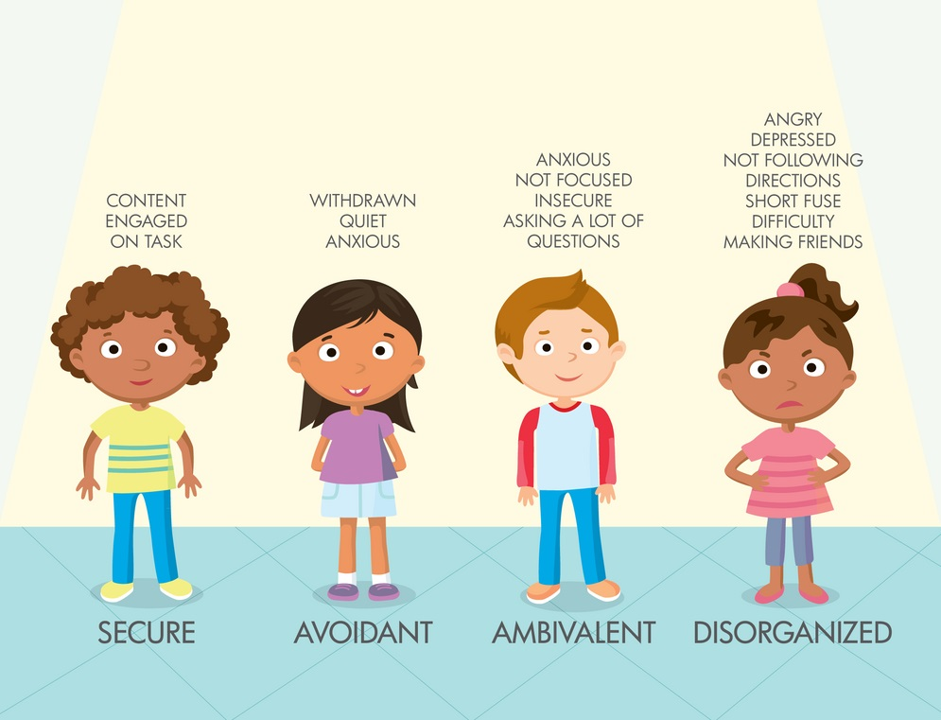
Childhood Attachment Styles
There are four patterns of attachment, including:
- Secure attachment: Children who can depend on their caregivers show distress when separated and joy when reunited. Although the child may be upset, they feel assured that the caregiver will return. When frightened, securely attached children are comfortable seeking reassurance from caregivers. This is the most common attachment style.
- Avoidant attachment: Children with an avoidant attachment tend to avoid parents or caregivers, showing no preference between a caregiver and a complete stranger. This attachment style might be a result of abusive or neglectful caregivers. Children who are punished for relying on a caregiver will learn to avoid seeking help in the future.
- Ambivalent attachment: These children become very distressed when a parent leaves. Ambivalent attachment style is considered uncommon, affecting an estimated 7% to 15% of U.S. children. As a result of poor parental availability, these children cannot depend on their primary caregiver to be there when they need them.
- Disorganized attachment: These children display a confusing mix of behaviour, seeming disoriented, dazed, or confused. They may avoid or resist the parent. Lack of a clear attachment pattern is likely linked to inconsistent caregiver behaviour. In such cases, parents may serve as both a source of comfort and fear, leading to disorganized behaviour.

