

2024-25 ANNUAL REPORT



  - Conversations that matter

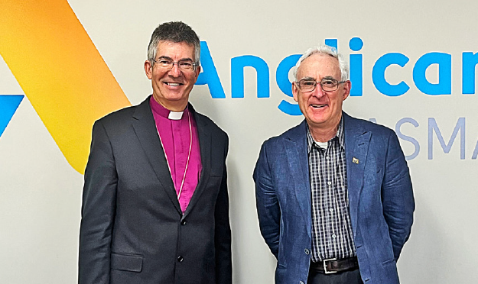
Board Chair Mike Blake AM (right) and CEO Chris Jones

Board Chair, Mike Blake AM

Consistent with our mission, Anglicare Tasmania provided Tasmanians with choice, hope and support during a challenging year.

We delivered a respectful Housing Connect Front Door service in the midst of a chronic housing shortage.
We assisted older Tasmanians to navigate the delayed introduction of the Australian Government’s new Support at Home program.
Our wide-ranging Community Services programs provided practical support to Tasmanians in need, while the Social Action and Research Centre published work that was influential and solutions-focused.
We embedded the Quality of Life program in our corporate governance framework so that we regularly ask clients what they need from life and our service.
This year we welcomed Isabel Legg to the Board and thanked retiring member Ruth Croser for her valuable contribution to the work of Anglicare Tasmania.
I commend CEO Chris Jones and the Anglicare team for their commitment to delivering excellent services to the Tasmanian community.

CEO, Chris Jones

The Anglicare values of justice, respect, compassion and hope underpin every aspect of our work.

Our team members draw on their expertise and passion to support people from various backgrounds and stages of life.
When someone calls Anglicare or walks into one of our offices, it’s an opportunity to treat them with dignity and to make a difference where we can.
By putting Anglicare’s values into action, team members show our deeply-held commitment to positive change.
As an organisation we are serious about listening, learning and improving the services we deliver to the Tasmanian community.

We ask people about their quality of life. These important conversations help us to make improvements to our services and connect people with tailored supports.

We use special Quality of Life survey tools to engage with people supported by our Aged Care services and residents at a number of accommodation facilities. This year we also began extending this project to clients of our Acquired Injury Support Services.
People told us that increasing ‘social participation and involvement’ and their ‘control over daily life’ were high priorities for them.

New passport has tails wagging

Until this year and for safety reasons, the older Tasmanians we support at home were required to put their pet outside or in another room while we delivered their service.

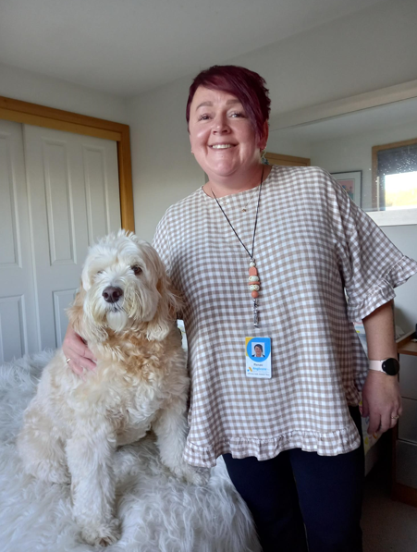
When we heard how important it was for people to keep their pets by their side, we consulted with our workers and the RSPCA and the idea of a ‘pet passport’ was born. Now, pets that complete a special assessment are free to remain with their owners while Anglicare provides support. Labradoodle Molly, pictured above with Intake and Training Lead Renae Fleming, passed her test with flying colours.
“It’s heart-warming, it’s changing lives and I love being part of this,” said Home Care Worker Wendy.
“We hope this inspires other community service providers to follow Anglicare’s lead,” said RSPCA CEO Andrea Dawkins.

Our supporters

Thank you to the many individuals, businesses, parish partners, schools, and other organisations who donated time, money, food or other gifts this year.

In 2024-25, Anglicare received funding and support from ABC Giving Tree, Allport Bequest, Attorney-General’s Department, Brotherhood of St Laurence, Colin Bisdee Trust, CatholicCare Tasmania, Department for Education, Children and Young People, Department of Health (Commonwealth), Department of Health (Tasmania), Department of Premier and Cabinet (Tasmania), Department of Social Services (Commonwealth), Department of Veterans’ Affairs (Commonwealth), Farrell Foundation, Homes Tasmania, icare, Launch Housing, Motor Accidents Insurance Board, National Disability Insurance Agency, National Injury Insurance Scheme Queensland, Primary Health Tasmania, and The Salvation Army.


We congratulated Zayden Dare-Rainey (above) who was awarded the University of Tasmania’s Anglicare Scholarship in Social Work, and Vanessa Henry of St John Ambulance, the winner of the volunteer impact category sponsored by Anglicare at the 2024 Tasmanian Volunteering Awards.
Saddened at the passing of Anglicare Life Member Margaret Kelly, we are grateful that her colleagues in the Howrah Biscuit Ladies are continuing to show care for those who use the Youthcare service for young men.
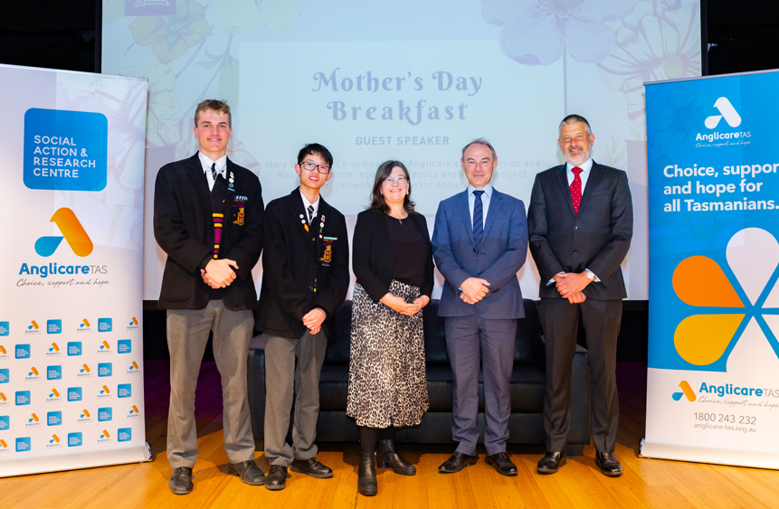
The year 12 class at The Hutchins School chose us as its charity partner for 2025. The coordinator of our Social Action and Research Centre, Mary Bennett, was invited to speak about our work at an assembly to mark Mothers’ Day.

Financial performance

Anglicare delivered $77.7 million worth of vital services to Tasmanians during 2024-25, up from $71.5 million in the previous year.

A strong focus on client outcomes drove investment in our people, systems, advocacy and service delivery.
We invested over $55.5 million in our Tasmanian workforce. With 1,037 people on our payroll throughout the year, we continue to be one of the state’s largest employers.
We’re proud of the role we play in supporting the Tasmanian economy, including in rural and remote communities. We spent more than $20 million with Tasmanian businesses, in line with our policy of prioritising the purchase of local goods and services wherever possible.
A surplus of over $3.5 million will be reinvested into services to support Tasmanians in future years.
Read Anglicare’s full financial statements.

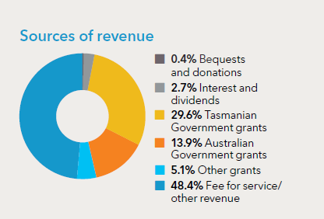
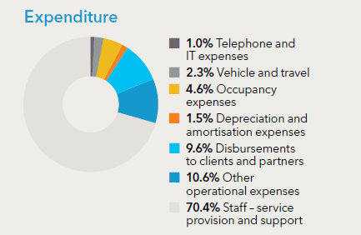

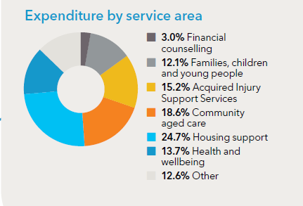

We are respectful
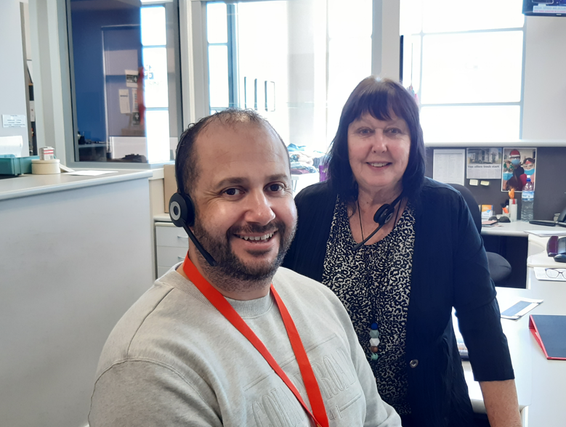
Dylan and Julie provided a warm welcome for people coming through the doors of our Devonport office.

Every person has value and a unique perspective to offer.
Anglicare is committed to developing and promoting respectful relationships with the Tasmanian Aboriginal community.
The conversations we have with our advisory group, yarnin’ up, assist us to provide services that are culturally appropriate, accessible and effective for community members. Together, we have created an action plan that we regularly review with group members.
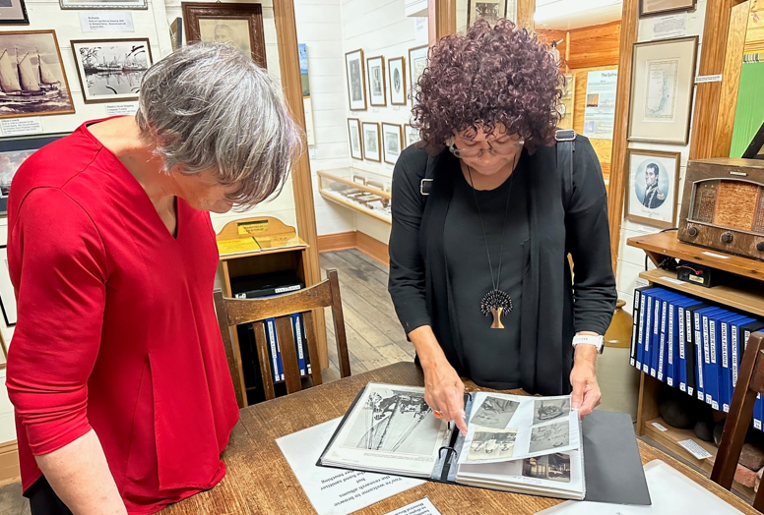
A trip to Flinders Island and Truwana with CEO Chris Jones gave yarnin’ up members Aunty Nola (left) and Aunty Delia the opportunity to walk on country and revisit their community’s history.

Our Aged Care Services continued to grow this year. We supported 2,394 older Tasmanians this year to remain living well in their own homes.
Independence is at the heart of healthy ageing. Our Wellness and Reablement policy directs our Aged Care team to do tasks with the people they support, rather than for them. Each client has a personal care plan that is a living document reflecting their personal history, interests and aspirations.

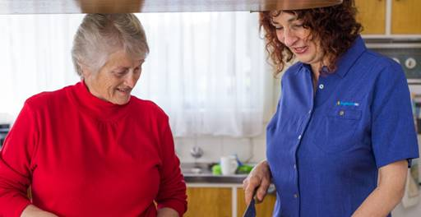
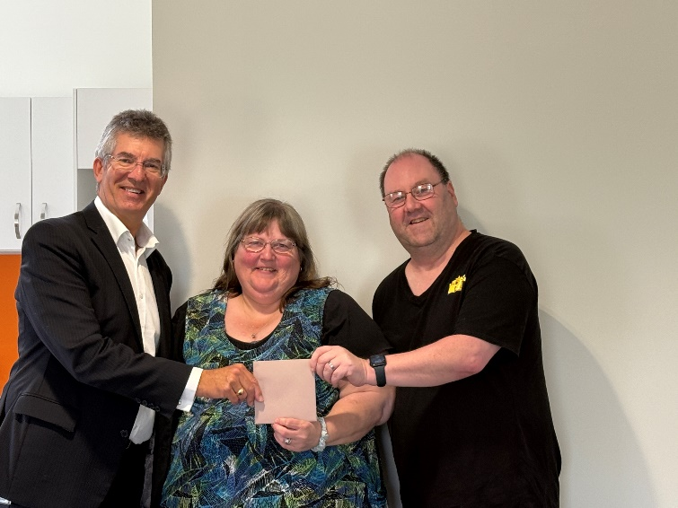
We have a Participant Advisory Council that meets with the CEO to talk about operational matters and how to bring our values to life. Its members are current or former clients and their supporters, and we draw on their insights to improve our services. We thanked retiring members including Jason and Diane, and long term contributors Christina and Brett Horton, pictured here with CEO Chris Jones.

We are hopeful

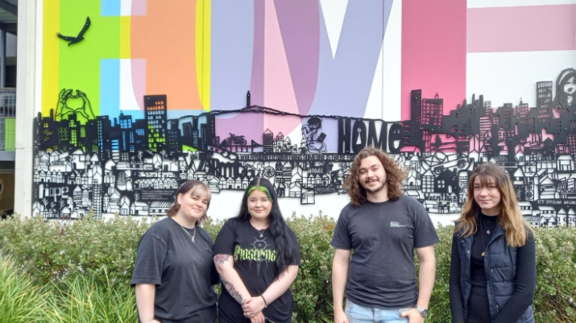
Youth2Independence students (from left) Maddie, Ebony, Jonas and Mahalia are pictured at Trinity Hill in North Hobart.

The state’s housing shortage has seen the community demand greater action from decision-makers.
Tasmanians are urging governments at all levels to do more to end homelessness and increase the supply of affordable housing. This year, rents rose almost two times faster than income, rental vacancy rates fell in all regions, and the social housing register grew by nearly 10% to a record 5,163 applications.
In the midst of the crisis, the statewide Housing Connect Front Door service operated by Anglicare responded to 48,662 enquiries from Tasmanians in housing need. 45% of people had a mental health condition, while 11% identified family and domestic violence as the main reason for seeking support.
The Front Door supported people to apply for social housing and maintain their tenancies in the private rental market. It expanded outreach to people in mental health centres and facilities, safe spaces and prisons. Client satisfaction surveys showed 95% of respondents were ‘very satisfied’ with the customer service they received from our team.

John walked into the Housing Connect Front Door late on a Friday afternoon and saw a Connections Coach straight away. He explained he was couch-surfing after breaking up with his fiancée and wanted to find somewhere that his two young children could stay with him. They talked about the problems John had had with his mental health and some new physical fitness goals he’d set.
On the Monday they met again and looked up gyms together, and Housing Connect funded a 4-week trial of a boxing class. The Connections Coach then supported John to find a casual job and he worked his first shift the following week. While he hasn’t got housing yet, John is building the foundations to get his life back on track.
- Housing Connect Front Door Service snapshot, March 2025

Anglicare provides supported accommodation to young people and older adults across the regions. It’s a successful model that offers Tasmanians at risk of homelessness stable, communal housing and the opportunity to gain practical life skills. A resident at Bayview Lodge in the South said in a Quality of Life survey: “The service I am given is exceptional especially the staff in the way they communicate [and] show genuine interest in your mental, social, and emotional state of being.” A resident at Burnie Lodge said: “The staff have helped me move forward in life and I’m so grateful.”
A student living at Trinity Hill in Hobart as part of the Youth2Independence program described their home environment as “safe and inclusive.” 216 young people were supported to engage with education, employment and community during the year.
Anglicare’s mental health programs encourage people to set realistic goals, celebrate wins and persevere through setbacks. We support people to build and retain connections with their local community.
The Supported Youth Program in the North West provides young people with a starting point for healing from childhood trauma and disadvantage. An early years parenting support program in the region promotes care-giving that is warm and consistent so that children feel loved and safe.
The Tech4Kids digital and social inclusion program is helping more Tasmanian families to support their children’s education. This year we used our local knowledge to identify families in the greatest need of a laptop for their child or children. Launceston parent Jennifer was thrilled when four of her five sons were eligible: “Our future as a family is looking bright,” she said.

“It's a privilege to be there for those lightbulb moments when residents acknowledge their own value or conquer a barrier and move towards a more stable future.”
- Jenelle, Senior Support Worker at Bilton Lodge in Southern Tasmania.

We work for justice

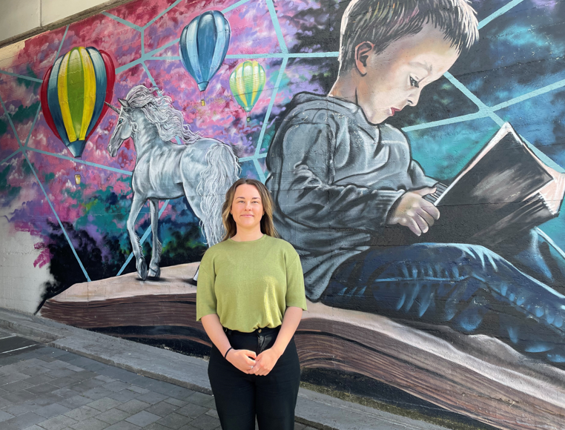
Policy & Advocacy Officer Ginny Toombs, pictured in Burnie for the media launch of the Unsafe and Unhoused report.

We advocate for changes to improve people’s lives.

Anglicare’s Social Action and Research Centre challenges systems and practices that perpetuate disadvantage, and makes evidence-based recommendations for change.
This year its research and advocacy work supported parliamentary debate, legislative changes and budget allocations that are making people safer. It also contributed to a decision by the Commonwealth Grants Commission to allocate an additional $151 million in GST revenue to Tasmania in 2025-26. This decision recognized the state’s disadvantaged and remotely located population.
Public health continued to be the focus of our advocacy on gambling harm this year. We shared the effectiveness of a pre-commitment system for poker machine gambling in Finland, and a personal story about how the proceeds of crime are used to fuel gambling addiction. We published a policy brief that argued a universal card was the only effective way to reduce gambling harm.
The Unsafe and Unhoused report (October 2024) shone a light on the domestic and family violence emergency in the North West. A drastic shortage of affordable housing continues to jeopardise the safety of women and children living in the region.
The annual Rental Affordability Snapshot (April 2025) urged governments to work together to deliver social housing at the scale that is required.
The Stretched Too Far report (October 2024) called for more help for Tasmanian families trying to shield their children from the effects of financial hardship. It also showed how children’s experiences in the first years of life affect the physical architecture of their developing brains.
Quarterly snapshots of the Housing Connect Front Door service revealed a severe shortage of all types of housing, from crisis and emergency accommodation to transitional housing and permanent homes.

There is an urgent need for more Rapid Rehousing properties for women and children fleeing domestic and family violence – but they must be safe.
The home that Matilda and her children were moving into had no security screen doors. The front door had large panels of glass that could be easily broken. The rear door had a dog door large enough for a person to fit through. Our worker advocated for security screen doors to be installed to protect the family’s safety and give Matilda peace of mind.
Unsafe and Unhoused, October 2024

We are compassionate

We provide non-judgemental support to the people we serve.

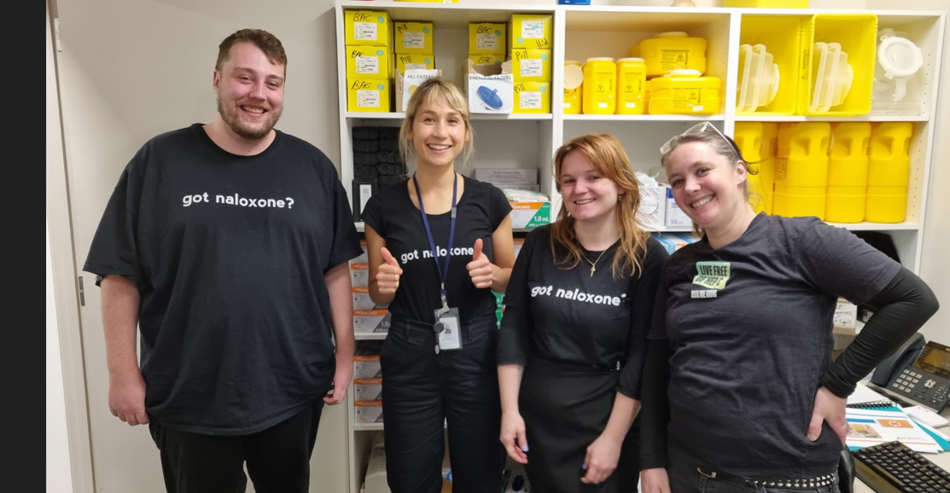 Needle and Syringe Program team members in the Collins Street office during the year, from left: Oscar, Natalia, Jamila and Jo.
Anglicare manages Needle and Syringe Program outlets at our offices in Hobart, Glenorchy and Burnie. The program is an important public health initiative that minimises harm and saves lives. On International Overdose Awareness Day in August 2024 we welcomed people to a memorial garden at our Glenorchy office. The garden was developed in conjunction with the local community.
“With Anglicare’s support, we’re creating a welcoming and uplifting space where people can come together to pay their respects to friends and family members and learn about harm reduction. There’s no stigma here.”
– Advocate Kerrie Dare on the creation of a community garden at Anglicare’s Glenorchy office.
Anglicare operates the National Debt Helpline in Tasmania. This year we took 3,727 calls and online chats, a 24% increase on the previous year’s figure. Issues of concern to Tasmanian callers included mortgage repayments, rent, utility and insurance costs and Buy Now Pay Later (BNPL) loan repayments. In June 2025 we welcomed the introduction of a new legal framework for BNPL products. Meanwhile, the ‘superpower’ of Anglicare’s financial counselling service is our capacity to advocate on behalf of our clients with creditors.
Anglicare’s Gamblers Help service provides free and confidential advice about managing gambling behaviour. We shared inspiring stories of recovery in Gamble Aware Month. An event in the North West recognised the contribution of people who care for someone with an addiction. In May 2025, forums across the North encouraged conversations between frontline professionals about reframing language and reducing stigma.


Anglicare client Garry catches a wave at Carlton Beach during the Let’s Go Surfing event. Photo by Tim Pargiter.
Disability advocate and community leader Alysse Gavlik is a client of the Acquired Injury Support Services provided by Anglicare on behalf of the Motor Accidents Insurance Board (MAIB). She enjoyed a Let’s Go Surfing all-abilities event in March 2025. “Being part of this event was absolutely incredible,” she said. “It wasn’t just about surfing, it was about inclusion, empowerment, and proving that adventure is for everyone.”

Anglicare’s Snapshot newsletter
If you would like to read more about how Anglicare’s work improves the lives of Tasmanians, subscribe to Snapshot, our monthly newsletter that arrives by email.

